The heights of 80 plants were measured.  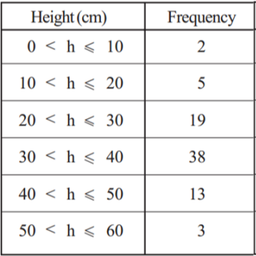  Draw a cumulative frequency graph for the plants and estimate how many plants were taller than 35cm. | The box plot below represents the life of 30 Regular electric light bulbs tested by the Shiny Electric Light Company.  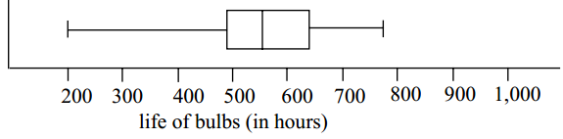  Draw the boxplot for Superbulbs  Shortest life 350 hours Longest life 950 hours  Lower quartile 650 hours Upper quartile 770 hours  Median life 740 hours  Compare the two companies together. | 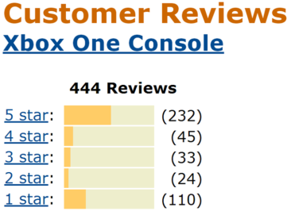  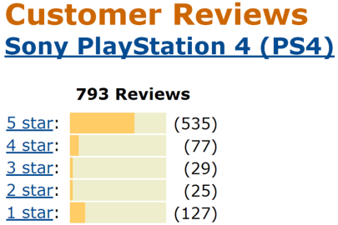  The Amazon customer ratings for the PS4 and Xbox One are shown above. Which is more popular?
Work out the inter-quartile range for the heights of the plants.  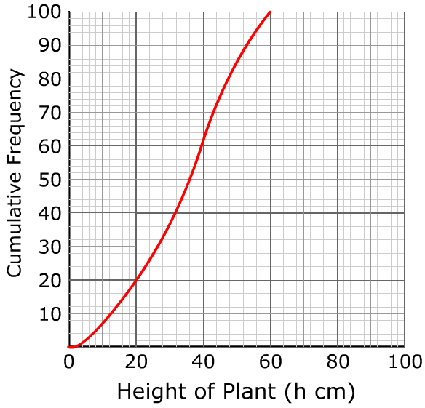 | The probability of winning a game is 0.8 Kaneez plays the game 250 times.  How many times would you expect her to lose? | 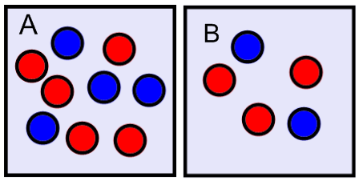  One ball is taken at random from each box. Work out the probability that they are the same colour.
Nafisa wants to know how much people spend on their lunch. She uses this question in her questionnaire:  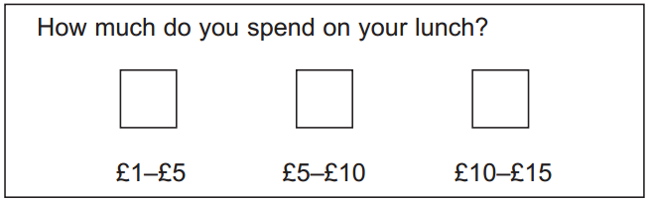  Write down two things wrong with the question.  Write a better question including response boxes. | A bag contains red, blue and green balls in the ratio 2:3:4. A ball is taken at random. Work out the probability of the ball not being green. | Two surveys were made of the ages of patients in 2 hospitals, A&B.  Compare the boxplots.  