KS3 MATHEMATICS

10 4 10

Level 6 Questions

Day 1

Mental Arithmetic Questions

- What number is five cubed?

- A circle has radius r.
What is the formula for the area of the circle?

- Jenny and Mark share some money in the ratio two to three. Jenny’s share is one hundred and ten pounds.
How much is Mark’s share?

- The net of a triangular prism is made from triangles and rectangles.
How many of each shape are needed?

5. Multiply minus six by minus two.
Advert
You can work out the cost of an advert in a newspaper by using this formula:
(a) An advert has 18 words.
Work out the cost of the advert.
Show your working.

2 marks
(b) The cost of an advert is £615
How many words are in the advert?
Show your working.

………………… words
2 marks

Toys
The cost of an old toy vehicle depends on its condition and on whether it is in its original box.
A Mail Van in excellent condition, and in its original box, costs £125.
(a) How much is a Mail Van in good condition, and in its box?
£ ..............................
1 mark
(b) How much is a Mail Van in good condition, but not in its box?

(c) A Petrol Tanker in excellent condition, and in its box, costs £152.
Another Petrol Tanker should be sold for £98.80
Using the chart above, what is its condition and does it have a box?

KS3 MATHEMATICS

10 4 10

Level 6 Questions

Day 2

Mental Arithmetic Questions

- What is one third of three-quarters of one hundred?

- I’m thinking of a number. I call it n.
I square my number then add four.
Write an expression to show the result.

- Twenty-one out of thirty-six pupils said they watched Top of the Pops.
What angle would show this on a pie chart?

- There are seven red and three blue balls in a bag.
I am going to take a ball out of the bag at random. What is the probability that the ball will be blue?

- Write a multiple of three that is bigger than one hundred.

Angles
Area
The information in the box describes three different squares, A, B and C.
The area of square A is 36 cm2
The side length of square B is 36 cm
The perimeter of square C is 36 cm
Put squares A, B and C in order of size, starting with the smallest.
You must show calculations to explain how you work out your answer.

........................ ........................ ................... smallest largest
2 marks

Kay is drawing shapes on her computer. She wants to draw this triangle. She needs to know angles

a, b and c.
Calculate angles a, b and c.
a = .............................. º
1 mark
b = .............................. º
c = ...........................º
1 mark

(b) Kay draws a rhombus:
Calculate angles d and e.
d = .............................. º
1 mark
e = .............................. º
1 mark

Mental Arithmetic Questions

- I am thinking of a number. I call it n.
I double my number then I subtract three.
Write an expression to show the result.

- What percentage of fifty pounds is thirty-five pounds?

- On average, the driest place on earth gets only nought point five millimetres of rain every year.
In total, how much rain would it expect to get in twenty years?

- To the nearest whole number, what is the square root of eighty-three point nine?

- It takes me one and a half minutes to swim one length of the pool.
How many lengths can I swim in fifteen minutes

KS3 MATHEMATICS

10 4 10

Level 6 Questions

Day 3

Sheep and Lambs
On a farm 80 sheep gave birth.
30% of the sheep gave birth to two lambs.
The rest of the sheep gave birth to just one lamb.
In total, how many lambs were born?
Show your working.

………………… Lambs
2 marks

Equations
These straight line graphs all pass through the point (10, 10 )
(a) Fill in the gaps to show which line has which equation.
line …………... has equation x = 10
line …………... has equation y = 10
line …………... has equation y = x
line …………... has equation y = x – 5
line …………... has equation y = x + 5
2 marks
b) Does the line that has the equation y = 2x – 5 pass through the point (10, 10 )?
Explain how you know.
1 mark

m = …………………
1 mark
Total 4 marks

Mental Arithmetic Questions
- Tariq won one hundred pounds in a maths competition. He gave two-fifths of his prize money to charity. How much of his prize money, in pounds, did he have left?

- What is three point nine divided by two?

- The instructions for a fruit drink say to mix one part blackcurrant juice with four parts water. I want to make one litre of this fruit drink. How much blackcurrant juice should I use? Give your answer in millilitres.

- What is half of two-thirds?

- The population of the United Kingdom is about fifty-nine million. Write this number in figures.

KS3 MATHEMATICS

10 4 10

Level 6 Questions

Day 4

Horses
The scatter diagram shows the heights and masses of some horses. The scatter diagram also shows a line of best fit.
(a) What does the scatter diagram show about the relationship between the height and mass of horses?
1 mark
(b) The height of a horse is 163cm.
Use the line of best fit to estimate the mass of the horse.
.........……………….. kg
1 mark
(c) A different horse has a mass of 625kg.
Use the line of best fit to estimate the height of the horse.
...........……………. cm
1 mark

(d) A teacher asks his class to investigate this statement:
"The length of the back leg of a horse is always
less than the length of the front leg of a horse."
What might a scatter graph look like if the statement is correct? Use the axes below to show your answer.

1 mark

L-shape
What is the area of this L-shape?
Show your working.

............................ cm²
2 marks

KS3 MATHEMATICS

10 4 10

Level 6 Questions

Day 5

Mental Arithmetic Questions

- What is three-fifths of forty pounds?

- The longest bone in the human body is in the leg. The average length of this bone in a man is fifty centimetres. In a woman it is ten per cent less.
What is the average length of this bone in a woman?

- Using three as an approximation for pi, what is the area of a circle with radius five centimetres?

- I am thinking of a two-digit number that is a multiple of eight.
The digits add up to six.
What number am I thinking of?

- I am thinking of a number. I call it n. I add five to my number.
Write an expression to show the result.

Mental Arithmetic Questions

- What is three-fifths of forty pounds?

- The longest bone in the human body is in the leg.
The average length of this bone in a man is fifty centimetres. In a woman it is ten per cent less.
What is the average length of this bone in a woman?

- Using three as an approximation for pi, what is the area of a circle with radius five centimetres?

- I am thinking of a two-digit number that is a multiple of eight.
The digits add up to six.
What number am I thinking of?

- I am thinking of a number. I call it n. I add five to my number.
Write an expression to show the result.

Fractions
(a) Add and

............................
1 mark
Now use an arrow (↓) to show the result on the number line.

1 mark
(b) How many sixths are there in 3?

............................
1 mark
(c) Work out 3÷
Show your working.
....................... 1 mark

Puzzle
You can often use algebra to show why a number puzzle works.
Fill in the missing expressions.

2 marks

KS3 MATHEMATICS

10 4 10

Level 6 Questions

Day 6

Mental Arithmetic Questions

- Five percent of a number is 8. What is the number?

- A fair spinner has eight equal sections with a number on each section. Five of them are even numbers. Three are odd numbers.
What is the probability that I spin an even number?

- I can make a three-digit number from the digits two, three and four in six different ways.
How many of these three-digit numbers are even?

- What is the volume of a cuboid measuring five centimetres by six centimetres by seven centimetres?

- What is the remainder when you divide three hundred by twenty-nine?

Wheelchair
Wyn and Jay are using their wheelchairs to measure distances.
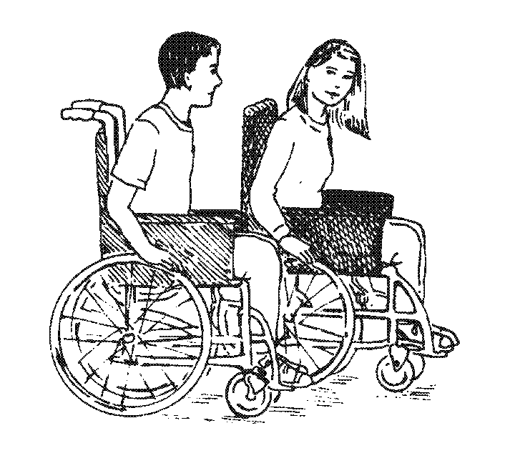
- The large wheel on Wyn’s wheelchair has a diameter of 60cm. Wyn pushes the wheel round exactly once.
Calculate how far Wyn has moved.
Show your working.

............................... cm
2 marks
(b) The large wheel on Jay’s wheelchair has a diameter of 52cm.
Jay moves her wheelchair forward 950cm.
Calculate how many times the large wheel goes round. Show your working.

............................... Times
2 marks

Wedges
This door wedge is the shape of a prism.
(a) The shaded face of the door wedge is a trapezium.
Calculate the area of the shaded face.
Show your working.

............................... cm²
2 marks
(b) Calculate the volume of the door wedge.
Show your working.

............................... cm³
1 mark
KS3 MATHEMATICS

10 4 10

Level 6 Questions

Day 7

Mental Arithmetic Questions

- Twenty-five per cent of a number is seven.
What is the number?

- There are fourteen girls and thirteen boys in a class.
What is the probability that a pupil chosen at random will be a girl?

- The first even number is two.
What is the hundredth even number?

- The mean of two numbers is 8. One of the numbers is two. What is the other number?

- How many edges are there on a square based pyramid?

Number Cards
James has these four number cards:
The mean is 4.

James takes another card. The mean of the five cards is still 4. What number is on his new card? ............................... 1 mark
(b)Tara has these four number cards:

She takes another card. The mean goes up by 2. What number is on her new card?

Show your working. ................................2 marks
(c) Ali has six cards. The mean of the six cards is 10. The range of the six cards is 4.
What are the numbers on the other two cards?
.............................. and ..............................
1 mark

Libraries

A newspaper wrote an article about public libraries in England and Wales.
It published this diagram.
Data on libraries from LISU (Library and Information Statistics Unit)
Use the diagram to decide whether each statement below is true or false, or whether you cannot be certain.
(a) The number of libraries open for more than 45 hours per week fell by more than half from 1988 to 1998.
True | False | Cannot be certain
Explain your answer.
1 mark
(b) In 2004 there will be about 450 libraries open in England and Wales for more than 45 hours a week.
True | False | Cannot be certain
Explain your answer. 1 mark

KS3 MATHEMATICS

10 4 10

Level 6 Questions

Day 8

Mental Arithmetic Questions

- Multiply 8.7 by 2

- A bat flies at an average speed of 32 kilometres an hour. At this speed, how far will it fly in 15 minutes?

- Multiply the brackets (2x +1) (x – 1)

- I’m thinking of a number. I call it t. I half it and subtract five. Write an expression to show the result.

- The first odd number is 1. What is the hundredth odd number?

Equations

Solve these equations.
Show your working.
8k − 1 = 15

k = ............................
1 mark
2m + 5 = 10

m = ............................
1 mark
3t + 4 = t + 13

t = ............................
2 marks
2(3n + 7) = 8

n = ............................
1 mark

Sibling ages
Paul is 14 years old.
His sister is exactly 6 years younger, so this year she is 8 years old.
This year, the ratio of Paul’s age to his sister’s age is 14 : 8
14 : 8 written as simply as possible is 7 : 4
(a) When Paul is 21, what will be the ratio of Paul’s age to his sister’s age?
Write the ratio as simply as possible.
........................ : .....................
1 mark
(b) When his sister is 36, what will be the ratio of Paul’s age to his sister’s age?
Write the ratio as simply as possible.
........................ : .....................
1 mark
(c) Could the ratio of their ages ever be 7 : 7?
Tick () Yes or No.
Yes No
Explain how you know.
1 mark

KS3 MATHEMATICS

10 4 10

Level 6 Questions

Day 9

Mental Arithmetic Questions

- Add four to minus five.

- What number should you add to minus three to get the answer five?

- How many nought point fives are there in ten?

- On average, the driest place on earth gets only nought point five millimetres of rain every year. In total, how much rain would it expect to get in twenty years?

- What is the sum of the angles in a rhombus?

Glasses
There are 60 pupils in a school.
6 of these pupils wear glasses.
(a) The pie chart is not drawn accurately.
What should the angles be?
Show your working.
……………… ° and ………………°
2 marks
(b) Exactly half of the 60 pupils in the school are boys.
From this information, what percentage of boys in this school wear glasses?
Tick () the correct box below.
5% 6% 10%
20% 50% not possible to tell

1 mark

Light Bulbs

Brightlite company makes light bulbs.
The state of the company’s machines can be:
available for use and being used
or available for use but not needed
or broken down.
(a) The table shows the probabilities of the state of the machines in July 1994.
Write in the missing probability.
1 mark
(b) During another month the probability of a machine being available for use was 0.92.
What was the probability of a machine being broken down?
..............................
1 mark
(c) Brightlite calculated the probabilities of a bulb failing within 1000 hours and within 2000 hours. Complete the table below to show the probabilities of a bulb still working at 1000 hours and at 2000 hours.
KS3 MATHEMATICS

10 4 10

Level 6 Questions

Day 10

Mental Arithmetic Questions

- It takes some-one one and a half minutes to swim the length of the pool. How many lengths can I swim in 15 minutes?

- Multiply minus eight by minus three.

- If 4x + 3 = 23, what is the value of x?

- I have a fair eight sided dice numbered 12 to 19. What is the probability that I will throw a prime number?

- What must I multiply n squared by to get n cubed?

Hedging
A garden centre sells plants for hedges.
The table shows what they sold in one week.
Plants | Number of plants sold | Takings
Beech | 125 | £212.50
Leylandii | 650 | £2437.50
Privet | 35 | £45.50
Hawthorn | 18 | £23.40
Laurel | 5 | £32.25
Total | 833 | £2751.15
(a) What percentage of the total number of plants sold was Leylandii?
Show your working.
……………… %
2 marks
(b) What percentage of the total takings was for Leylandii?
Show your working.

……………… %
2 marks
(c) Which is the cheaper plant, Beech or Privet?
Show working to explain how you know.
1 mark
1 mark

Algebra Pairs
(a) Join pairs of algebraic expressions that have the same value when a = 3, b = 2 and c = 6
One pair is joined for you.
2 marks
(b) Draw lines to join any pairs that will always have the same value when a = b = c
3 marks

