Producing mailmerged letters that are sent out via email
1. Open Outlook (Microsoft Office Outlook).
2. Record the table of required data in a spreadsheet, example shown below. Save the file, then exit.

3. The column headings will be the fields to use on the standard letter.
4. Open Word and compose the standard letter as it should finally look, without the data. Part of an example is shown below. After a mock exam these can get very detailed. I usually take the opportunity to reinforce the message about equipment, homework, Mathswatch, etc. on page 1 of my letter then use page 2 for the detailed information.
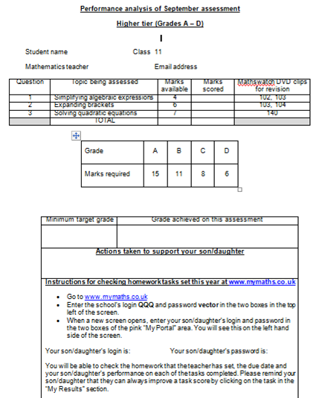
5. Now choose “Mailings” at the top of the screen.
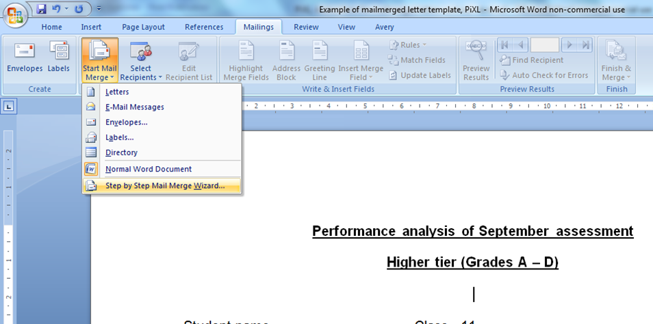
Select “Start Mail Merge” as shown above and select Step by Step Mail Merge Wizard.

6. On the right of your screen, select Email messages, as shown, then select Next at the bottom of the box.

7. This takes you to step 2 of 6. Select Next at the bottom of the screen since you will be using the “current” document as your base.

8. At step 3, you will select your recipients. Select Browse and then find your saved spreadsheet. When you have opened it, you will get a dialogue box, like the one shown below. If you put all the data on Sheet 1, highlighted that one and click OK.
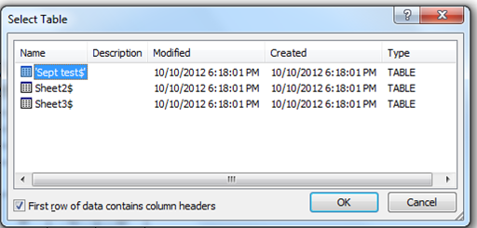

Now, you will see a dialogue box where you can select which ROWS of data you want to use.
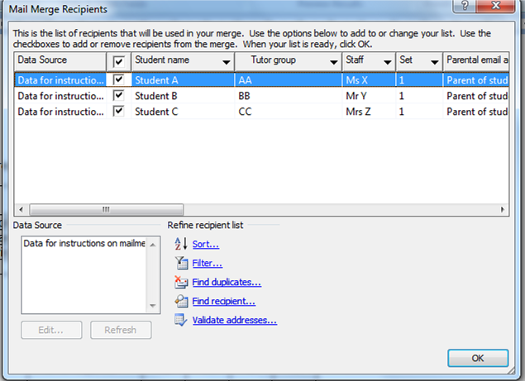

You can select whichever rows you want by checking/unchecking the box next to the Name column. Uncheck rows where you do not have the parental email address.
Now click Next at the bottom of the screen to go to step 4.
9. Step 4 of 6. Use the Insert Merge field menu, shown below, to insert information from the appropriate column in your spreadsheet, into your Word document.
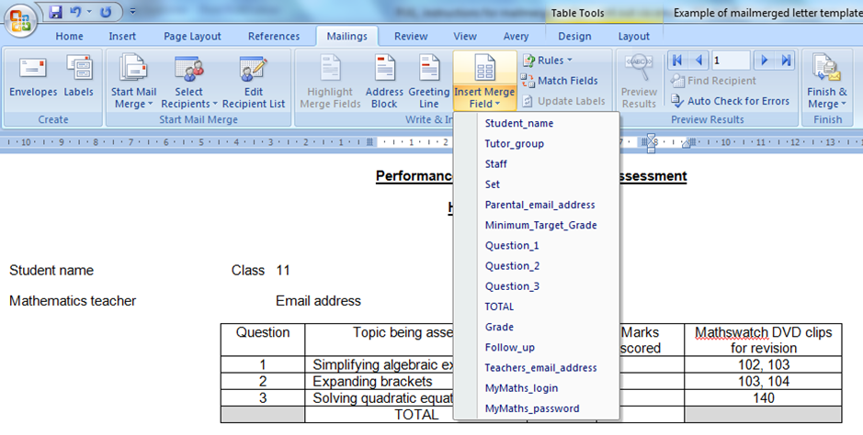

Just click on the space you want the information to go, then select the merge field using the menu as shown above.
Your document will now look like this. (part of screen shown)
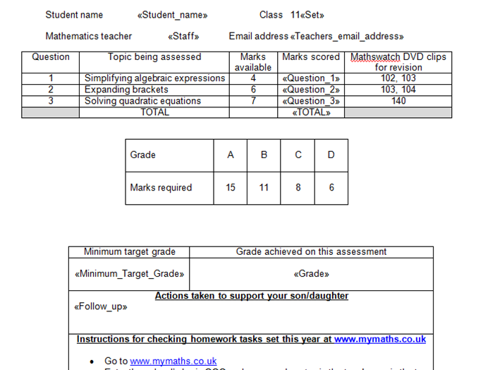

Don’t be concerned if it looks as if information is being “pushed” on to the next line. You can check that it is in the correct place at the next step (Preview)
Select Next at the bottom of the screen to go to step 5 of 6.
10. Step 5 of 6. This previews your letters and you can use the arrows at the right of the screen to go through each letter, as it should appear when sent.
When ready, select Next to go the step 6 of 6.

11. At the right of the screen will be an option “Electronic mail”. Click it and when the dialogue box below comes up, just make sure that the To: section shows the column you are using for the Email address, as shown. (I used this as a column heading on the spreadsheet; if you had used “Who to send to” as your title, you would select that on the drop down menu.
Note: Choose a subject line. I have found parents are more likely to open the document if they can see this.
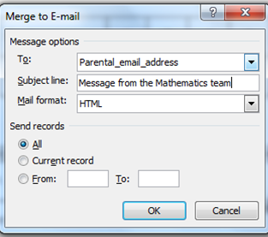

12. Choose OK and you’re done. The emails are being sent now.

Note: At this stage, I maximise Outlook and check for any “undeliverable” notifications or any other problems, then update my tracking sheet, as required.

