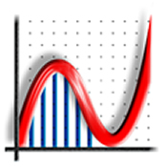 Program, 48: 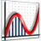 32: 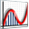 16: |  |  |  | .agg File, 48: 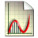 32: 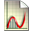 16: |  |  |  | 
Autograph 3.20 Button Icons [Advanced Level only]
MAIN |  | STATISTICS |  |  | 2D GRAPHING |  | 3D GRAPHING |  | MODES
 | New Statistics page |  | Relabel f-x |  |  | Reset x-y axes |  | Restore x-y-z orientation |  | Select object  Marquee select points
 | New 2D Graph page |  | Relabel F-x |  |  | Reset x-t axes |  | Restore y-x orientation |  | Add point
 | New 3D Graph page |  | Relabel %-x |  |  | Reset x-axis only |  | Default scales |  | Scribble
 | Results Box |  | Relabel f(x)-x |  |  | Default scales |  | Black background |  | Rub-out
 | Key below |  | Relabel p-x |  |  | Cartesian grid |  | Medium background |  | Drag (3D: camera)
 | Key at right |  | Auto-scale |  |  | Polar grid |  | Light background |  | Zoom-in
 | x 1 snap |  | Discrete plotting |  |  | No axes |  | Show grid |  | Zoom-out
 | x 0.1 snap |  | Continuous plotting |  |  | Equal Aspect |  | Show bounding box |  | Zoom in ‘x’
 | Degrees |  | Enter Grouped data - |  |  | Enter XY data |  | Enter equation |  | Zoom out ‘x’
 | Radians |  | Enter Raw data - , |  |  | Enter Equation |  | Enter vector line |  | Zoom in ‘y’
 | Edit Axes |  | Enter Box plot |  |  | Enter vector line |  | Enter vector plane |  |  | Zoom out ‘y’
 | Text Box |  | Enter Prob. Distribution |  |  | Enter Shape |  | Enter shape |  | Zoom in ‘z’
 | Constant Controller |  | Histogram |  |  | Enter 2D Coordinates |  | Enter 3D coordinates |  | Zoom out ‘z’
 | Animation Controller |  | Cumulative F.D. |  |  | Re-plot, and start-up |  | Re-plot |  | Rectangle zoom in
 | Whiteboard Mode |  | Box Plot |  |  | Pause /continue |  | Pause /continue |  | Rectangle zoom out
 | Line thickness |  | Dot Plot |  |  | Fast forward |  | Fast forward |  | D. E. /Integral solution
 | Line colour |  | Sample Means |  |  | Slow Plot mode |  | Slow Plot mode
MAIN |  | STATISTICS |  |  | 2D GRAPHING |  | 3D GRAPHING |  | EXTRAS
 | Fill colour |  | Mean and 3 SD |  |  | Gradient function |  |  |  |  | Area of a Circle
 | Zoom modes on/off |  | Line Plot |  |  | Integral function |  |  |  |  | Trigonometry
 | Equation History |  | Moving Average |  |  | Reflection in y=x |  |  |  |  | Monte-Carlo π
 | View Keyboard |  | Histogram Measure |  |  | Manage equation list |  |  |  |  | Dice Simulation
 | Undo |  | C.F.D. Measure |  |  | Define f(x) and g(x) |  |  |  |  | Confidence Intervals
 |  |  | Prob. Distr. measure |  |  |  |  |  |  |  | Poisson Grid
 | File Save |  | Table of Stats |  |  |  |  |  | ✓
 | File Open |  | Statistics box |  |  | Right-Click option |  | Right-Click option
 |  |  | Stem and Leaf diagram |  |  | Area under curve |  | Volume of Revolution
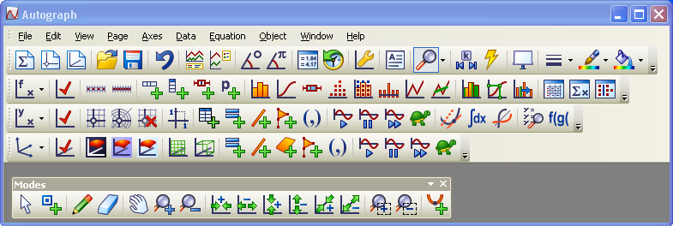
AUTOGRAPH 3.20 May 2007

