Autograph Tutorial 3 – Intersections in Autograph

Autograph Buttons covered:
Enter equations
Edit axes
Zooming, dragging
Select Mode
Text boxes

Other Autograph Functions covered:
- Solve f(x) = 0
- Solve f’(x) = 0
- Solve f(x) = g(x)
- Change the line/curve appearance
- Adjust the degree of accuracy

Point Mode
Undo

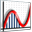 Open up Autograph in Advanced Mode and ensure you have a blank 2D graph page
Make sure you are not in Whiteboard Mode
Click on Slow Plot
Enter the equation: y = x² + 4x – 3
NOTE: To enter x², either use the little 2 button, press “alt 2” together, or type in “xx”

 Predict: What will this curve look like? Where will it cross the axes? Which direction will it slope?
Click OK

As you will see, not all of the curve fits on the page, so we need to edit our axes.
Edit the axes as follows:
x: Minimum: -6 Maximum: 4 Numbers: 1 Pips: 0.2
y: Minimum: -8 Maximum: 6 Numbers: 1 Pips: 0.5
Remove all of the green ticks underneath Auto
NOTE: You must ensure all the ticks under Auto are removed or Autograph will attempt to re-scale your axes for you.

NOTE: Before you attempt to re-scale the axes yourself, often pressing the Default Scale button will do a good job of sorting the scales out for you.

Now we have our curve on the page, let’s see what Autograph can help us find out about it:

1. Where does the curve cross the x-axis?

Use the zoom-in function to take a closer look at the first crossing point which is close to -5.
Notice how the scale automatically adjusts the closer in you get.
Use the drag function to move across the screen to find the other point where the curve crosses the x-axis.

Zoom back out so we are looking at the original graph again.
NOTE: Pressing Undo several times is often a quicker way of getting back to your original view.

Now, there is a way to find where the curve crosses the x-axis much more accurately:

Make sure you are in Select Mode
Left-click on the curve (it should turn black).
Right-click to bring up a menu.
Select Solve f(x) = 0.
This will mark on the two points where the curve crosses the x axis, and give you there values to four significant figures in the status bar at the bottom of the page.

Left-click to select one of the crossing points (it should turn black)
NOTE: Because these two points are related, they will both be selected

Click on Text Box
. In the text field, delete “Equation solver”, and instead write “x-axis crossing points”
Click OK.
This displays the results in a moveable text box on the page.

Your page should look something like this:

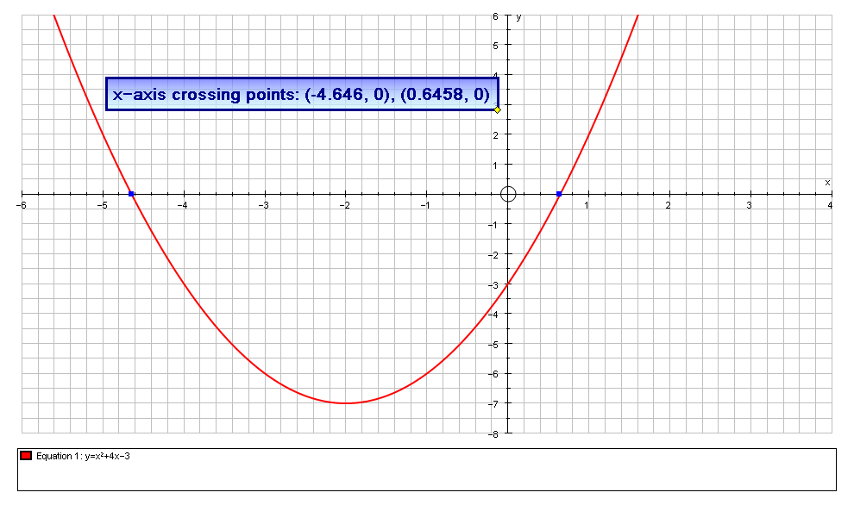

2. Where does the curve cross another line?

Enter another equation: y = –x – 4
Still on the enter Equation screen, click on Draw Options:
Change the colour of the line to purple
Choose a dashed line style
Set the line thickness to 3 pts

Predict: What will this line look like? Where will it cross the axes? Which direction will it slope?
Click OK twice

You can see that it crosses our curve at two points.
Again, we can zoom-in to take a closer look at the points of intersection, but we can also use a similar technique to find out their co-ordinates more accurately:

After zooming in, press Undo until you return to the original view of the graph

Ensure you are in Select Mode
Hold down the SHIFT button on the keyboard to select more than one object:
Left-click on both the curve and the straight line (they should both turn black)
NOTE: The use of the Shift button to select more than one object is very important!

Right-click, select Solve f(x) = g(x), and once again the co-ordinates of the crossing points are marked, and the results are displayed in the status bar.

If you want to improve the accuracy of the calculations:
Go to Page > Edit Settings
Adjust the level of accuracy to 8 significant figures.
Another quite nice way to achieve all this is to have a moveable co-ordinate on the curve.

Select Point Mode and place a point somewhere on the left-hand side of the curve
NOTE: When the cursor hovers over a section of the curve, it should turn from a cross into a black arrow.

Click on Text Box
. In the text field, delete “Point”, and instead write “A”
Click OK.
This will keep a record of the current co-ordinates of point A.

Ensure you are in Select Mode and point A is selected (it should have a square around it)
Use the left and right arrow buttons on the keyboard to move the point along the curve.
Use the up and down arrow buttons on the keyboard to switch between the curve and the line.

Place the point somewhere on the curve.
Left-click twice on the point, and type in the x-value -5

Your screen should look something like this:

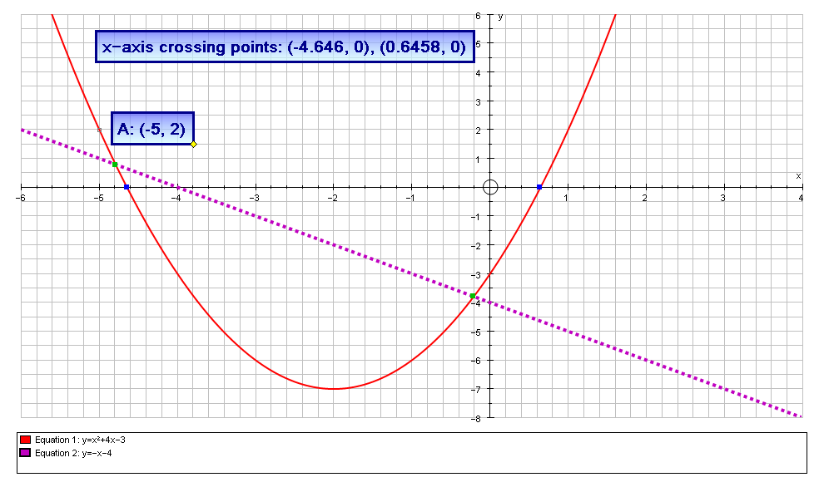

With the point still selected, if you right-click you also have the following options:
- Move to next f(x) = 0 which will move you to the next crossing of the x axis
- Move to next f’(x) = 0 which will move you to the next stationary point on the curve.

