Autograph Tutorial 1 - Basic 2D Plotting

Autograph Buttons covered:
Enter equations
Edit axes
Enter Co-ordinates
Select Mode
Text boxes
Other Autograph Functions covered:
- The use of Alt
- The use of left-right buttons
- Family Plots

Animate
Undo

 Open up Autograph in Standard Mode and ensure you have a blank 2D graph page
Make sure you are not in Whiteboard Mode
Enter the equation: y = 2x + 5
NOTE: A quick way to access the Enter Equation screen is to press Enter on the keyboard

 Predict: What will this line look like? Where will it cross the axes? Which direction will it slope?
Click OK

As you will see, the line does not fit on the page very well, so we need to edit our axes.
Edit the axes as follows:
x: Minimum: -8 Maximum: 8 Numbers: 1 Pips: 1
y: Minimum: -12 Maximum: 12 Numbers: 1 Pips: 1
Remove all of the green ticks underneath Auto
NOTE: You must ensure all the ticks under Auto are removed or Autograph will attempt to re-scale your axes for you.

NOTE: Before you attempt to re-scale the axes yourself, often pressing the Default Scale button will do a good job of sorting the scales out for you.

We will now label our line.

Make sure you are in Select Mode
Left-click on the line to select it (it should turn black).

Click on Text Box
. In the text field, delete “Equation 1”, and instead write “Line 1”
Click OK.
This displays the equation of the line in a moveable text box on the page.

Your page should look something like this:

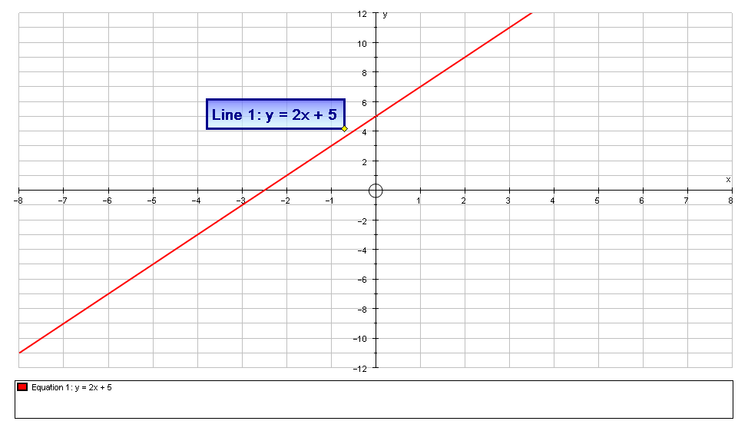

Let’s place a point on our curve:

Left-click on the line (it should turn black)
Add a point on the line with an x value of 1

Predict: Where will this point appear on the line? What will be the y-value?
Click OK

Let’s label our point:

Make sure the point is still selected (it should have a little square around it)
Click on Text Box
. In the text field, change “Point” to “Point A”
Click OK.

This displays the co-ordinates of Point A in a moveable text box on the page.

Now let’s move our point:
Make sure the point is still selected (it should have a little square around it)
Use the left-right arrows on the keyboard to move the point one grid space along the line.
Notice how the co-ordinates of the point also change.

NOTE: If you hold down Alt at the same time, the point moves 1/10th of a grid space

Your page should look something like this:

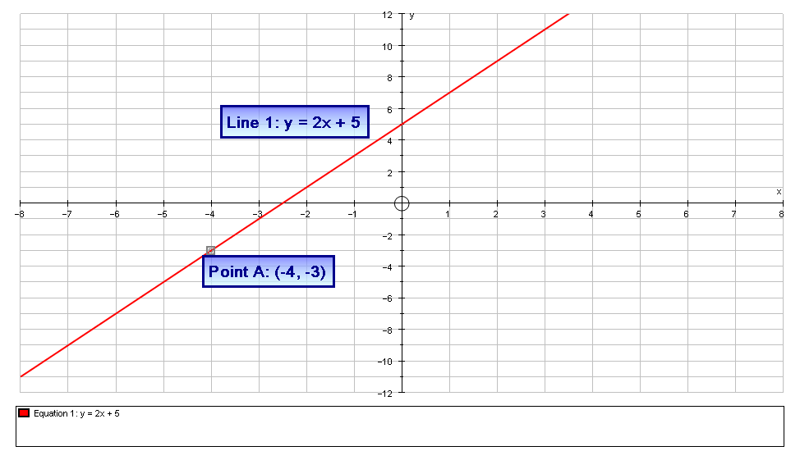

But better than that, we can animate our point:

Make sure the point is still selected (it should have a little square around it)
Select the Animate button, which brings up the Adjust Position box
You now have the option of selecting the exact starting location for the point, and the size of the step which it increases in.
Select a position of -2, and a step of 0.5
Use the left-right buttons to move your point along the curve.

Still in the Adjust Position box, click on Animate
Here you can set up Autograph to adjust the step automatically.
Try these settings on Automatic - Repeat:
- Animation speed as far to the left as it will go
- Start: -7 Finish: 2 Step: 0.5
Click the Play button

When you are happy, close the Adjust Position box

Now, let’s experiment with another line:

Enter the equation: y = mx + c

Predict: m and c are just constants which can take any value. What values would they have to take for the line to lie exactly on top of our red one?

Still on the Enter Equation screen, click on Edit Constants, and set the values as follows:
m = 2 c = 5
Click OK twice
The new blue line should lie exactly on top of the red line.

We are now going to experiment changing the value of the constants:

Predict: What effect will changing the values of m and c have on the line? Will they change the shape? The position? Will they change the slope? What if m goes negative?

Click on Constant Controller
You can now change the values of either of the two constants and observe the effect it has on the shape and position of the curve
The drop-down menu is used to switch between constants
The up-down buttons alter the value of the constant
The left-right buttons alter the size of the step

Experiment with different values of m and c, observing the effect on the line.
When you are satisfied, set m to a value of 3 and c to a value of -4.

We can now do a number of things with our new dynamic line.

1. Create a Dynamic Text Box

Ensure the line is selected to select the line (it should be black)
Select Text Box
In the text field, change “Equation 2” to “Line 2”
Tick the box next to Show Detailed Object Text and click OK
The equation of the curve and the current values of the constants should now be displayed in a moveable Text Box.

If you alter the values of the constants there current values will always be displayed.

Your page should look something like this:

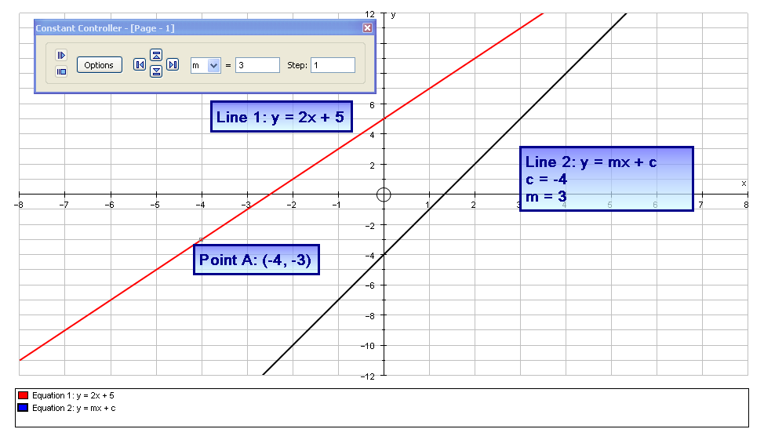

2. Animate

With Line 2 selected, and the Constant Controller still open, choose constant c from the menu,
Click on Options.
Select Animation
Keep the Animation Speed and the same, and set the following:
Start: -10 Finish: 10 Step: 0.5

Predict: What will this look like?

Click OK and press the Play button
This automatically adjusts the value of c for you so you can observe its effects on the shape and position of the line.

3. Family Plot

Set the value of c to -2
Select constant m
Click on Options on the Constant Controller
Select Family Plot
Adjust the parameters as follows:
Start: -5 Finish: 5 Step: 1

Predict: What will this look like?
Click OK.

Your screen should look something like this:

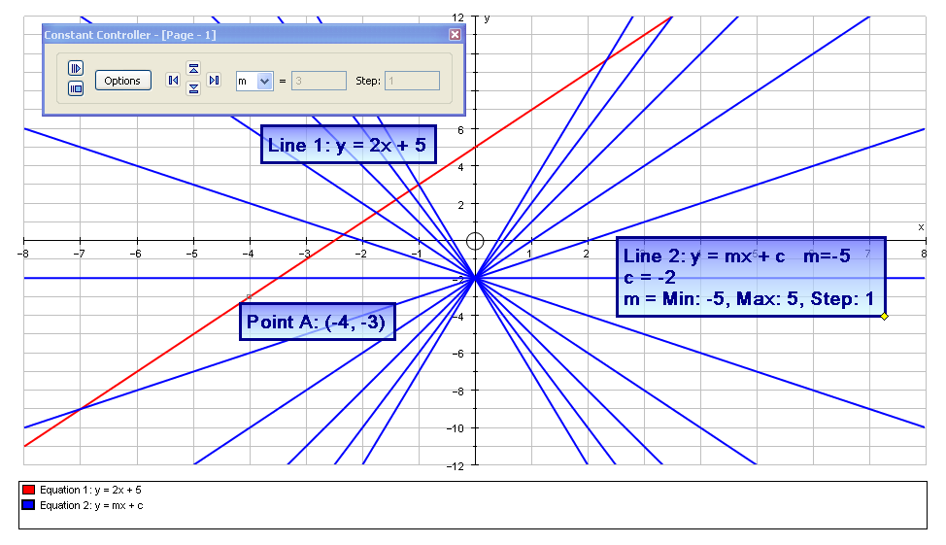

In the Edit menu on the top toolbar, pressing Undo.
Close the Constant Controller and you should be left with your two lines and Point A.

How about a challenge to finish?...

Left-click to select Point A (it should have a little square around it)
Use the left-right arrows on the keyboard to move the point so its co-ordinates are (-4, -3)

Add a point with the co-ordinates (2, -6 )

Can you adjust the values of m and c so that the blue line passes through both Point A and this new point?

When you have done it, hit the Equal aspect button
This adjusts the axes so that the scales on the axes are the same.
What do you notice about your two lines?

