Using Autograph – Angle at a Centre

page-new 2d 24 h p Open Autograph in Standard Level.

axes-edit 24 h p Edit Axes and remove the axes, grid and key (under “Options” tab).

Click the 0.1 Snap Settings.



mode-point 24 h p Draw a point in roughly the middle of the page.

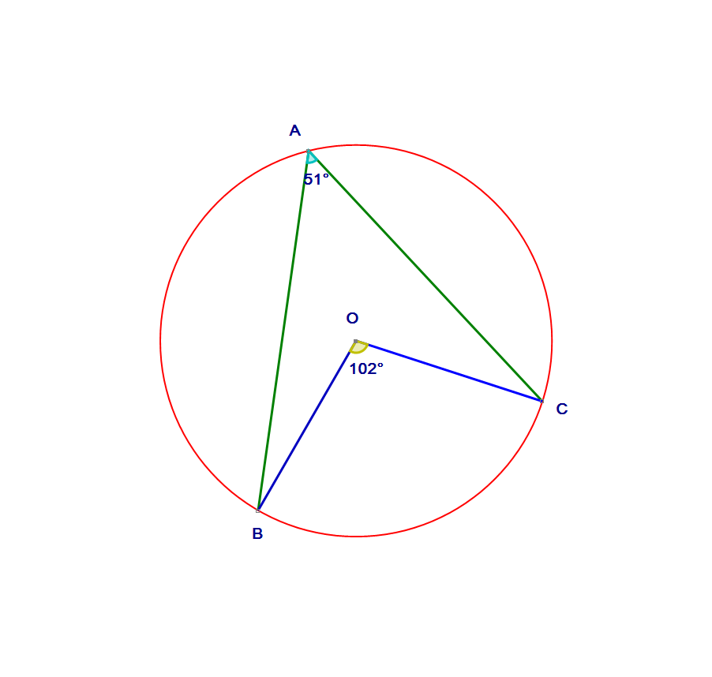 Select the point and right click to add a “Circle (Radius)…”. In the dialogue box give it a radius of 2.5.



Add three points on the circle.



Join point A to point B by selecting the points, right clicking and choosing “Line Segment”. Also join point A to point C. Join the centre O to points B and C. It should look like the diagram.



Select points B, A and C (in that order) and right click to add “Angle…”. Click OK in the dialogue box.  
Now add an angle for BOC. Take a note of both angles.



Select point B or C, and move it to a new position. Again take a note of the angles.



Repeat until you can complete the box.

Write ***in your own words*** about the connection between the angle at the centre of a circle and the angle at the circumference.