Pure FP3

Revision Notes

May 2013

Contents
1 Hyperbolic functions 3
Definitions and graphs 3
Addition formulae, double angle formulae etc. 3
Osborne’s rule 3
Inverse hyperbolic functions 4
Graphs 4
Logarithmic form 4
Equations involving hyperbolic functions 5
2 Further coordinate systems 6
Ellipse 6
Hyperbola 6
Parabola 7
Parametric differentiation 7
Tangents and normals 8
Finding a locus 9
3 Differentiation 10
Derivatives of hyperbolic functions 10
Derivatives of inverse functions 10
4 Integration 12
Standard techniques 12
Recognise a standard function 12
Using formulae to change the integrand 12
Reverse chain rule 12
Standard substitutions 13
Integration inverse functions and ln x 14
Reduction formulae 14
Arc length 18
Area of a surface of revolution 19
5 Vectors 22
Vector product 22
The vectors i, j and k 22
Properties 22
Component form 23
Applications of the vector product 23
Volume of a parallelepiped 24
Triple scalar product 24
Volume of a tetrahedron 25
Equations of straight lines 25
Vector equation of a line 25
Cartesian equation of a line in 3-D 26
Vector product equation of a line 26
Equation of a plane 27
Scalar product form 27
Cartesian form 27
Vector equation of a plane 28
Distance from origin to plane 29
Distance between parallel planes 30
Distance of a point from a plane 31
Line of intersection of two planes 32
Angle between line and plane 33
Angle between two planes 34
Shortest distance between two skew lines 34
6 Matrices 35
Basic definitions 35
Dimension of a matrix 35
Transpose and symmetric matrices 35
Identity and zero matrices 35
Determinant of a 3 × 3 matrix 35
Properties of the determinant 36
Singular and non-singular matrices 36
Inverse of a 3 × 3 matrix 36
Cofactors 36
Finding the inverse 37
Properties of the inverse 37
Matrices and linear transformations 38
Linear transformations 38
Base vectors $i, j, k$ 38
Image of a line 40
Image of a plane 1 40
Image of a plane 2 40
7 Eigenvalues and eigenvectors 41
Definitions 41
2 × 2 matrices 41
Orthogonal matrices 42
Normalised eigenvectors 42
Orthogonal vectors 42
Orthogonal matrices 42
Diagonalising a 2 × 2 matrix 43
Diagonalising 2 × 2 symmetric matrices 44
Eigenvectors of symmetric matrices 44
Diagonalising a symmetric matrix 44
3 × 3 matrices 46
Finding eigenvectors for 3 × 3 matrices. 46
Diagonalising 3 × 3 symmetric matrices 47

1 Hyperbolic functions

Definitions and graphs
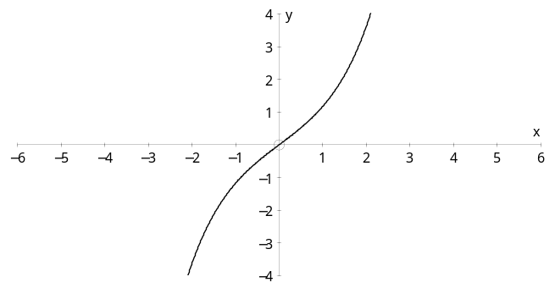
$\sinh{x}= \frac{1}{2}\left(e^{x}-e^{-x}\right)$ $\cosh{x}= \frac{1}{2}\left(e^{x}+e^{-x}\right)$ $\tanh{x}= \frac{\sinh{x}}{\cosh{x}}= \frac{\left(e^{x}-e^{-x}\right)}{\left(e^{x}+e^{-x}\right)}$
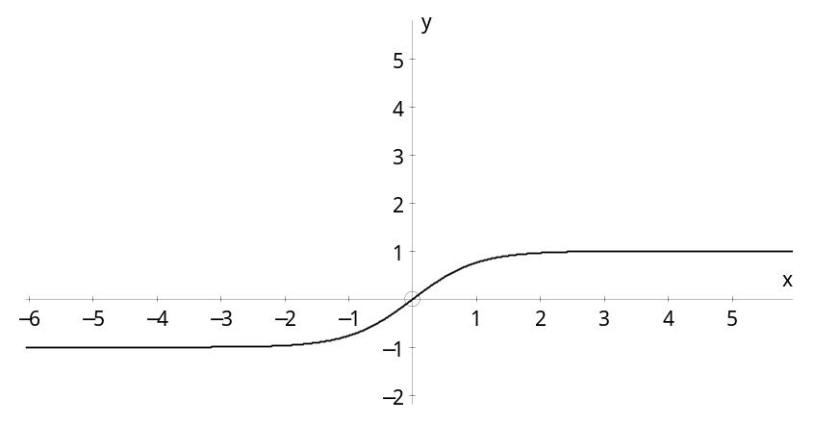
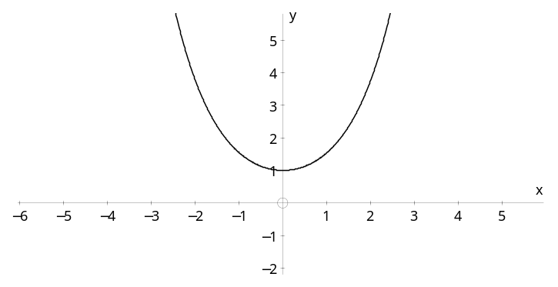

You should be able to draw the graphs of cosech x, sech x and coth x from the above:
cosech x sech x coth x
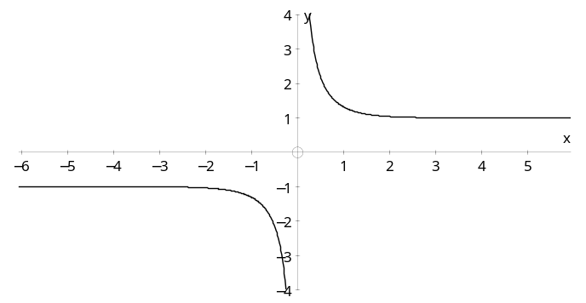
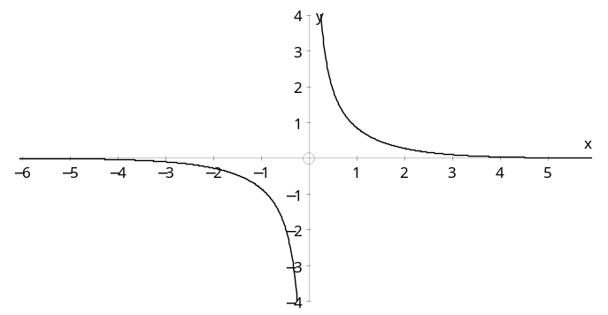
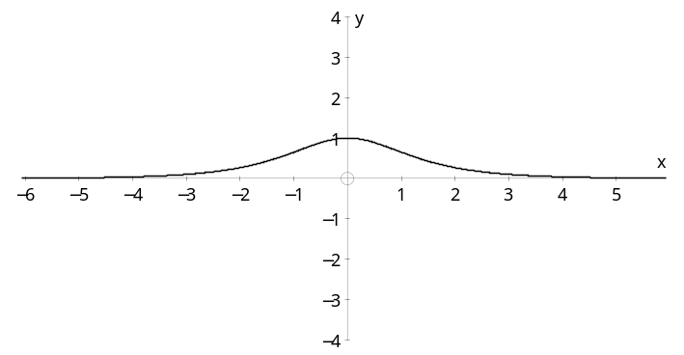

Addition formulae, double angle formulae etc.
The standard trigonometric formulae are very similar to the hyperbolic formulae.

Osborne’s rule
If a trigonometric identity involves the product of two sines, then we change the sign to write down the corresponding hyperbolic identity.
Examples:
$\sin\left(A+B\right) = \sin{A}\cos{B} + \cos{A}\sin{B}$
⇒ $\sinh\left(A+B\right) = \sinh{A}\cosh{B} + \cosh{A}\sinh{B}$ no change
but $\cos\left(A+B\right) = \cos{A}\cos{B}- \sin{A}\sin{B}$
⇒ $\cosh\left(A+B\right) = \cosh{A}\cosh{B} + \sinh{A}\sinh{B}$ product of two sines, so change sign
and 1 + tan² A = sec² A
⇒ 1 – tanh² A = sech² A $\tan^{2}{A}=\frac{\sin^{2}{A}}{\cos^{2}{A}}$, product of two sines, so change sign

Inverse hyperbolic functions

Graphs
Remember that the graph of $y=f^{-1}(x)$ is the reflection of $y=f\left(x\right) in y=x$.
y = arsinh x y = arcosh x y = artanh x
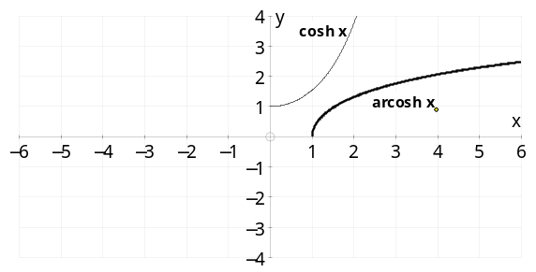
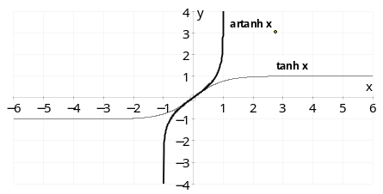
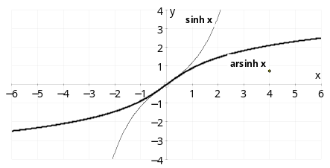

Notice arcosh x is a function defined so that arcosh x ≥ 0.
⇒ there is only one value of arcosh x.
However, the equation cosh z = 2, has two solutions, +arcosh 2 and –arcosh 2.

Logarithmic form
1) y = arsinh x
⇒ $\sinh{y}= \frac{1}{2}\left(e^{y}-e^{-y}\right)=x$
⇒ $e^{2y}-2xe^{y}-1=0$
⇒ $e^{y} = \frac{2x±\sqrt{4x^{2}+4}}{2} = x+\sqrt{x^{2}+1}$ or $x-\sqrt{x^{2}+1}$
But $e^{y}>0$ and $x-\sqrt{x^{2}+1} < 0$ ⇒ $e^{y}= x+\sqrt{x^{2}+1}$ only
⇒ $y=arsinh x= \ln\left(x+\sqrt{x^{2}+1}\right)$
2) y = arcosh x
⇒ $\cosh{y}= \frac{1}{2}\left(e^{y}+e^{-y}\right)=x$
⇒ $e^{2y}-2xe^{y}+1=0$
⇒ $e^{y} = \frac{2x±\sqrt{4x^{2}-4}}{2} = x±\sqrt{x^{2}-1}$ both roots are positive
⇒ $y=arcosh x= \ln\left(x+\sqrt{x^{2}-1}\right)$ or $\ln\left(x-\sqrt{x^{2}-1}\right)$
It can be shown that $\ln\left(x-\sqrt{x^{2}-1}\right) = -\ln\left(x+\sqrt{x^{2}-1}\right)$
⇒ $y=arcosh x= ± ln\left(x+\sqrt{x^{2}-1}\right)$
But arcosh x is a function and therefore has only one value (positive)
⇒ $y=arcosh x= \ln\left(x+\sqrt{x^{2}-1}\right)$ ( x ≥ 1)
3) Similarly artan x = $\frac{1}{2}\ln\left(\frac{1+x}{1-x}\right)$ $\left(\left|x\right|<1\right)$

Equations involving hyperbolic functions
It would be possible to solve $6\sinh{x} - 2\cosh{x} = 7$ using the $R\sinh{(x-α}$) technique from trigonometry, but it is easier to use the exponential form.
Example: Solve $6\sinh{x} - 2\cosh{x} = 7$
Solution: $6\sinh{x} - 2\cosh{x} = 7$
⇒ $6×\frac{1}{2}\left(e^{x}-e^{-x}\right)- 2×\frac{1}{2}\left(e^{x}+e^{-x}\right)=7$
⇒ $2e^{2x}- 7e^{x}- 4=0$
⇒ $\left(2e^{x}+1\right)\left(e^{x}-4\right)=0$
⇒ $e^{x}= -\frac{1}{2}$ (not possible) or 4
⇒ x = ln 4

In other cases, the ‘trigonometric’ solution may be preferable
Example: Solve cosh 2x + 5 sinh x – 4 = 0
Solution: cosh 2x + 5 sinh x – 4 = 0
⇒ 1 + 2 sinh² x + 5 sinh x – 4 = 0 note use of Osborn’s rule
⇒ 2 sinh² x + 5 sinh x – 3 = 0
⇒ (2sinh x – 1)(sinh x + 3) = 0
⇒ $\sinh{x}= \frac{1}{2} or -3$
⇒ x = arsinh 0.5 or arsinh (–3)
⇒ $x=\ln\left(0.5+\sqrt{{0.5}^{2}+1}\right)$ or $\ln\left((-3)+\sqrt{{(-3)}^{2}+1}\right)$ using log form of inverse
⇒ $x=\ln\left(\frac{1+\sqrt{5}}{2}\right)$ or $\ln\left(\sqrt{10}-3\right)$

2 Further coordinate systems
a
–a
–b
b
x
y

Ellipse
Cartesian equation
$\frac{x^{2}}{a^{2}}+ \frac{y^{2}}{b^{2}}=1$
Parametric equations
$x=a\cos{θ}, y= b\sin{θ}$
ae
–ae

x
y
x = $\frac{a}{e}$
x = –$\frac{a}{ e}$

Foci at S (ae, 0) and S′ (–ae, 0)
Directrices at x = $±\frac{a}{e}$
Eccentricity e < 1, b² = a²(1 – e²)
S
x
y
x = $\frac{a}{e}$
P
N
An ellipse can be defined as the locus of a
point P which moves so that PS = e PN,
where S is the focus, e < 1
and N lies on the directrix.

Hyperbola
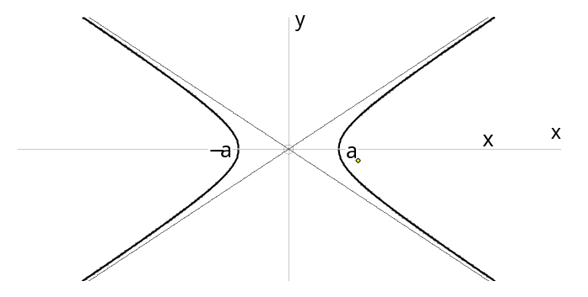
Cartesian equation
y = $\frac{b}{a}x$
y = $-\frac{b}{a}x$
$\frac{x^{2}}{a^{2}}- \frac{y^{2}}{b^{2}}=1$
Parametric equations
$$x=a\cosh{θ}, y= b\sinh{θ}$$
($x=a\sec{θ}, y= b\tan{θ}$ also work)
Asymptotes $\frac{x}{a}= ±\frac{y}{b}$
Foci at S (ae, 0) and S′ (–ae, 0)
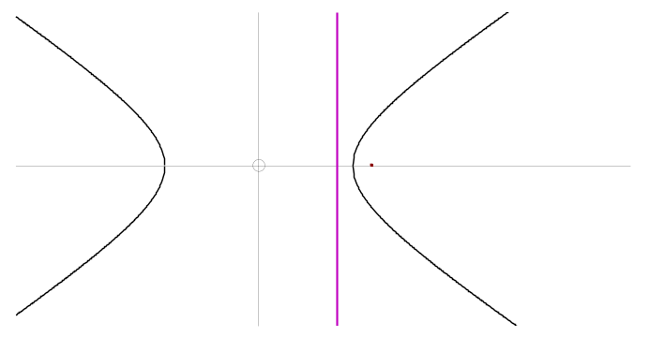
Directrices at x = $±\frac{a}{e}$
P
Eccentricity e >1, b² = a²(e² – 1)
N

A hyperbola can be defined as the locus of a
point P which moves so that PS = e PN,
where S is the focus, e > 1 and N lies on the directrix.
S
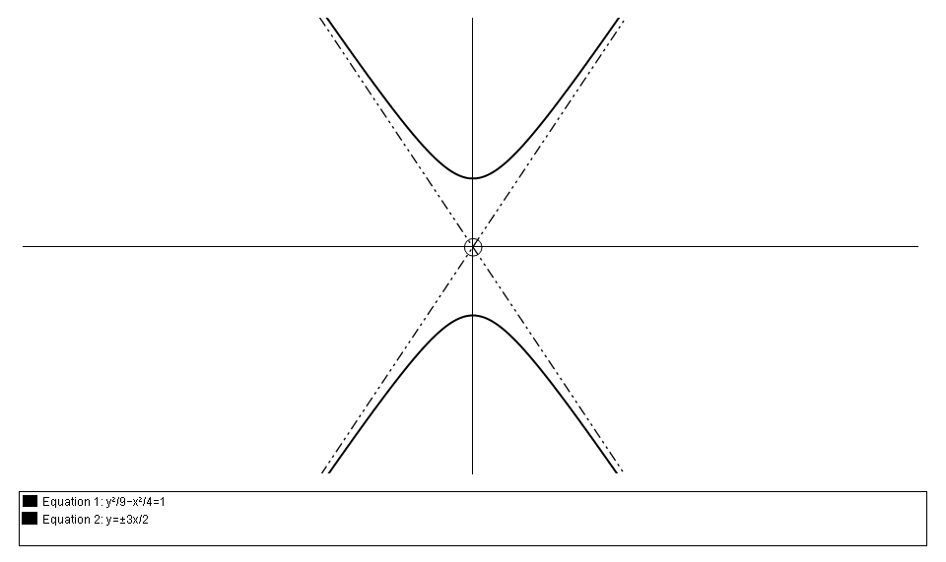
$\frac{y^{2}}{c^{2}}- \frac{x^{2}}{d^{2}}=1$
$$x=\frac{a}{e}$$
is a hyperbola with foci on the y-axis,

Parabola
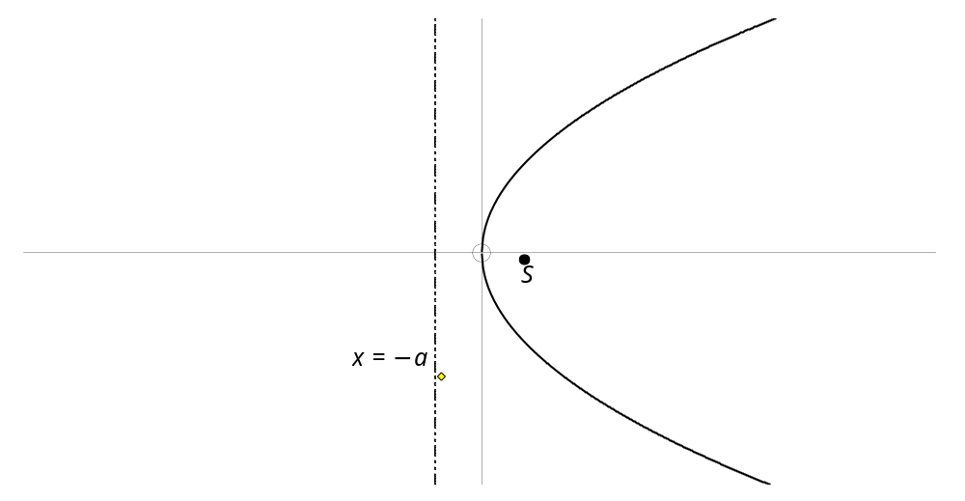
Cartesian equation
$y^{2}=4ax$
N
P
Parametric equations
$$x=at^{2}, y= 2at$$
Focus at S (a, 0)
Directrix at x = – a

A parabola can be defined as the locus of a
point P which moves so that PS = PN,
where S is the focus, N lies on the directrix
and eccentricity e = 1.

Parametric differentiation
From the chain rule $\frac{dy}{dθ} = \frac{dy}{dx} × \frac{dx}{dθ}$
⇒ $\frac{dy}{dx} = \frac{ \frac{dy}{dθ} }{\frac{dx}{dθ}}$ or $\frac{dy}{dx} = \frac{ \frac{dy}{dt} }{\frac{dx}{dt}}$ using any parameter

Tangents and normals
It is now easy to find tangents and normals.
Example: Find the equation of the normal to the curve given by the parametric equations
x = 5 cos θ , y = 8 sin θ at the point where θ = $\frac{π}{3}$
Solution: When θ = $\frac{π}{3}$, $\cos{θ}= \frac{1}{2}$ and $\sin{θ}= \frac{\sqrt{3}}{2}$
⇒ x = $\frac{5}{2}$, y = $4\sqrt{3}$
and $\frac{dy}{dx} = \frac{ \frac{dy}{dθ} }{\frac{dx}{dθ}} = \frac{8 cos θ}{-5 sin θ} = \frac{-8}{5\sqrt{3}}$ when $θ= \frac{π}{3}$
⇒ gradient of normal is $\frac{5\sqrt{3}}{8}$
⇒ equation of normal is $y-4\sqrt{3} = \frac{5\sqrt{3}}{8}\left(x-\frac{5}{2}\right)$
⇒ $5\sqrt{3} x-8y= \frac{17\sqrt{3}}{2}$
Sometimes normal, or implicit, differentiation is (slightly) easier.
Example: Find the equation of the tangent to xy = 36, or x = 6t, $y=\frac{6}{t}$ , at the point where t = 3.
Solution: When t = 3, x = 18 and y = 2.
$\frac{dy}{dx}$ can be found in two (or more!) ways:
$\frac{dy}{dx}=\frac{ \frac{dy}{dt} }{\frac{dx}{dt}}= \frac{-6t^{-2}}{6}$  ⇒ $\frac{dy}{dx}=\frac{-1}{t^{2}}=\frac{-1}{9}$, when $t= 3$ | xy = 36 ⇒ $y=\frac{36}{x}$  ⇒ $\frac{dy}{dx} = \frac{-36}{x^{2}}$  ⇒ $\frac{dy}{dx} = \frac{-36}{{18}^{2}}$ = $\frac{-1}{9}$ , when x = 18

⇒ equation of tangent is $y-2 = \frac{-1}{9} \left(x-18\right)$
⇒ x + 9y – 36 = 0

Finding a locus
First find expressions for x and y coordinates in terms of a parameter, t or θ , then eliminate the parameter to give an expression involving only x and y, which will be the equation of the locus.
Example: The tangent to the ellipse $\frac{x^{2}}{9}+ \frac{y^{2}}{16}=1$, at the point P, (3 cos θ , 4 sin θ ), crosses the x-axis at A, and the y-axis at B.
Find an equation for the locus of the mid-point of AB as P moves round the ellipse, or as θ varies.
Solution: $\frac{dy}{dx} = \frac{ \frac{dy}{dθ} }{\frac{dx}{dθ}} = \frac{4 cos θ}{-3 sin θ}$
⇒ equation of tangent is $y-4\sin{θ} = \frac{4 cos θ}{-3 sin θ}\left(x-3\cos{θ}\right)$
⇒ $3y\sin{θ}+ 4x\cos{θ}=12$ cos²θ + 12 sin²θ = 12
Tangent crosses x-axis at A when y = 0, ⇒ x = $\frac{3}{\cos{θ}}$,
and crosses y-axis at B when x = 0, ⇒ $y= \frac{4}{\sin{θ}}$
⇒ mid-point of AB is $\left(\frac{3}{2\cos{θ}} , \frac{4}{2sin{θ}}\right)$
Here x = $\frac{3}{2\cos{θ}}$ and $y= \frac{2}{\sin{θ}}$
⇒ $\cos{θ}= \frac{3}{2x} and \sin{θ}= \frac{2}{y}$
⇒ equation of the locus is $\frac{9}{4x^{2}} + \frac{4}{y^{2}} = 1$ since $\cos^{2}{θ} + \sin^{2}{θ} = 1$

3 Differentiation

Derivatives of hyperbolic functions
$y=\sinh{x = \frac{1}{2}\left(e^{x}-e^{-x}\right)}$
⇒ $\frac{dy}{dx} = \frac{1}{2}\left(e^{x}+e^{-x}\right)$ = cosh x
and, similarly, $\frac{d\left(\cosh{x}\right)}{dx}=\sinh{x}$
Also, $y=\tanh{x}= \frac{\sinh{x}}{\cosh{x}}$
⇒ $\frac{dy}{dx} = \frac{\cosh{x}\cosh{x-\sinh{x\sinh{x}}}}{\cosh^{2}{x}} = \frac{1}{\cosh^{2}{x}} = {sech}^{2}{x}$
In a similar way, all the derivatives of hyperbolic functions can be found.

$f(x)$ | $f^{'}(x)$
sinh x  cosh x  tanh x | cosh x  sinh x  sech²x | all positive
coth x  cosech x  sech x | – cosech²x  – cosech x coth x  – sech x tanh x | all negative

Notice: these are similar to the results for sin x, cos x, tan x etc., but the minus signs do not always agree.
The minus signs are ‘wrong’ only for cosh x and sech x $\left(=\frac{1}{\cosh{x}}\right)$.

Derivatives of inverse functions
y = arsinh x
⇒ sinh y = x ⇒ $\cosh{y} \frac{dy}{dx} = 1$
⇒ $\frac{dy}{dx} = \frac{1}{\cosh{y}} = \frac{1}{\sqrt{1+s{inh}^{2}{y}}}$
⇒ $\frac{d\left(arsinh x\right)}{dx} = \frac{1}{\sqrt{1+x^{2}}}$
The derivatives for other inverse hyperbolic functions can be found in a similar way.
You can also use integration by substitution to find the integrals of the $f^{'}(x)$ column
$f(x)$ $f^{'}(x)$ substitution needed for integration
arcsin x $\frac{1}{\sqrt{1-x^{2}}}$ 1 – sin² u = cos² u ⇒ use x = sin u
arccos x $\frac{-1}{\sqrt{1-x^{2}}}$ 1 – cos² u = sin² u ⇒ use x = cos u
arctan x $\frac{1}{1+x^{2}}$ 1 + tan² u = sec² u ⇒ use x = tan u
arsinh x $\frac{1}{\sqrt{1+x^{2}}}$ 1 + sinh² u = cosh² u ⇒ use x = sinh u
arcosh x $\frac{1}{\sqrt{x^{2}-1}}$ cosh² u – 1 = sinh² u ⇒ use x = cosh u
artanh x $\frac{1}{1-x^{2}}$ 1 – tanh² u = sech² u ⇒ use x = tanh u
$\frac{1}{2}\ln\left(\frac{1+x}{1-x}\right)$ $\frac{1}{1-x^{2}}$ partial fractions, see example below

Note that $\int{\frac{1}{1-x^{2}}} dx = \frac{1}{2}\int{\frac{1}{1+x}} + \frac{1}{1-x} dx= \frac{1}{2}\ln\left(\frac{1+x}{1-x}\right)$ + c
With chain rule, product rule and quotient rule you should be able to handle a large variety of combinations of functions.

4 Integration

Standard techniques

Recognise a standard function
Examples: $\int{\sec{x}}\tan{x} dx = \sec{x}$ + c
$\int{\operatorname{sech}{x}}\tanh{x} dx = -sec{x}$ + c

Using formulae to change the integrand
Examples: $\int{\tan^{2}{x}} dx = \int{1+\sec^{2}{x}} dx = x+\tan{x}$ + c
$\int{\cos^{2}{x}} dx = \frac{1}{2} \int{1+\cos{2x} dx} = \frac{1}{2} \left(x+\frac{1}{2}\sin{2x}\right) +c$
$\int{\sinh^{2}{x}} dx = \frac{1}{2} \int{\cosh{2x}- 1 dx} = \frac{1}{2} \left(\frac{1}{2}\sinh{2x} - x\right) +c$

Reverse chain rule
Notice the chain rule pattern, guess an answer and differentiate to find the constant.
Example: $\int{\cos^{2}{x}}\sin{x dx}$ ‘looks like’ $u^{2}\frac{∂u}{∂x}$ so try u³ ⇔ cos³ x
$\frac{d\left(\cos^{3}{x}\right)}{dx}$ = 3cos² x (– sin x) = – 3cos² x sin x so divide by –3
⇒ $\int{\cos^{2}{x}}\sin{x dx}$ = $-\frac{1}{3}\cos^{3}{x} +c$
Example: $\int{x^{2}}{\left(2x^{3}- 7\right)}^{4} dx$ ‘looks like’ $u^{4}\frac{∂u}{∂x}$ so try u⁵ ⇔ ${\left(2x^{3}- 7\right)}^{5}$
$\frac{d{\left(2x^{3}- 7\right)}^{5} }{dx}$ $= 5{\left(2x^{3}- 7\right)}^{4} ×6x^{2}$ = 30${\left(2x^{3}- 7\right)}^{4}$ so divide by 30
⇒ $\int{x^{2}}{\left(2x^{3}- 7\right)}^{4} dx$ = $\frac{1}{30 }{\left(2x^{3}- 7\right)}^{5}+c$

Example: $\int{{sech}^{4}{x}\tanh{x} dx }$
= $\int{{sech}^{3}{x}\left(sech x tanh{x}\right) dx }$ ‘looks like’ $u^{3}\frac{∂u}{∂x}$ so try u⁴ = sech⁴ x
$\frac{d\left({sech}^{4}{x}\right)}{dx}$ $= -4{sech}^{3}{x}\operatorname{sech}{x} \tanh{x}$ so divide by 4
⇒ $\int{{sech}^{4}{x}\tanh{x} dx }= -\frac{1}{4}{sech}^{4}{x}+ c$

Standard substitutions
$\int{\frac{1}{a^{2}+{b^{2}x}^{2}} dx}$ $bx=a\tan{u}$ better than bx = a sinh u when there is no
$\int{\frac{1}{\sqrt{a^{2}+{b^{2}x}^{2}}} dx}$ $bx=a\sinh{u}$ better than bx = a tan u when there is
$\int{\frac{1}{a^{2}-{b^{2}x}^{2}} dx}$ $bx=a\tanh{u}$ or use partial fractions
$\int{\frac{1}{\sqrt{{b^{2}x}^{2}-a^{2}}} dx}$ $bx=a\cosh{u}$ better than bx = a sec u when there is
For more complicated integrals like
$\int{\frac{1}{px^{2}+qx+r}} dx$ or $\int{\frac{1}{\sqrt{px^{2}+qx+r}}} dx$
complete the square to give $p{\left(x+a\right)}^{2} + b$ and then use a substitution similar to one of the four above.

Example: $\int{\frac{1}{\sqrt{4x^{2}-8x-5}}} dx$ $4x^{2}-8x-5$ = $4\left(x^{2}-2x+1\right)-9 =4{\left(x-1\right)}^{2}-9$ = $\int{\frac{1}{\sqrt{4{\left(x-1\right)}^{2}-9}}} dx$
Substitute 2(x – 1) = 3 cosh u ⇒ 2 dx = 3 sinh u du
= $\int{\frac{1}{\sqrt{9\left(\cosh^{2}{u}-1\right)}}} \frac{3\sinh{u}}{2} du$
= $\frac{1}{2}\int{ du}$ = u + c = $\frac{1}{2}$ $arcosh \left(\frac{2x-2}{3}\right)$ + c

Important tip
$\int{\frac{x^{n}}{\sqrt{a^{2}±x^{2}}} dx}$ is best done with the substitution
u (or u²) = a² ± x², when n is odd,
or a trigonometric or hyperbolic function when n is even.

Integration inverse functions and ln x
To integrate inverse trigonometric or hyperbolic functions and ln x we use integration by parts with $\frac{dv}{dx}$ = 0
Example: Find $\int{\arctan{x} dx}$
Solution: I = $\int{\arctan{x} dx}$ take u = arctan x ⇒ $\frac{du}{dx} = \frac{1}{1+x^{2}}$
and $\frac{dv}{dx}$ = 1 ⇒ v = x
⇒ I = x arctan x − $\int{x×\frac{1}{1+x^{2}} dx}$
⇒ I = $\int{\arctan{x} dx}$ = x arctan x − $\frac{1}{2}$ ln (1 + x ²) + c
Example: Find $\int{\operatorname{arcosh}{x} dx}$
Solution: I = $\int{\operatorname{arcosh}{x} dx}$ take u = arcosh x ⇒ $\frac{du}{dx} = \frac{1}{\sqrt{x^{2}-1}}$
and $\frac{dv}{dx}$ = 1 ⇒ v = x
⇒ I = x arcosh x − $\int{x×\frac{1}{\sqrt{x^{2}-1}} dx}$
⇒ I = $\int{\operatorname{arcosh}{x} dx}$ = x arcosh x − $\sqrt{x^{2}-1}$ + c

Reduction formulae
The first step in finding a reduction formula is usually often integration by parts (sometimes twice). The following examples show a variety of techniques.
Example 1: $I_{n} = \int{x^{n}}e^{x} dx$.
(a) Find a reduction formula,
(b) Find $I_{0}$, and (c) find $I_{4}$
Solution:
(a) Integrating by parts
$u= x^{n}$ ⇒ $\frac{du}{dx}$ $= nx^{n-1}$
and $\frac{dv}{dx} = e^{x}$ ⇒ v = e ^{x}
⇒ $I_{n} = x^{n}e^{x} - \int{nx^{n-1}e^{x}} dx$
⇒ $I_{n} = x^{n}e^{x} - nI_{n-1}$
(b) $I_{0} = \int{e^{x}} dx$ = e ^{x} + c
(c) Using the reduction formula
$I_{4} = x^{4}e^{x} - 4I_{3} = x^{4}e^{x} - 4\left(x^{3}e^{x} - 3I_{2}\right)$
$$= x^{4}e^{x} - 4x^{3}e^{x}+ 12\left(x^{2}e^{x} - 2I_{1}\right)$$
$$= x^{4}e^{x} - 4x^{3}e^{x}+ 12x^{2}e^{x}- 24\left(xe^{x} - I_{0}\right)$$
$= x^{4}e^{x} - 4x^{3}e^{x}+ 12x^{2}e^{x}- 24xe^{x}+ 24e^{x}+ c$ since $I_{0}=e^{x}+c$

Example 2: Find a reduction formula for $I_{n} = \int_{0}^{π/2}{\sin^{n}{x}} dx$.
Use the formula to find $I_{6} = \int_{0}^{π/2}{\sin^{6}{x}} dx$

Solution: $I_{n} = \int_{0}^{π/2}{\sin^{n}{x}} dx$ = $\int_{0}^{π/2}{\sin^{n-1}{x }}\sin{x} dx$
take u = sin ^{n − 1} x ⇒ $\frac{du}{dx}$ = (n − 1) sin ^{n − 2} x cos x
and $\frac{dv}{dx}$ = sin x ⇒ v = − cos x
⇒ $I_{n} = {\left[ cos x \sin^{n 1} x\right]}_{0}^{π/2}$ − $\int_{0}^{π/2}{ cos x (n 1) \sin^{n 2} x} cos x dx$
= 0 + $(n 1)\int_{0}^{π/2}{\cos^{2} x \sin^{n 2} x} dx$
= $(n 1)\int_{0}^{π/2}{\left(1-\sin^{2} x \right) \sin^{n 2} x} dx$
= $\left(n 1\right)\int_{0}^{π/2}{ \sin^{n 2} x} dx - (n 1)\int_{0}^{π/2}{ \sin^{n} x} dx$
⇒ I_{n} = (n − 1) I_{n−2} − (n − 1) I_{n}
⇒ I_{n} = $\frac{n-1}{n}$I_{n−2 .}
Now I₆ = $\frac{5}{6}$ I₄ = $\frac{5}{6}×\frac{3}{4}$ I₂ = $\frac{5}{6}×\frac{3}{4}×\frac{1}{2}$ I₀
⇒ I₆ = $\frac{5}{16} \int_{0}^{π/2}{1} dx$ = $\frac{5π}{32}$ .

Example 3: Find a reduction formula for $I_{n} = \int{\sec^{n}{x}} dx$.
Solution: $I_{n} =\int{\sec^{n}{x}} dx = \int{\sec^{n-2}{x}}\sec^{2}{x} dx$
take u = sec^{n − 2}x ⇒ $\frac{du}{dx}$ = (n − 2) sec^{n − 3}x sec x tan x
and $\frac{dv}{dx}$ = sec² x ⇒ v = tan x
⇒ $I_{n}$ = sec^{n − 2}x tan x − $\int{tan x}\left(n 2\right) \sec^{n 3}x sec x tan x dx$
= sec^{n − 2}x tan x − $\left(n 2\right)\int{\tan^{2} x} \sec^{n 2}x dx$
= sec^{n − 2}x tan x − $\left(n 2\right)\int{\left(\sec^{2} x-1\right)} \sec^{n 2}x dx$
= sec^{n − 2}x tan x − $\left(n 2\right)I_{n}$ +$\left(n 2\right)I_{n-2}$
⇒ $\left(n 1\right)I_{n}$ = sec^{n − 2}x tan x + $\left(n 2\right)I_{n-2}$

Example 4: Find a reduction formula for $I_{n} = \int{\tan^{n}{x}} dx$.
Solution: $I_{n} = \int{\tan^{n}{x}} dx= \int{\tan^{n-2}{x}}\tan^{2}{x} dx$
⇒ $I_{n} = \int{\tan^{n-2}{x}}\left(\sec^{2}{x}- 1\right) dx$
= $\int{\tan^{n-2}{x}}\sec^{2}{x} dx$ − $\int{\tan^{n-2}{x}} dx$
⇒ $I_{n}$ = $\frac{1}{n-1}$ tan^{n − 1}x − I_{n − 2} .

Example 5: Find a reduction formula for $I_{n}$ = $\int_{-1}^{ 0}{{ x}^{n}}{\left(1+x\right)}^{2} dx$.
Solution: $I_{n}$ = $\int_{-1}^{0}{{ x}^{n}}{\left(1+x\right)}^{2} dx$ take u = x^{n} ⇒ $\frac{du}{dx}$ = nx^{n −1}
and $\frac{dv}{dx}$ = (1 + x)² ⇒ v = $\frac{1}{3}{\left(1+x\right)}^{3}$
⇒ $I_{n}$ = ${\left[x^{n} \frac{1}{3}{(1 + x)}^{3}\right]}_{-1}^{ 0}$ − $\int_{-1}^{ 0}{{nx}^{n-1}}×{\frac{1}{3} (1 + x)}^{3} dx$.
⇒ $I_{n}$ = 0 − $\frac{n}{3}\int_{-1}^{ 0}{x^{n-1}}{(1 + x)}^{2} \left(1+x\right)dx$
⇒ $I_{n}$ = − $\frac{n}{3}\int_{-1}^{ 0}{x^{n-1}}{(1 + x)}^{2}dx$ − $\frac{n}{3}\int_{-1}^{ 0}{x^{n}}{(1 + x)}^{2}dx$
⇒ $I_{n}$ = − $\frac{n}{3}$ $I_{n-1}$ − $\frac{n}{3}$ $I_{n}$
⇒ $\frac{n+3}{3}$ $I_{n}$ = − $\frac{n}{3}$ $I_{n-1}$
⇒ $I_{n}$ = − $\frac{n}{n+3}$ $I_{n-1}$
Example 6: Find a reduction formula for $I_{n}$ = $\int_{0}^{π/2}{ x^{n}}\cos{x} dx$
Solution: $I_{n}$ = $\int_{0}^{π/2}{ x^{n}}\cos{x} dx$ take u = x^{n} ⇒ $\frac{du}{dx}$ = nx^{n −1}
and $\frac{dv}{dx}$ = cos x ⇒ v = sin x
⇒ $I_{n}$ = ${\left[x^{n} sin x\right]}_{0}^{π/2}$ − $n\int_{0}^{π/2}{ sin x × x^{n-1}} dx$
take u = x^{n−1} ⇒ $\frac{du}{dx}$ = (n−1) x^{n −2}
and $\frac{dv}{dx}$ = sin x ⇒ v = −cos x
⇒ $I_{n}$ = ${\left(\frac{π}{2}\right)}^{n}$ − n{${\left[ x^{n1}(-\cos{x)}\right]}_{0}^{π/2}$ − $\int_{0}^{π/2}{- cos x × (n-1)x^{n-2}} dx$}
⇒ $I_{n}$ = ${\left(\frac{π}{2}\right)}^{n}$ − n{0 + $(n-1)\int_{0}^{π/2}{ x^{n-2}cos x }dx$}
⇒ $I_{n}$ = ${\left(\frac{π}{2}\right)}^{n}$ − n $(n-1)$ $I_{n-2}$

Example 7: Find a reduction formula for $I_{n}$ = $\int{ \frac{\sin{nx}}{\sin{x}}}$ dx
Solution: $I_{n}$ = $\int{ \frac{\sin{[\left(n-2\right)x+2x]}}{\sin{x}}}$ dx
= $\int{ \frac{\sin\left(n-2\right)x\cos{2x +\cos\left(n-2\right)x\sin{2x}}}{\sin{x}}}$ dx
= $\int{ \frac{\sin\left(n-2\right)x(1-2\sin^{2} x){ +\cos\left(n-2\right)x ×2\sin{x}\cos{x}}}{\sin{x}}}$ dx
= $\int{ \frac{\sin\left(n-2\right)x}{\sin{x}}}$ dx + 2$\int{\cos\left(n-2\right)x\cos{x}-\sin\left(n-2\right)x\sin{x} }$ dx
= I_{n − 2} + 2$\int{\cos\left(n-1\right)x }$ dx using cos(A + B) = cos A cos B – sin A sin B
⇒ $I_{n}$ = I_{n − 2} + $\frac{2}{n-1}$ sin(n − 1)x .

Arc length
P
Q
δ x
δ y
δ s
All the formulae you need can be remembered from this diagram
arc PQ ≈ line segment PQ
⇒ (δ s)² ≈ (δ x)² + (δ y)²
⇒ ${\left(\frac{δs}{δx}\right)}^{2} ≈ 1 + {\left(\frac{δy}{δx}\right)}^{2}$
and as δ x → 0
⇒ ${\left(\frac{ds}{dx}\right)}^{2} = 1 + {\left(\frac{dy}{dx}\right)}^{2}$ ⇒ $\frac{ds}{dx} = \sqrt{1 + {\left(\frac{dy}{dx}\right)}^{2}}$
⇒ arc length = s = $\int{\sqrt{1 + {\left(\frac{dy}{dx}\right)}^{2}} } dx$

Similarly
${\left(\frac{δs}{δy}\right)}^{2} ≈ {\left(\frac{δx}{δy}\right)}^{2}+ 1$ ⇒ s = $\int{\sqrt{{\left(\frac{dx}{dy}\right)}^{2}+ 1}} dy$
and ${\left(\frac{δs}{δt}\right)}^{2} ≈ {\left(\frac{δx}{δt}\right)}^{2}+ {\left(\frac{δy}{δt}\right)}^{2}$
⇒ s = $\int{\sqrt{{\left(\frac{dx}{dt}\right)}^{2}+ {\left(\frac{dy}{dt}\right)}^{2}}} dt$ or s = $\int{\sqrt{{\dot{x}}^{2}+ {\dot{y}}^{2}}} dt$
for parametric equations.
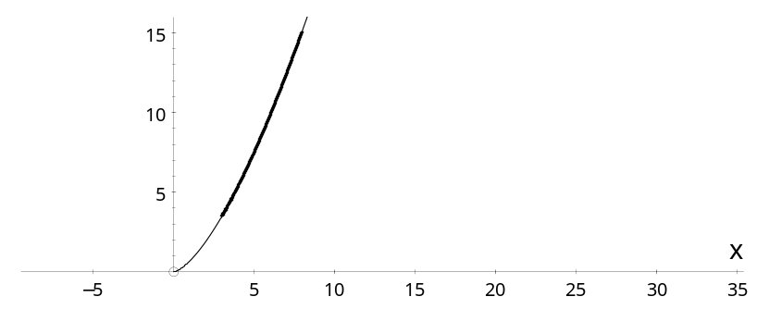
Example 1: Find the length of the curve $y=\frac{2}{3}x^{3/2}$ , from the point where x = 3 to the point where x = 8.
Solution: The equation of the curve is in Cartesian form so we use s = $\int{\sqrt{1 + {\left(\frac{dy}{dx}\right)}^{2}} } dx$ .
$y = \frac{2}{3}x^{3/2}$ ⇒ $\frac{dy}{dx}$ = $\sqrt{x}$
⇒ s = $\int_{3}^{8}{\sqrt{1+x}} dx$
= ${\left[\frac{2}{3}{\left(1+x\right)}^{3/2}\right]}_{3}^{8}$ = $\frac{2}{3} ×{\left(9\right)}^{3/2} - \frac{2}{3} ×{\left(4\right)}^{3/2}$
⇒ s = 12$\frac{2}{3}$ .

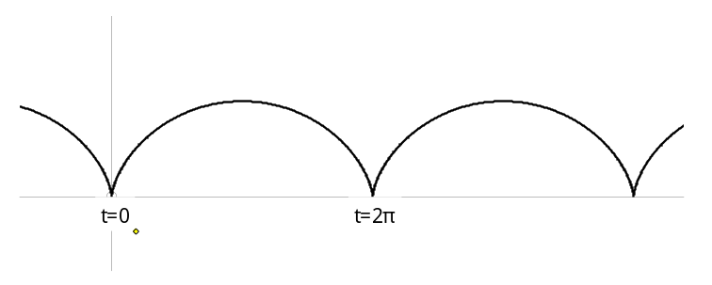
Example 2: Find the length of one arch of the cycloid x = a(t − sin t), y = a(1 − cos t).
Solution: The curve is given in parametric form so we use s = $\int{\sqrt{{\dot{x}}^{2}+ {\dot{y}}^{2}}} dt$ .
x = a(t − sin t), y = a(1 − cos t)
⇒ $\frac{dx}{dt}$ = a(1 − cos t), and $\frac{dy}{dt}$ = a sin t
⇒ ${\dot{x}}^{2}+ {\dot{y}}^{2}$ = a²(1 − 2 cos t + cos²t + sin²t) = 2a²(1 − cos t)
⇒ $\sqrt{{\dot{x}}^{2}+ {\dot{y}}^{2}}$ = $a\sqrt{2\left(1-\left[1-2\sin^{2}\left(\frac{t}{2}\right)\right]\right)}$ = $2a\sin\left(\frac{t}{2}\right)$
⇒ s = $\int_{0}^{2π}{2a\sin\left(\frac{t}{2}\right)} dt$
⇒ s = ${\left[-4a\cos\left(\frac{t}{2}\right)\right]}_{0}^{2π}$ = 4a − − 4a = 8a.

Area of a surface of revolution
A curve is rotated about the x-axis.
x
b
a
y
y
δ s
To find the area of the surface formed between x = a and x = b, we consider a small section of the curve, δs, at a distance of y from the x-axis.
When this small section is rotated about the x-axis, the shape formed is approximately a cylinder of radius y and length δs.
The surface area of this (cylindrical) shape ≈ 2π rl ≈ 2π yδs
⇒ The total surface area ≈ $\sum_{a}^{b}{ 2 ys}$
and, as δs → 0, the area of the surface is A = $\int_{a}^{b}{ 2 y} ds$.
And so A = $\int_{a}^{b}{ 2 y} \frac{ds}{dx} dx$ or A = $\int_{a}^{b}{ 2 y} \frac{ds}{dt} dt$
We can use $\frac{ds}{dx} = \sqrt{1 + {\left(\frac{dy}{dx}\right)}^{2}}$ or $\frac{ds}{dt} = \sqrt{{\left(\frac{dx}{dt}\right)}^{2}+ {\left(\frac{dy}{dt}\right)}^{2}}$, as appropriate,
remembering that (δ s)² ≈ (δ x)² + (δ y)²

Example 1: Find the surface area of a sphere with radius r,
, between the planes x = a and x = b.
Solution: The Cartesian form is most suitable here.
A = $\int_{a}^{b}{ 2 y} \frac{ds}{dx} dx$
x² + y² = r²
⇒ $2x+2y\frac{dy}{dx} =0$ ⇒ $\frac{dy}{dx}=\frac{-x}{y}$
and $\frac{ds}{dx} = \sqrt{1 + {\left(\frac{dy}{dx}\right)}^{2}}$
⇒ A = $\int_{a}^{b}{ 2y} \sqrt{1+\frac{x^{2}}{y^{2}}} dx$ = $\int_{a}^{b}{ 2 }\sqrt{y^{2}+x^{2}} dx$
= $\int_{a}^{b}{ 2r} dx$ since x² + y² = r²
⇒ A = ${\left[2rx\right]}_{a}^{b} = 2r(b-a)$ since r is constant
Notice that the area of the whole sphere is from a = −r to b = r giving
surface area of a sphere is 4π r².

Historical note.
h = 2r
r
Archimedes showed that the area of a sphere is equal to the area of the curved surface of the surrounding cylinder.
Thus the area of the sphere is
A = 2π rh = 4π r² since h = 2r.

Example 2: The parabola, x = at², y = 2at, between the origin (t = 0) and P (t = 2) is rotated about the x-axis.
Find the surface area of the shape formed.
P, (t = 2)
x
y
Solution: The parametric form is suitable here.
A = $\int_{a}^{b}{ 2 y} \frac{ds}{dt} dt$
and $\frac{ds}{dt} = \sqrt{{\left(\frac{dx}{dt}\right)}^{2}+ {\left(\frac{dy}{dt}\right)}^{2}}$
$\frac{dx}{dt}=2at$ and $\frac{dy}{dt}=2a$
⇒ $\frac{ds}{dt} = \sqrt{{\left(2at\right)}^{2}+ {\left(2a\right)}^{2}}$ = $2a\sqrt{t^{2}+1}$
⇒ A = $\int_{0}^{2}{ 2 2at×2a\sqrt{t^{2}+1}} dt$
= 8πa² $×\frac{1}{3}{\left[{\left(t^{2}+1\right)}^{3/2}\right]}_{0}^{2}$
⇒ A = $\frac{8πa^{2}}{3}$ $\left(5^{3/2}- 1\right)$

5 Vectors

Vector product
The vector, or cross, product of a and b is
a
b
$\hat{n}$
θ
a × b = ab sinθ $\hat{n}$
where $\hat{n}$ is a unit (length 1) vector which is perpendicular to both a and b, and θ is the angle between a and b.
The direction of $\hat{n}$ is that in which a right hand corkscrew would move when turned through the angle θ from a to b.
a
b
$$-\hat{n}$$
θ
Notice that b × a = ab sinθ $-\hat{n}$, where $-\hat{n}$ is in the opposite direction to $\hat{n}$, since the corkscrew would move in the opposite direction when moving from b to a.
Thus b × a = − a × b.

The vectors i, j and k
For unit vectors, i, j and k, in the directions of the axes
i
j
$\hat{k}$
i × j = k, j × k = i, k × i = j,
i × k = −j, j × i = −k, k × j = −i.

Properties
a × a = 0 since θ = 0
a × b = 0 ⇒ a is parallel to b since sin θ = 0 ⇒ θ = 0 or π
or a or b = 0
a × (b + c) = a × b + a × c remember the brilliant demo with the straws!
a × b is perpendicular to both a and b from the definition

Component form
Using the above we can show that
a × b = $\left(\begin{matrix}a_{1} \\ a_{2} \\ a_{3}\end{matrix}\right) × \left(\begin{matrix}b_{1} \\ b_{2} \\ b_{3}\end{matrix}\right) = \left(-\begin{matrix}a_{2}b_{3}- a_{3}b_{2} \\ a_{1}b_{3}+ a_{3}b_{1} \\ a_{1}b_{2}- a_{2}b_{1}\end{matrix}\right)$ = $\left|\begin{matrix}\underline{i} & \underline{j} & \underline{k} \\ a_{1} & a_{2} & a_{3} \\ b_{1} & b_{2} & b_{3}\end{matrix}\right|$

Applications of the vector product
a
b
θ
A
B
O
Area of triangle OAB = $\frac{1}{2}ab\sin{θ}$
⇒ area of triangle OAB = $\frac{1}{2}$⏐a × b⏐

Area of parallelogram OADB is twice the area of the triangle OAB
a
b
θ
A
B
O
D
⇒ area of parallelogram OADB = ⏐a × b⏐

Example: A is (−1, 2, 1), B is (2, 3, 0) and C is (3, 4, −2).
Find the area of the triangle ABC.
A
B
C
Solution: The area of the triangle ABC = $\left|\frac{1}{2}\vec{AB}×\vec{AC}\right|$
$\vec{AB}$ = b − a = $\left(\begin{matrix}3 \\ 1 \\ -1\end{matrix}\right)$ and $\vec{AC}$ = c − a = $\left(\begin{matrix}4 \\ 2 \\ -3\end{matrix}\right)$
⇒ $\vec{AB}×\vec{AC}$ = $\left|\begin{matrix}\underline{i} & \underline{j} & \underline{k} \\ 3 & 1 & -1 \\ 4 & 2 & -3\end{matrix}\right|$ = $\left(\begin{matrix}-1 \\ 5 \\ 2\end{matrix}\right)$
⇒ area ABC = $\frac{1}{2}\sqrt{1^{2}+5^{2}+3^{2}}$ = $\frac{1}{2}\sqrt{35}$

Volume of a parallelepiped
$$\hat{n}$$
a
c
b
θ
φ
h
In the parallelepiped
h = a cos φ
and area of base = bc sin θ
⇒ volume = h × bc sin θ
= a × bc sin θ × cos φ
and (i) φ is the angle between $\hat{n}$ and a
(ii) bc sin θ is the magnitude of b × c
⇒ a . (b × c) = a × bc sin θ × cos φ
⇒ volume of parallelepiped = ⏐a . (b × c)⏐

Triple scalar product
⏐a . (b × c)⏐ = $\left(\begin{matrix}a_{1} \\ a_{2} \\ a_{3}\end{matrix}\right)$ . $\left(-\begin{matrix}b_{2}c_{3}- b_{3}c_{2} \\ b_{1}c_{3}+ b_{3}c_{1} \\ b_{1}c_{2}- b_{2}c_{1}\end{matrix}\right)$
= $a_{1}\left(b_{2}c_{3}- b_{3}c_{2}\right)+a_{2}\left(-b_{1}c_{3}+ b_{3}c_{1}\right)+a_{3}{(b}_{1}c_{2}- b_{2}c_{1})$
= $\left|\begin{matrix}a_{1} & a_{2} & a_{3} \\ b_{1} & b_{2} & b_{3} \\ c_{1} & c_{2} & c_{3}\end{matrix}\right|$
By expanding the determinants we can show that
a . (b × c) = (a × b) . c keep the order of a, b, c but change the order of the × and .

For this reason the triple scalar product is written as {a, b, c}
{a, b, c} = a . (b × c) = (a × b) . c
It can also be shown that a cyclic change of the order of a, b, c does not change the value, but interchanging two of the vectors multiplies the value by −1.
⇒ {a, b, c} = {c, a, b} = {b, c, a } = −{a, c, b} = −{c, b, a} = −{b, a, c}

Volume of a tetrahedron
h
a
b
c
The volume of a tetrahedron is
$\frac{1}{3} Area of base ×h$
The height of the tetrahedron is the same as the height of the parallelepiped, but its base has half the area
⇒ volume of tetrahedron = $\frac{1}{6}$ volume of parallelepiped
⇒ volume of tetrahedron $=$ $\left| LINK Word.Document.12 "C:\backslash \backslash Users\backslash \backslash simon\backslash \backslash Documents\backslash \backslash Maths\backslash \backslash Revision Notes\backslash \backslash FP 3 Revision Notes 2012.docx" OLE_LINK1 \backslash a \backslash r \frac{1}{6} \{a, b, c\}\right|$

Example: Find the volume of the tetrahedron ABCD,
given that A is (1, 0, 2), B is (−1, 2, 2), C is (1, 1, −3) and D is (4, 0, 3).
Solution: Volume = $\left|\frac{1}{6}\left\{\vec{AD}, \vec{AC}, \vec{AB}\right\}\right|$
$\vec{AD} = \underline{d}-\underline{a} = \left(\begin{matrix}3 \\ 0 \\ 1\end{matrix}\right)$ , $\vec{AC} = \left(\begin{matrix}0 \\ 1 \\ -5\end{matrix}\right)$ , $\vec{AB} = \left(\begin{matrix}-2 \\ 2 \\ 0\end{matrix}\right)$
⇒ $\left\{\vec{AD}, \vec{AC}, \vec{AB}\right\} = \left|\begin{matrix}3 & 0 & 1 \\ 0 & 1 & -5 \\ -2 & 2 & 0\end{matrix}\right| = 3 ×10+2 = 32$
⇒ volume of tetrahedron is $\frac{1}{6}$ × 32 = 5$\frac{1}{3}$

Equations of straight lines

Vector equation of a line
l
A
a
b
P
r
r = a + λ b is the equation of a line through the point A and parallel to the vector b,
or $\left(\begin{matrix}x \\ y \\ z\end{matrix}\right) = \left(\begin{matrix}l \\ m \\ n\end{matrix}\right) + λ\left(\begin{matrix}α \\ β \\ γ\end{matrix}\right)$ .

Cartesian equation of a line in 3-D
Eliminating λ from the above equation we obtain
$\frac{x-l}{α} = \frac{y-m}{β} = \frac{z-n}{γ}$ (= λ)
is the equation of a line through the point (l, m, n) and parallel to the vector $\left(\begin{matrix}α \\ β \\ γ\end{matrix}\right)$ .
This strange form of equation is really the intersection of the planes
$\frac{x-l}{α} = \frac{y-m}{β}$ and $\frac{y-m}{β} = \frac{z-n}{γ}$ $\left(and \frac{x-l}{α} = \frac{z-n}{γ} \right)$ .

Vector product equation of a line
l
A
a
b
P
r
$\vec{AP}$ = r − a and is parallel to the vector b
⇒ $\vec{AP}$ × b = 0
⇒ (r − a) × b = 0 is the equation of a line through A and parallel to b.
or r × b = a × b = c is the equation of a line parallel to b.

Notice that all three forms of equation refer to a line through the point A and parallel to the vector b.
Example: A straight line has Cartesian equation
$x = \frac{2y+4}{5} = \frac{3-z}{2}$ .
Find its equation (i) in the form r = a + λ b, (ii) in the form r × b = c .
Solution:
First re-write the equation in the standard manner
⇒ $\frac{x-0}{1} = \frac{y--2}{2.5} = \frac{z-3}{-2}$
⇒ the line passes through A, (0, −2, 3), and is parallel to b, $\left(\begin{matrix}1 \\ 2.5 \\ -2\end{matrix}\right)$ or $\left(\begin{matrix}2 \\ 5 \\ -4\end{matrix}\right)$
(i) r $= \left(\begin{matrix}0 \\ -2 \\ 3\end{matrix}\right) + λ\left(\begin{matrix}2 \\ 5 \\ -4\end{matrix}\right)$
(ii) $\left(\underline{r} - \left(\begin{matrix}0 \\ -2 \\ 3\end{matrix}\right)\right) ×\left(\begin{matrix}2 \\ 5 \\ -4\end{matrix}\right)$ = 0
⇒ $\underline{r} ×\left(\begin{matrix}1 \\ 2.5 \\ -2\end{matrix}\right)$ = $\left(\begin{matrix}0 \\ -2 \\ 3\end{matrix}\right) ×\left(\begin{matrix}2 \\ 5 \\ -4\end{matrix}\right)$ = $\left|\begin{matrix}\underline{i} & \underline{j} & \underline{k} \\ 0 & -2 & 3 \\ 2 & 5 & -4\end{matrix}\right|$ = $\left(\begin{matrix}-7 \\ 6 \\ 4\end{matrix}\right)$
⇒ $\underline{r} ×\left(\begin{matrix}2 \\ 5 \\ -4\end{matrix}\right)$ = $\left(\begin{matrix}-7 \\ 6 \\ 4\end{matrix}\right)$ .

Equation of a plane
π
A
P
O
a
r
$$n$$

Scalar product form
Let $n$ be a vector perpendicular to the plane π.
Let A be a fixed point in the plane, and P be a general point, (x, y, z), in the plane.
Then is parallel to the plane, and therefore perpendicular to n
⇒ $\vec{AP}$ . n = 0 ⇒ (r − a) . n = 0
⇒ r. n = a . n = a constant, d
⇒ r. n = d is the equation of a plane perpendicular to the vector n .

Cartesian form
If n = $\left(\begin{matrix}α \\ β \\ γ\end{matrix}\right)$ then r . n = $\left(\begin{matrix}x \\ y \\ z\end{matrix}\right) . \left(\begin{matrix}α \\ β \\ γ\end{matrix}\right)$ = α x + β y + γ z
⇒ α x + β y + γ z = d is the Cartesian equation of a plane perpendicular to $\left(\begin{matrix}α \\ β \\ γ\end{matrix}\right)$ .

Example: Find the scalar product form and the Cartesian equation of the plane through the points A, (1, 2, 5), B, (−1, 0, 3) and C, (2, 1, −2).

Solution: We first need a vector perpendicular to the plane.
A, (3, 2, 5), B, (−1, 0, 3) and C, (2, 1, −2) lie in the plane
⇒ $\vec{AB}$ = $\left(\begin{matrix}-4 \\ -2 \\ -2\end{matrix}\right)$ and $\vec{AC}$ = $\left(\begin{matrix}-1 \\ -1 \\ -7\end{matrix}\right)$ are parallel to the plane
⇒ $\vec{AB}$ × $\vec{AC}$ is perpendicular to the plane
$\vec{AB}$ × $\vec{AC}$ = $\left|\begin{matrix}\underline{i} & \underline{j} & \underline{k} \\ -4 & -2 & -2 \\ -1 & -1 & -7\end{matrix}\right|$ = $\left(\begin{matrix}12 \\ -26 \\ 2\end{matrix}\right)$ = 2 × $\left(\begin{matrix}6 \\ -13 \\ 1\end{matrix}\right)$ using smaller numbers
⇒ 6x − 13y + z = d
but A, (3, 2, 5) lies in the plane ⇒ d = 6 × 3 − 13 × 2 + 5 = −3
⇒ Cartesian equation is 6x − 13y + z = −3
and scalar product equation is r . $\left(\begin{matrix}6 \\ -13 \\ 1\end{matrix}\right)$ = −3.

Vector equation of a plane
A
P
O
a
r
π
b
c

r = a + λ b + μ c is the equation of a plane, π , through A and parallel to the vectors b and c.

Example: Find the vector equation of the plane through the points A, (1, 4, −2), B, (1, 5, 3) and C, (4, 7, 2).
Solution: We want the plane through A, (1, 4, −2), parallel to $\vec{AB}$ = $\left(\begin{matrix}0 \\ 1 \\ 5\end{matrix}\right)$ and $\vec{AC}$ = $\left(\begin{matrix}3 \\ 3 \\ 4\end{matrix}\right)$
⇒ vector equation is r = $\left(\begin{matrix}1 \\ 4 \\ -2\end{matrix}\right) + λ\left(\begin{matrix}0 \\ 1 \\ 5\end{matrix}\right) + μ\left(\begin{matrix}3 \\ 3 \\ 4\end{matrix}\right)$.

Distance from origin to plane
$\underline{n}$
O
M
Example: Find the distance from the origin to the plane
4x − 2y + 4z = 7.
Solution: Let M be the foot of the perpendicular from the origin to the plane. The distance of the origin from the plane is OM.
We must first find the intersection of the line OM with the plane.
OM is perpendicular to the plane
and so is parallel to n = $\left(\begin{matrix}4 \\ -2 \\ 4\end{matrix}\right)$ .
⇒ the line OM is r = $\left(\begin{matrix}0 \\ 0 \\ 0\end{matrix}\right)$ + λ$\left(\begin{matrix}4 \\ -2 \\ 4\end{matrix}\right) = \left(\begin{matrix}4 \\ -2 \\ 4\end{matrix}\right)$, since it passes through (0, 0, 0)
and the point of intersection of OM with the plane is given by
4(4λ) − 2(− 2λ) + 4 (4 λ) = 7
⇒ 16λ + 4λ + 16λ = 7
⇒ λ = $\frac{7}{36}$
⇒ $\vec{OM}$ = $\frac{7}{36}\left(\begin{matrix}4 \\ -2 \\ 4\end{matrix}\right)$
⇒ distance = $\left|\vec{OM}\right|$ = $\frac{7}{36}\sqrt{4^{2}+2^{2}+4^{2}} = \frac{7}{6}$
The distance of the origin from the plane is 1 $\frac{1}{6}$.

Distance between parallel planes
$\underline{n}$
O
M
L
π ₁
π ₂
l
Example: Find the distance between the parallel planes
π ₁: 2x – 6y + 3z = 9 and π ₂: 2x – 6y + 3z = 5
Solution: Let l be the line which passes through the origin and which is perpendicular to both planes.
The distance between the planes will be the length of LM, where L and M are the points of intersection of the line l and the planes π ₁ and π ₂.
$\underline{n} = \left(\begin{matrix}2 \\ -6 \\ 3\end{matrix}\right)$
⇒ the equation of l is $\underline{r} = λ\left(\begin{matrix}2 \\ -6 \\ 3\end{matrix}\right)$
L is given by 2 × 2λ – 6 × (−6λ) + 3 × 3λ = 9 ⇒ λ = $\frac{9}{49}$
⇒ $\vec{OL}$ = $\frac{9}{49}\left(\begin{matrix}2 \\ -6 \\ 3\end{matrix}\right)$
Similarly $\vec{OM}$ = $\frac{5}{49}\left(\begin{matrix}2 \\ -6 \\ 3\end{matrix}\right)$
⇒ $\vec{ML}$ = $\frac{9}{49}\left(\begin{matrix}2 \\ -6 \\ 3\end{matrix}\right) - \frac{5}{49}\left(\begin{matrix}2 \\ -6 \\ 3\end{matrix}\right) = \frac{4}{49}\left(\begin{matrix}2 \\ -6 \\ 3\end{matrix}\right)$
⇒ ML = $\left|\vec{ML}\right|$ = $\frac{4}{49}\sqrt{2^{2}+6^{2}+3^{2}}$ = $\frac{4}{49}\sqrt{49}$ = $\frac{4}{7}$
The distance between the planes is $\frac{4}{7}$ .

Distance of a point from a plane
Example: Find the distance from the point K, (5, −4, 7), to the plane 3x − 2y + z = 2.
$\underline{n}$
K
M
Solution: Let M be the foot of the perpendicular from K to the plane. The distance from the point, K, to the plane is KM.
We must first find the intersection of the line KM with the plane.
KM is perpendicular to the plane
and so is parallel to n = $\left(\begin{matrix}3 \\ -2 \\ 1\end{matrix}\right)$ .
It also passes through K, (5, −4, 7),
⇒ the line KM is r = $\left(\begin{matrix}5 \\ -4 \\ 7\end{matrix}\right)$ + λ$\left(\begin{matrix}3 \\ -2 \\ 1\end{matrix}\right)$, which meets the plane when
3(5 + 3λ) − 2(−4 − 2λ) + (7 + λ) = 2
⇒ 15 + 9λ + 8 +4λ + 7 + λ = 2
⇒ λ = –2
⇒ m = = $\left(\begin{matrix}5 \\ -4 \\ 7\end{matrix}\right)$ – 2$\left(\begin{matrix}3 \\ -2 \\ 1\end{matrix}\right)$
⇒ $\vec{KM}$ = m − k = $\left(\begin{matrix}5 \\ -4 \\ 7\end{matrix}\right)$ – 2$\left(\begin{matrix}3 \\ -2 \\ 1\end{matrix}\right) - \left(\begin{matrix}5 \\ -4 \\ 7\end{matrix}\right)$ = –2 $\left(\begin{matrix}3 \\ -2 \\ 1\end{matrix}\right)$
⇒ distance = $\left|\vec{KM}\right|$ = $2× \sqrt{3^{2}+2^{2}+1^{2}} = 2 ×\sqrt{14}$

For the general case, the above method gives –
The distance from the point (α, β, γ ) to the plane n₁x + n₂y + n₃z + d = 0 is
$\frac{\left|n_{1}α+n_{2}β+n_{3}γ+d\right|}{\sqrt{{n_{1}}^{2}+{n_{2}}^{2}+{n_{3}}^{2}}}$
This formula is in the formula booklet, but is not mentioned in the text book‼
In the above example the formula gives the distance as
$\frac{\left|3×5-2×(-4)+1×7-2\right|}{\sqrt{3^{2}+2^{2}+1^{2}}}$ = $\frac{28}{\sqrt{14}} = 2\sqrt{14}$ notice that the d is on the L.H.S. of the equation

Line of intersection of two planes

Example: Find an equation for the line of intersection of the planes
x + y + 2z = 4 I
and 2x − y + 3z = 4 II

Solution: Eliminate one variable –
I + II ⇒ 3x + 5z = 8
We are not expecting a unique solution, so put one variable, z say, equal to λ and find the other variables in terms of λ.
z = λ ⇒ x = $\frac{8-5λ}{3}$
I ⇒ y = 4 − x – 2z = 4 − $\frac{8-5λ}{3}$ − 2λ = $\frac{4-λ}{3}$
⇒ $\left(\begin{matrix}x \\ y \\ z\end{matrix}\right) =$ $\left(\begin{matrix}8/3 \\ 4/3 \\ 0\end{matrix}\right) + λ \left(\begin{matrix}{-5}/3 \\ {-1}/3 \\ 1\end{matrix}\right)$
or $\left(\begin{matrix}x \\ y \\ z\end{matrix}\right) =$ $\left(\begin{matrix}8/3 \\ 4/3 \\ 0\end{matrix}\right) + λ \left(\begin{matrix}-5 \\ -1 \\ 3\end{matrix}\right)$ making the numbers nicer in the direction vector only
which is the equation of a line through $\left(\frac{8}{3}, \frac{4}{3}, 0\right)$ and parallel to $\left(\begin{matrix}-5 \\ -1 \\ 3\end{matrix}\right)$ .

Angle between line and plane

Let the acute angle between the line and the plane be φ.
First find the angle between the line and the normal vector, θ .
There are two possibilities − as shown below:
θ
φ
n
l
θ
φ
n
l

(i) n and the angle φ are on the same side of the plane  ⇒ φ = 90 − θ | (ii) n and the angle φ are on opposite sides of the plane  ⇒ φ = θ − 90

Example: Find the angle between the line $\frac{x+1}{2} = \frac{y-2}{1} = \frac{z-3}{-2}$
and the plane 2x + 3y − 7z = 5.
Solution: The line is parallel to $\left(\begin{matrix}2 \\ 1 \\ -2\end{matrix}\right)$, and the normal vector to the plane is $\left(\begin{matrix}2 \\ 3 \\ -7\end{matrix}\right)$.
a . b = ab cos θ ⇒ 21 = $\sqrt{2^{2}+1^{2}+2^{2}} \sqrt{2^{2}+3^{2}+7^{2}}$ cos θ
⇒ cos θ = $\frac{7}{\sqrt{62}}$ ⇒ θ = 27.3º
⇒ the angle between the line and the plane, φ = 90 − 27.3 = 62.7º

Angle between two planes
plane 1
plane 2
$${\underline{n}}_{1}$$
$${\underline{n}}_{2}$$
θ
θ
If we look ‘end-on’ at the two planes, we can see that the angle between the planes, θ, equals the angle between the normal vectors.

Example: Find the angle between the planes
2x + y + 3z = 5 and 2x + 3y + z = 7
Solution: The normal vectors are $\left(\begin{matrix}2 \\ 1 \\ 3\end{matrix}\right)$ and $\left(\begin{matrix}2 \\ 3 \\ 1\end{matrix}\right)$
a . b = ab cos θ ⇒ 10 = $\sqrt{2^{2}+1^{2}+3^{2}} ×\sqrt{2^{2}+1^{2}+3^{2}}$ cos θ
⇒ cos θ = $\frac{10}{14}$ ⇒ θ = 44.4º

Shortest distance between two skew lines
l₁ r = a + λ b
l₂ r = c + μ d
X
Y
C
A
It can be shown that there must be a line joining two skew lines which is perpendicular to both lines.
This is XY and is the shortest distance between the lines.
Suppose that A and C are points on l₁ and l₂.
The projection of AC onto XY is of length AC cos θ , where θ is the angle between AC and XY
⇒ XY = AC cos θ = $\vec{AC} . \hat{\underline{n}}$ where $\hat{\underline{n}}$ is a unit vector (length 1) parallel to XY and so perpendicular to l₁ and l₂.
But b × d is perpendicular to l₁ and l₂
⇒ $\hat{\underline{n}}$ = $\frac{\underline{b} \underline{d} }{\left|\underline{b} \underline{d}\right|}$
⇒ shortest distance between l₁ and l₂ is d = XY = $\vec{AC} . \hat{\underline{n}}$
⇒ d = $\left|(\underline{c} \underline{a}) . \frac{\underline{b} \underline{d} }{\left|\underline{b} \underline{d}\right|}\right|$
This result is not in your formula booklet, SO LEARN IT − please

6 Matrices

Basic definitions

Dimension of a matrix
A matrix with r rows and c columns has dimension r × c.

Transpose and symmetric matrices
The transpose, A^{T}, of a matrix, A, is found by interchanging rows and columns
A = $\left(\begin{matrix}a & b & c \\ d & e & f \\ g & h & i\end{matrix}\right)$ ⇒ A^{T} = $\left(\begin{matrix}a & d & g \\ b & e & h \\ c & f & i\end{matrix}\right)$
(AB)^{T} = B^{T}A^{T} - note the change of order of A and B.

A matrix, S, is symmetric if the elements are symmetrically placed about the leading diagonal,
or if S = S^{T}.
Thus, S = $\left(\begin{matrix}a & b & c \\ b & d & e \\ c & e & f\end{matrix}\right)$ is a symmetric matrix.

Identity and zero matrices
The identity matrix I = $\left(\begin{matrix}1 & 0 & 0 \\ 0 & 1 & 0 \\ 0 & 0 & 1\end{matrix}\right)$
and the zero matrix is 0 = $\left(\begin{matrix}0 & 0 & 0 \\ 0 & 0 & 0 \\ 0 & 0 & 0\end{matrix}\right)$

Determinant of a 3 × 3 matrix×
The determinant of a 3 × 3 matrix, A, is
det (A) = Δ = $\left|\begin{matrix}a & b & c \\ d & e & f \\ g & h & i\end{matrix}\right|$ = $a\left|\begin{matrix}e & f \\ h & i\end{matrix}\right| - b\left|\begin{matrix}d & f \\ g & i\end{matrix}\right| + c\left|\begin{matrix}d & e \\ g & h\end{matrix}\right|$
⇒ Δ = aei − afh − bdi + bfg + cdh − ceg

Properties of the determinant
1) A determinant can be expanded by any row or column using $\left|\begin{matrix}+ & - & + \\ - & + & - \\ + & - & +\end{matrix}\right|$
e.g Δ = $\left|\begin{matrix}a & b & c \\ d & e & f \\ g & h & i\end{matrix}\right|$ = $-d\left|\begin{matrix}b & c \\ h & i\end{matrix}\right|+e\left|\begin{matrix}a & c \\ g & i\end{matrix}\right|-f\left|\begin{matrix}a & b \\ g & h\end{matrix}\right|$ .
using the middle row and leaving the value unchanged
2) Interchanging two rows changes the sign of the determinant
$\left|\begin{matrix}a & b & c \\ d & e & f \\ g & h & i\end{matrix}\right|$ = − $\left|\begin{matrix}d & e & f \\ a & b & c \\ g & h & i\end{matrix}\right|$ which can be shown by evaluating both determinants
3) A determinant with two identical rows (or columns) has value 0.
Δ = $\left|\begin{matrix}a & b & c \\ a & b & c \\ g & h & i\end{matrix}\right|$ interchanging the two identical rows gives Δ = −Δ ⇒ Δ = 0
4) det(AB) = det(A) × det(B) this can be shown by multiplying out

Singular and non-singular matrices
A matrix, A, is singular if its determinant is zero, det(A) = 0
A matrix, A, is non-singular if its determinant is not zero, det(A) ≠ 0

Inverse of a 3 × 3 matrix×
This is tedious, but no reason to make a mistake if you are careful.

Cofactors
In $\left(\begin{matrix}a & b & c \\ d & e & f \\ g & h & i\end{matrix}\right)$ the cofactors of a, b, c, etc. are A, B, C etc., where
A = + $\left|\begin{matrix}e & f \\ h & i\end{matrix}\right|$ , B = − $\left|\begin{matrix}d & f \\ g & i\end{matrix}\right|$ , C = +$\left|\begin{matrix}d & e \\ g & h\end{matrix}\right|$ ,
D = −$\left|\begin{matrix}b & c \\ h & i\end{matrix}\right|$ , E = + $\left|\begin{matrix}a & c \\ g & i\end{matrix}\right|$ F = − $\left|\begin{matrix}a & b \\ g & h\end{matrix}\right|$ ,
G = + $\left|\begin{matrix}b & c \\ e & f\end{matrix}\right|$ , H = − $\left|\begin{matrix}a & c \\ d & f\end{matrix}\right|$ , I = + $\left|\begin{matrix}a & b \\ d & e\end{matrix}\right|$

These are the 2 × 2 matrices used in finding the determinant, together with the correct sign from $\left|\begin{matrix}+ & - & + \\ - & + & - \\ + & - & +\end{matrix}\right|$

Finding the inverse

1) Find the determinant, det(A).
If det(A) = 0, then A is singular and has no inverse.
2) Find the matrix of cofactors C = $\left(\begin{matrix}A & B & C \\ D & E & F \\ G & H & I\end{matrix}\right)$
3) Find the transpose of C, C^{T} = $\left(\begin{matrix}A & D & G \\ B & E & H \\ C & F & I\end{matrix}\right)$
4) Divide C^{T} by det(A) to give A^{–1} = $\frac{1}{det⁡(A)}$ $\left(\begin{matrix}A & D & G \\ B & E & H \\ C & F & I\end{matrix}\right)$
See example 10 on page 148.

Properties of the inverse
1) A⁻¹A = AA⁻¹ = I
2) (AB)⁻¹ = B⁻¹A⁻¹ - note the change of order of A and B.
Proof (AB)⁻¹ AB = I from definition of inverse
⇒ (AB)⁻¹ AB (B⁻¹A⁻¹) = I (B⁻¹A⁻¹)
⇒ (AB)⁻¹ A (BB⁻¹)A⁻¹ = B⁻¹A⁻¹ ⇒ (AB)⁻¹ A I A⁻¹ = B⁻¹A⁻¹
⇒ (AB)⁻¹ A A⁻¹ = B⁻¹A⁻¹ ⇒ (AB)⁻¹ = B⁻¹A⁻¹
3) det(A⁻¹) = $\frac{1}{det⁡(A)}$

Matrices and linear transformations

Linear transformations
T is a linear transformation on a set of vectors if
(i) T (x₁ + x₂) = T (x₁) + T (x₂) for all vectors x and y
(ii) T (kx) = kT (x) for all vectors x

Example: Show that T $\left(\begin{matrix}x \\ y \\ z\end{matrix}\right)$ = $\left(\begin{matrix}2x \\ x+y \\ -z\end{matrix}\right)$ is a linear transformation.
Solution: (i) T (x₁ + x₂) = T $\left(\left(\begin{matrix}x_{1} \\ y_{1} \\ z_{1}\end{matrix}\right) + \left(\begin{matrix}x_{2} \\ y_{2} \\ z_{2}\end{matrix}\right)\right)$ = T $\left(\left(\begin{matrix}x_{1}+x_{2} \\ y_{1}+y_{2} \\ z_{1}+z_{2}\end{matrix}\right) \right)$
= $\left(\begin{matrix}2\left(x_{1}+x_{2}\right) \\ {x_{1}+x_{2}+y}_{1}+y_{2} \\ -z_{1}-z_{2}\end{matrix}\right)$ = $\left(\begin{matrix}{2x}_{1} \\ x_{1}{+y}_{1} \\ {-z}_{1}\end{matrix}\right)$ + $\left(\begin{matrix}{2x}_{2} \\ x_{2}{+y}_{2} \\ {-z}_{2}\end{matrix}\right)$ = T (x₁) + T (x₂)
⇒ T (x₁ + x₂) = T (x₁) + T (x₂)
(ii) T (kx) = T $\left(k\left(\begin{matrix}x \\ y \\ z\end{matrix}\right)\right)$ = T $\left(\begin{matrix}kx \\ ky \\ kz\end{matrix}\right)$ = $\left(\begin{matrix}2kx \\ kx+ky \\ -kz\end{matrix}\right)$ = k $\left(\begin{matrix}{2x}_{1} \\ x_{1}{+y}_{1} \\ {-z}_{1}\end{matrix}\right)$ = kT (x)
⇒ T (kx) = kT (x)
Both (i) and (ii) are satisfied, and so T is a linear transformation.

All matrices can represent linear transformations.

Base vectors $\underline{i}, \underline{j}, \underline{k}$
$\underline{i} = \left(\begin{matrix}1 \\ 0 \\ 0\end{matrix}\right), \underline{j} = \left(\begin{matrix}0 \\ 1 \\ 0\end{matrix}\right), \underline{k} = \left(\begin{matrix}0 \\ 0 \\ 1\end{matrix}\right)$
Under the transformation with matrix $\left(\begin{matrix}a & b & c \\ d & e & f \\ g & h & i\end{matrix}\right)$
$\left(\begin{matrix}1 \\ 0 \\ 0\end{matrix}\right) → \left(\begin{matrix}a \\ d \\ g\end{matrix}\right)$ the first column of the matrix
$\left(\begin{matrix}0 \\ 1 \\ 0\end{matrix}\right) → \left(\begin{matrix}b \\ e \\ h\end{matrix}\right)$ the second column of the matrix
$\left(\begin{matrix}0 \\ 0 \\ 1\end{matrix}\right) → \left(\begin{matrix}c \\ f \\ i\end{matrix}\right)$ the third column of the matrix
This is an important result, as it allows us to find the matrix for given transformations.
Example: Find the matrix for a reflection in the plane y = x
Solution: The z-axis lies in the plane y = x so $\left(\begin{matrix}0 \\ 0 \\ 1\end{matrix}\right) → \left(\begin{matrix}0 \\ 0 \\ 1\end{matrix}\right)$
⇒ the third column of the matrix is $\left(\begin{matrix}0 \\ 0 \\ 1\end{matrix}\right)$
Also $\left(\begin{matrix}1 \\ 0 \\ 0\end{matrix}\right) → \left(\begin{matrix}0 \\ 1 \\ 0\end{matrix}\right)$ ⇒ the first column of the matrix is $\left(\begin{matrix}0 \\ 1 \\ 0\end{matrix}\right)$
$\left(\begin{matrix}0 \\ 1 \\ 0\end{matrix}\right) → \left(\begin{matrix}1 \\ 0 \\ 0\end{matrix}\right)$ ⇒ the second column of the matrix is $\left(\begin{matrix}1 \\ 0 \\ 0\end{matrix}\right)$
⇒ the matrix for a reflection in y = x is $\left(\begin{matrix}0 & 1 & 0 \\ 1 & 0 & 0 \\ 0 & 0 & 1\end{matrix}\right)$ .

Example: Find the matrix of the linear transformation, T, which maps (1, 0, 0) → (3, 4, 2),
(1, 1, 0) → (6, 1, 5) and (2, 1, −4) → (1, 1, −1).
Solution:
Firstly $\left(\begin{matrix}1 \\ 0 \\ 0\end{matrix}\right)$ → $\left(\begin{matrix}3 \\ 4 \\ 2\end{matrix}\right)$ ⇒ first column is $\left(\begin{matrix}3 \\ 4 \\ 2\end{matrix}\right)$
Secondly $\left(\begin{matrix}1 \\ 1 \\ 0\end{matrix}\right)$ → $\left(\begin{matrix}6 \\ 1 \\ 5\end{matrix}\right)$ but $\left(\begin{matrix}1 \\ 1 \\ 0\end{matrix}\right)$ = $\left(\begin{matrix}1 \\ 0 \\ 0\end{matrix}\right)$ + $\left(\begin{matrix}0 \\ 1 \\ 0\end{matrix}\right)$ → $\left(\begin{matrix}3 \\ 4 \\ 2\end{matrix}\right)$ + T $\left(\begin{matrix}0 \\ 1 \\ 0\end{matrix}\right)$
⇒ T $\left(\begin{matrix}0 \\ 1 \\ 0\end{matrix}\right)$ = $\left(\begin{matrix}6 \\ 1 \\ 5\end{matrix}\right)$ − $\left(\begin{matrix}3 \\ 4 \\ 2\end{matrix}\right)$ = $\left(\begin{matrix}3 \\ -3 \\ 3\end{matrix}\right)$ ⇒ second column is $\left(\begin{matrix}3 \\ -3 \\ 3\end{matrix}\right)$
Thirdly $\left(\begin{matrix}2 \\ 1 \\ -4\end{matrix}\right)$ → $\left(\begin{matrix}1 \\ 1 \\ -1\end{matrix}\right)$
but $\left(\begin{matrix}2 \\ 1 \\ -4\end{matrix}\right)$ = 2 $\left(\begin{matrix}1 \\ 0 \\ 0\end{matrix}\right)$ + $\left(\begin{matrix}0 \\ 1 \\ 0\end{matrix}\right)$ − 4$\left(\begin{matrix}0 \\ 0 \\ 1\end{matrix}\right)$ → 2$\left(\begin{matrix}3 \\ 4 \\ 2\end{matrix}\right)$ + $\left(\begin{matrix}3 \\ -3 \\ 3\end{matrix}\right)$ − 4T $\left(\begin{matrix}0 \\ 0 \\ 1\end{matrix}\right)$
⇒ 2$\left(\begin{matrix}3 \\ 4 \\ 2\end{matrix}\right)$ + $\left(\begin{matrix}3 \\ -3 \\ 3\end{matrix}\right)$ − 4T $\left(\begin{matrix}0 \\ 0 \\ 1\end{matrix}\right)$ = $\left(\begin{matrix}1 \\ 1 \\ -1\end{matrix}\right)$
⇒ T $\left(\begin{matrix}0 \\ 0 \\ 1\end{matrix}\right)$ = $\left(\begin{matrix}2 \\ 1 \\ 2\end{matrix}\right)$ ⇒ third column is $\left(\begin{matrix}2 \\ 1 \\ 2\end{matrix}\right)$
⇒ T = $\left(\begin{matrix}3 & 3 & 2 \\ 4 & -3 & 1 \\ 2 & 3 & 2\end{matrix}\right)$ .

Image of a line
Example: Find the image of the line r = $\left(\begin{matrix}2 \\ 0 \\ -3\end{matrix}\right)$ + λ $\left(\begin{matrix}3 \\ -2 \\ 1\end{matrix}\right)$ under T,
where T = $\left(\begin{matrix}3 & -2 & 1 \\ 1 & 3 & 4 \\ 2 & -1 & 1\end{matrix}\right)$ .
Solution: As T is a linear transformation, we can find
T (r) = T $\left(\left(\begin{matrix}2 \\ 0 \\ -3\end{matrix}\right) + \left(\begin{matrix}3 \\ -2 \\ 1\end{matrix}\right)\right)$ = T $\left(\begin{matrix}2 \\ 0 \\ -3\end{matrix}\right)$ + λT$\left(\begin{matrix}3 \\ -2 \\ 1\end{matrix}\right)$
⇒ T (r) = $\left(\begin{matrix}3 & -2 & 1 \\ 1 & 3 & 4 \\ 2 & -1 & 1\end{matrix}\right)$ $\left(\begin{matrix}2 \\ 0 \\ -3\end{matrix}\right)$ + λ$\left(\begin{matrix}3 & -2 & 1 \\ 1 & 3 & 4 \\ 2 & -1 & 1\end{matrix}\right) \left(\begin{matrix}3 \\ -2 \\ 1\end{matrix}\right)$
⇒ T (r) = $\left(\begin{matrix}3 \\ -10 \\ 1\end{matrix}\right)$ + λ $\left(\begin{matrix}14 \\ 1 \\ 9\end{matrix}\right)$ and so the vector equation of the new line is
r = $\left(\begin{matrix}3 \\ -10 \\ 1\end{matrix}\right)$ + λ $\left(\begin{matrix}14 \\ 1 \\ 9\end{matrix}\right)$ .

Image of a plane 1
Similarly the image of a plane r = a + λ b + μ c , under a linear transformation, T, is
T (r) = T (a + λ b + μ c) = T (a) + λ T(b) + μ T (c).

Image of a plane 2
To find the image of a plane with equation of the form ax + by + cz = d, first construct a vector equation.
Example: Find the image of the plane 3x − 2y + 4z = 7 under a linear transformation, T.
Solution: To construct a vector equation, put x = λ, y = μ and find z in terms of λ and μ.
⇒ 3λ − 2μ + 4z = 7 ⇒ z = $\frac{7-3λ+2μ}{4}$
⇒ $\left(\begin{matrix}x \\ y \\ z\end{matrix}\right) = \left(\begin{matrix}λ \\ μ \\ \frac{7-3λ+2μ}{4}\end{matrix}\right)$ = $\left(\begin{matrix}0 \\ 0 \\ 7/4\end{matrix}\right) + λ\left(\begin{matrix}1 \\ 0 \\ {-3}/4\end{matrix}\right) + μ\left(\begin{matrix}0 \\ 1 \\ 1/2\end{matrix}\right)$
⇒ $\left(\begin{matrix}x \\ y \\ z\end{matrix}\right)$= $\left(\begin{matrix}0 \\ 0 \\ 7/4\end{matrix}\right) + λ\left(\begin{matrix}4 \\ 0 \\ -3\end{matrix}\right) + μ\left(\begin{matrix}0 \\ 2 \\ 1\end{matrix}\right)$ making the numbers nicer in the ‘parallel’ vectors
and now continue as for in image for a plane 1.

7 Eigenvalues and eigenvectors

Definitions
1) An eigenvector of a linear transformation, T, is a non-zero vector whose direction is unchanged by T.
So, if e is an eigenvector of T then its image e′ is parallel to e, or e′ = λ e
⇒ e′ = T (e) = λ e.
e defines a line which maps onto itself and so is invariant as a whole line.
If λ = 1 each point on the line remains in the same place, and we have a line of invariant points.
2) The characteristic equation of a matrix A is det(A − λ I) = 0
Ae = λ e
⇒ (A − λ I) e = 0 has non-zero solutions eigenvectors are non-zero
⇒ A − λ I is a singular matrix
⇒ det(A − λ I) = 0
⇒ the solutions of the characteristic equation are the eigenvalues.

2 × 2 matrices×
Example: Find the eigenvalues and eigenvectors for the transformation with matrix
A = $\left(\begin{matrix}1 & 1 \\ -2 & 4\end{matrix}\right)$ .
Solution: The characteristic equation is det(A − λ I) = 0
⇒ $\left|\begin{matrix}1-λ & 1 \\ -2 & 4-λ\end{matrix}\right| = 0$
⇒ (1 − λ)(4 − λ) + 2 = 0
⇒ λ ² − 5λ + 6 = 0 ⇒ λ₁ = 2 and λ₂ = 3
For λ₁ = 2
$\left(\begin{matrix}1 & 1 \\ -2 & 4\end{matrix}\right)\left(\begin{matrix}x \\ y\end{matrix}\right)$ = 2$\left(\begin{matrix}x \\ y\end{matrix}\right)$
⇒ x + y = 2x ⇒ x = y
and −2x + 4y = 2y ⇒ x = y
⇒ eigenvector e₁ = $\left(\begin{matrix}1 \\ 1\end{matrix}\right)$ we could use $\left(\begin{matrix}3.7 \\ 3.7\end{matrix}\right)$, but why make things nasty

For λ₂ = 3
$\left(\begin{matrix}1 & 1 \\ -2 & 4\end{matrix}\right)\left(\begin{matrix}x \\ y\end{matrix}\right)$ = 3$\left(\begin{matrix}x \\ y\end{matrix}\right)$
⇒ x + y = 3x ⇒ 2x = y
and −2x + 4y = 3y ⇒ 2x = y
⇒ eigenvector e₂ = $\left(\begin{matrix}1 \\ 2\end{matrix}\right)$ choosing easy numbers.

Orthogonal matrices

Normalised eigenvectors
A normalised eigenvector is an eigenvector of length 1.
In the above example, the normalized eigenvectors are e₁ = $\left(\begin{matrix}1/{\sqrt{2}} \\ 1/{\sqrt{2}}\end{matrix}\right)$, and e₂ = $\left(\begin{matrix}1/{\sqrt{5}} \\ 2/{\sqrt{5}}\end{matrix}\right)$ .

Orthogonal vectors
A posh way of saying perpendicular, scalar product will be zero.

Orthogonal matrices
If the columns of a matrix form vectors which are
(i) mutually orthogonal (or perpendicular)
(ii) each of length 1
then the matrix is an orthogonal matrix.
Example:
$\left(\begin{matrix}1/{\sqrt{5}} \\ 2/{\sqrt{5}}\end{matrix}\right)$ and $\left(\begin{matrix}{-2}/{\sqrt{5}} \\ 1/{\sqrt{5}}\end{matrix}\right)$ are both unit vectors, and
$\left(\begin{matrix}1/{\sqrt{5}} \\ 2/{\sqrt{5}}\end{matrix}\right)$ . $\left(\begin{matrix}{-2}/{\sqrt{5}} \\ 1/{\sqrt{5}}\end{matrix}\right)$ = $\frac{-2}{5} + \frac{2}{5}$ = 0, ⇒ the vectors are orthogonal

⇒ M = $\left(\begin{matrix}\begin{matrix}1/{\sqrt{5}} \\ 2/{\sqrt{5}}\end{matrix} & \begin{matrix}{-2}/{\sqrt{5}} \\ 1/{\sqrt{5}}\end{matrix}\end{matrix}\right)$ is an orthogonal matrix
Notice that
M ^{T}M = $\left(\begin{matrix}\begin{matrix}1/{\sqrt{5}} \\ {-2}/{\sqrt{5}}\end{matrix} & \begin{matrix}2/{\sqrt{5}} \\ 1/{\sqrt{5}}\end{matrix}\end{matrix}\right)$ $\left(\begin{matrix}\begin{matrix}1/{\sqrt{5}} \\ 2/{\sqrt{5}}\end{matrix} & \begin{matrix}{-2}/{\sqrt{5}} \\ 1/{\sqrt{5}}\end{matrix}\end{matrix}\right)$ = $\left(\begin{matrix}1 & 0 \\ 0 & 1\end{matrix}\right)$
and so the transpose of an orthogonal matrix is also its inverse.

This is true for all orthogonal matrices think of any set of perpendicular unit vectors
Another definition of an orthogonal matrix is
M is orthogonal ⇔ M ^{T}M = I ⇔ M ⁻¹ = M ^{T}

Diagonalising a 2 × 2 matrix×

Let A be a 2 × 2 matrix with eigenvalues λ₁ and λ₂ ,
and eigenvectors e₁ = $\left(\begin{matrix}u_{1} \\ v_{1}\end{matrix}\right)$ and e₂ = $\left(\begin{matrix}u_{2} \\ v_{2}\end{matrix}\right)$
then A e₁ = $\left(\begin{matrix}u_{1} \\ v_{1}\end{matrix}\right)$ = $\left(\begin{matrix}{λ_{1}u}_{1} \\ {λ_{1}v}_{1}\end{matrix}\right)$ and A e₂ = $\left(\begin{matrix}u_{2} \\ v_{2}\end{matrix}\right)$ = $\left(\begin{matrix}{λ_{2}u}_{2} \\ {λ_{2}v}_{2}\end{matrix}\right)$
⇒ A $\left(\begin{matrix}\begin{matrix}u_{1} \\ v_{1}\end{matrix} & \begin{matrix}u_{2} \\ v_{2}\end{matrix}\end{matrix}\right)$ = $\left(\begin{matrix}\begin{matrix}{λ_{1}u}_{1} \\ {λ_{1}v}_{1}\end{matrix} & \begin{matrix}{λ_{2}u}_{2} \\ {λ_{2}v}_{2}\end{matrix}\end{matrix}\right)$ = $\left(\begin{matrix}\begin{matrix}u_{1} \\ v_{1}\end{matrix} & \begin{matrix}u_{2} \\ v_{2}\end{matrix}\end{matrix}\right)$ $\left(\begin{matrix}λ_{1} & 0 \\ 0 & λ_{2}\end{matrix}\right)$ ……….
I

Define P as the matrix whose columns are eigenvectors of A, and D as the diagonal matrix, whose entries are the eigenvalues of A
⇒ P = $\left(\begin{matrix}\begin{matrix}u_{1} \\ v_{1}\end{matrix} & \begin{matrix}u_{2} \\ v_{2}\end{matrix}\end{matrix}\right)$ and D = $\left(\begin{matrix}λ_{1} & 0 \\ 0 & λ_{2}\end{matrix}\right)$
I
⇒ AP = PD ⇒ P ⁻¹AP = D
The above is the general case for diagonalising any matrix.
In this course we consider only diagonalising symmetric matrices.

Diagonalising 2 × 2 symmetric matrices×

Eigenvectors of symmetric matrices
Preliminary result:
$\underline{x}$ = $\left(\begin{matrix}x_{1} \\ x_{2}\end{matrix}\right)$ and $\underline{y}$ = $\left(\begin{matrix}y_{1} \\ y_{2}\end{matrix}\right)$
The scalar product $\underline{x}$ . $\underline{y}$ = $\left(\begin{matrix}x_{1} \\ x_{2}\end{matrix}\right)$ . $\left(\begin{matrix}y_{1} \\ y_{2}\end{matrix}\right)$ = x₁y₁ + x₂y₂
but (x₁ x₂) $\left(\begin{matrix}y_{1} \\ y_{2}\end{matrix}\right)$ = x₁y₁ + x₂y₂
⇒ ${\underline{x}}^{T}$ $\underline{y}$ = $\underline{x}$ . $\underline{y}$
This result allows us to use matrix multiplication for the scalar product.

Theorem: Eigenvectors, for different eigenvalues, of a symmetric matrix are orthogonal.
Proof: Let A be a symmetric matrix, then A ^{T} = A
Let A e₁ = λ₁ e₁ , and A e₂ = λ₂ e₂ , λ₁ ≠ λ₂.
λ₁ e₁^{T} = (λ₁ e₁) ^{T} = (A e₁)^{T} = e₁^{T} A ^{T} = e₁^{T} A since A^{T} = A
⇒ λ₁ e₁^{T} = e₁^{T} A
⇒ λ₁ e₁^{T} e₂ = e₁^{T} A e₂ = e₁^{T} λ₂ e₂ = λ₂ e₁^{T} e₂
⇒ λ₁ e₁^{T} e₂ = λ₂ e₁^{T} e₂
⇒ (λ₁ − λ₂) e₁^{T} e₂ = 0
But λ₁ − λ₂ ≠ 0 ⇒ e₁^{T} e₂ = 0 ⇔ e₁ . e₂ = 0
⇒ the eigenvectors are orthogonal or perpendicular

Diagonalising a symmetric matrix
The above theorem makes diagonalising a symmetric matrix, A, easy.
1) Find eigenvalues, λ₁ and λ₂, and eigenvectors, e₁ and e₂
2) Normalise the eigenvectors, to give ${\hat{\underline{e}}}_{1}$ and ${\hat{\underline{e}}}_{2}$ .
3) Write down the matrix P with ${\hat{\underline{e}}}_{1}$ and ${\hat{\underline{e}}}_{2}$ as columns.
P will now be an orthogonal matrix since ${\hat{\underline{e}}}_{1}$ and ${\hat{\underline{e}}}_{2}$ are orthogonal
⇒ P ⁻¹ = P ^{T}
4) P ^{T}A P will be the diagonal matrix D = $\left(\begin{matrix}λ_{1} & 0 \\ 0 & λ_{2}\end{matrix}\right)$.
Example: Diagonalise the symmetric matrix A = $\left(\begin{matrix}6 & -2 \\ -2 & 9\end{matrix}\right)$.
Solution: The characteristic equation is $\left|\begin{matrix}6-λ & -2 \\ -2 & 9-λ\end{matrix}\right| = 0$
⇒ (6 − λ)(9 − λ) − 4 = 0
⇒ λ² − 15λ + 50 = 0 ⇒ (λ − 5)(λ − 10) = 0
⇒ λ = 5 or 10
For λ₁ = 5
$$\left(\begin{matrix}6 & -2 \\ -2 & 9\end{matrix}\right)\left(\begin{matrix}x \\ y\end{matrix}\right) = 5\left(\begin{matrix}x \\ y\end{matrix}\right)$$
⇒ 6x − 2y = 5x ⇒ x = 2y
and −2x + 9y = 5y ⇒ x = 2y
⇒ e₁ = $\left(\begin{matrix}2 \\ 1\end{matrix}\right)$
and normalising ⇒ ${\hat{\underline{e}}}_{1}$ = $\left(\begin{matrix}2/{\sqrt{5}} \\ 1/{\sqrt{5}}\end{matrix}\right)$
For λ₂ = 10
$$\left(\begin{matrix}6 & -2 \\ -2 & 9\end{matrix}\right)\left(\begin{matrix}x \\ y\end{matrix}\right) = 10\left(\begin{matrix}x \\ y\end{matrix}\right)$$
⇒ 6x − 2y = 10x ⇒ −2x = y
and −2x + 9y = 10y ⇒ −2x = y
⇒ e₂ = $\left(\begin{matrix}1 \\ -2\end{matrix}\right)$
and normalising ⇒ ${\hat{\underline{e}}}_{2}$ = $\left(\begin{matrix}1/{\sqrt{5}} \\ {-2}/{\sqrt{5}}\end{matrix}\right)$
Notice that the eigenvectors are orthogonal
⇒ P = $\left(\begin{matrix}\begin{matrix}2/{\sqrt{5}} \\ 1/{\sqrt{5}}\end{matrix} & \begin{matrix}1/{\sqrt{5}} \\ {-2}/{\sqrt{5}}\end{matrix}\end{matrix}\right)$
⇒ D = P ^{T}A P = $\left(\begin{matrix}λ_{1} & 0 \\ 0 & λ_{2}\end{matrix}\right)$ = $\left(\begin{matrix}5 & 0 \\ 0 & 10\end{matrix}\right)$.

3 × 3 matrices
All the results for 2 × 2 matrices are also true for 3 × 3 matrices (or n × n matrices). The proofs are either the same, or similar in a higher number of dimensions.

Finding eigenvectors for 3 × 3 matrices.
Example: Given that λ = 5 is an eigenvector of the matrix
$M= \left(\begin{matrix}3 & -1 & 2 \\ -2 & 1 & -1 \\ 4 & -1 & -2\end{matrix}\right)$, find the corresponding eigenvector.
Solution: Consider Me = 5e
⇒ $\left(\begin{matrix}3 & -1 & 2 \\ -2 & 1 & -1 \\ 4 & -1 & -2\end{matrix}\right) \left(\begin{matrix}x \\ y \\ z\end{matrix}\right) = 5\left(\begin{matrix}x \\ y \\ z\end{matrix}\right)$
⇒ 3x – y + 2z = 5x ⇒ –2x – y + 2z = 0 I
–2x + y – z = 5y ⇒ –2x – 4y – z = 0 II
4x – y – 2z = 5z ⇒ 4x – y – 7z = 0 III
Now eliminate one variable, say x:
I – II ⇒ 3y + 3z = 0 ⇒ y = –z
We are not expecting to find unique solutions, so put z = t, and then find x and y in terms of t.
⇒ y = –t, and,
from I, 2x = 2z – y = 2t + t = 3t
⇒ x = 1⋅5t
⇒ e = $\left(\begin{matrix}1∙5t \\ -t \\ t\end{matrix}\right)$ or $\left(\begin{matrix}3 \\ -2 \\ 2\end{matrix}\right)$ choosing t = 2 check in II and III O.K.

Diagonalising 3 × 3 symmetric matrices×
Example: A = $\left(\begin{matrix}2 & -2 & 0 \\ -2 & 1 & 2 \\ 0 & 2 & 0\end{matrix}\right)$ .
Find an orthogonal matrix P such that P ^{T}AP is a diagonal matrix.
Solution:
1) Find eigenvalues
The characteristic equation is det(A − λI) = 0
⇒ $\left|\begin{matrix}2-λ & -2 & 0 \\ -2 & 1-λ & 2 \\ 0 & 2 & -λ\end{matrix}\right|$ = 0
⇒ (2 − λ)[−λ (1 − λ) − 4] + 2 × [2λ − 0] + 0 = 0
⇒ λ³ − 3λ² − 6λ + 8 = 0
By inspection λ = −2 is a root ⇒ (λ + 2) is a factor
⇒ (λ + 2)(λ² − 5λ + 4) = 0
⇒ (λ + 2) (λ − 1) (λ − 4) = 0
⇒ λ = −2, 1 or 4.

2) Find normalized eigenvectors
λ₁ = −2 ⇒ $\left(\begin{matrix}2 & -2 & 0 \\ -2 & 1 & 2 \\ 0 & 2 & 0\end{matrix}\right)\left(\begin{matrix}x \\ y \\ z\end{matrix}\right)= -2\left(\begin{matrix}x \\ y \\ z\end{matrix}\right)$
⇒ 2x − 2y = –2x I
−2x + y + 2z = –2y II
2y = –2z III
I ⇒ y = 2x, and III ⇒ y = −z choose x = 1 and find y and z
⇒ e₁ = $\left(\begin{matrix}1 \\ 2 \\ -2\end{matrix}\right)$ and ⏐e₁⏐ = e₁ = $\sqrt{9}$ = 3 ⇒ ${\hat{\underline{e}}}_{1}$ = $\left(\begin{matrix}1/3 \\ 2/3 \\ {-2}/3\end{matrix}\right)$
λ₂ = 1 ⇒ $\left(\begin{matrix}2 & -2 & 0 \\ -2 & 1 & 2 \\ 0 & 2 & 0\end{matrix}\right)\left(\begin{matrix}x \\ y \\ z\end{matrix}\right)= 1\left(\begin{matrix}x \\ y \\ z\end{matrix}\right)$
⇒ 2x − 2y = x I
−2x + y + 2z = y II
2y = z III
I ⇒ x = 2y, and II ⇒ z = 2y choose y = 1 and find x and z
⇒ e₂ = $\left(\begin{matrix}2 \\ 1 \\ 2\end{matrix}\right)$ and ⏐e₂⏐ = e₂ = $\sqrt{9}$ = 3
⇒ ${\hat{\underline{e}}}_{2}$ = $\left(\begin{matrix}2/3 \\ 1/3 \\ 2/3\end{matrix}\right)$

λ₃ = 4 ⇒ $\left(\begin{matrix}2 & -2 & 0 \\ -2 & 1 & 2 \\ 0 & 2 & 0\end{matrix}\right)\left(\begin{matrix}x \\ y \\ z\end{matrix}\right)= 4\left(\begin{matrix}x \\ y \\ z\end{matrix}\right)$
⇒ 2x − 2y = 4x I
−2x + y + 2z = 4y II
2y = 4z III
I ⇒ x = −y, and III ⇒ y = 2z choose z = 1 and find x and y
⇒ e₃ = $\left(\begin{matrix}-2 \\ 2 \\ 1\end{matrix}\right)$ and ⏐e₃⏐ = e₃ = $\sqrt{9}$ = 3
⇒ ${\hat{\underline{e}}}_{3}$ = $\left(\begin{matrix}{-2}/3 \\ 2/3 \\ 1/3\end{matrix}\right)$

3) Find orthogonal matrix, P
⇒ P = $\left(\begin{matrix}{\hat{\underline{e}}}_{1} & {\hat{\underline{e}}}_{2} & {\hat{\underline{e}}}_{3}\end{matrix}\right)$
⇒ P = $\left(\begin{matrix}\begin{matrix}1/3 \\ 2/3 \\ {-2}/3\end{matrix} & \begin{matrix}2/3 \\ 1/3 \\ 2/3\end{matrix} & \begin{matrix}{-2}/3 \\ 2/3 \\ 1/3\end{matrix}\end{matrix}\right)$ is required orthogonal matrix

4) Find diagonal matrix, D
⇒ P ^{T}AP = D = $\left(\begin{matrix}λ_{1} & 0 & 0 \\ 0 & λ_{2} & 0 \\ 0 & 0 & λ_{3}\end{matrix}\right)= \left(\begin{matrix}-2 & 0 & 0 \\ 0 & 1 & 0 \\ 0 & 0 & 4\end{matrix}\right)$
A nice long question! But, although you will not be asked to do a complete problem, the examiners can test every step above!

Index

Differentiation
hyperbolic functions, 10
inverse hyperbolic functions, 10
Further coordinate systems
hyperbola, 6
locus problems, 9
parabola, 7
parametric differentiation, 7
tangents and normals, 8
Hyperbolic functions
addition formulae, 3
definitions and graphs, 3
double angle formulae, 3
inverse functions, 4
inverse functions, logarithmic form, 4
Osborne’s rule, 3
solving equations, 5
Integration
area of a surface, 19
inverse hyperbolic functions, 14
inverse trig functions, 14
ln x, 14
reduction formulae, 14
standard techniques, 12
Matrices
cofactors matrix, 36
determinant of 3×3 matrix, 35
diagonalising 2×2 matrices, 43
diagonalising symmetric 2×2 matrices, 44
diagonalising symmetric 3×3 matrices, 47
dimension, 35
identity matrix, 35
inverse of 3×3 matrix, 36
non-singular matrix, 36
singular matrix, 36
symmetric matrix, 35
transpose matrix, 35
zero matrix, 35
Matrices - eigenvalues and eigenvectors
2×2 matrices, 41
characteristic equation, 41
for 3 x 3 matrix, 46
normalised eigenvectors, 42
orthogonal matrices, 42
orthogonal vectors, 42
Matrices - linear transformations
base vectors, 38
image of a line, 40
image of a plane, 40
Vectors
triple scalar product, 24
vector product, 22
volume of parallelepiped, 24
volume of tetrahedron, 25
Vectors - lines
angle between line and plane, 33
cartesian equation of line in 3-D, 26
distance between skew lines, 34
line of intersection of two planes, 32
vector equation of a line, 25
vector product equation of a line, 26
Vectors - planes
angle between line and plane, 33
angle between two planes, 34
Cartesian equation, 27
distance between parallel planes, 30
distance of origin from a plane, 29
distance of point from a plane, 31
line of intersection of two planes, 32
vector equation, 28

