Pure FP1

Revision Notes

March 2013

Contents

1 Complex Numbers 3
Definitions and arithmetical operations 3
Complex conjugate 3
Properties 3
Complex number plane, or Argand diagram 4
Complex numbers and vectors 4
Multiplication by i 5
Modulus of a complex number 5
Argument of a complex number 5
Equality of complex numbers 6
Square roots 6
Roots of equations 6
2 Numerical solutions of equations 8
Accuracy of solution 8
Interval bisection 8
Linear interpolation 9
Newton-Raphson 10
3 Coordinate systems 11
Parabolas 11
Parametric form 11
Focus and directrix 11
Gradient 11
Tangents and normals 12
Rectangular hyperbolas 12
Parametric form 12
Tangents and normals 13

4 Matrices 14
Order of a matrix 14
Identity matrix 14
Determinant and inverse 14
Linear Transformations 15
Basis vectors 15
Finding the geometric effect of a matrix transformation 16
Finding the matrix of a given transformation. 16
Rotation matrix 17
Determinant and area factor 17
5 Series 18
6 Proof by induction 19
Summation 19
Recurrence relations 20
Divisibility problems 20
Powers of matrices 21
7 Appendix 22
Complex roots of a real polynomial equation 22
Formal definition of a linear transformation 22
Derivative of x^{n}, for any integer 23
8 Index 24

1 Complex Numbers

Definitions and arithmetical operations
i = $\sqrt{-1}$, so $\sqrt{-16}=4i, \sqrt{-11}$ = $\sqrt{11}$ i, etc.
These are called imaginary numbers
Complex numbers are written as z = a + bi, where a and b ∈ $R$.
a is the real part and b is the imaginary part.
+, –, × are defined in the ‘sensible’ way; division is more complicated.
(a + bi) + (c + di) = (a + c) + (b + d)i
(a + bi) – (c + di) = (a – c) + (b – d)i
(a + bi) × (c + di) = ac + bdi ² + adi + bci
= (ac – bd) + (ad +bc)i since i ² = –1
So (3 + 4i) – (7 – 3i) = –4 + 7i
and (4 + 3i) (2 – 5i) = 23 – 14i

Division – this is just rationalising the denominator.
$\frac{3+4i}{5+2i} =\frac{3+4i}{5+2i} × \frac{5-2i}{5-2i}$ multiply top and bottom by the complex conjugate
$= \frac{23+14i}{25+4} = \frac{23}{29}+\frac{14}{29}i$

Complex conjugate
z = a + bi
The complex conjugate of z is z* = $\overline{z}$ = a – bi

Properties
If z = a + bi and w = c + di, then
(i) {(a + bi) + (c + di)}* = {(a + c) + (b + d)i}*
= {(a + c) – (b + d)i}
= (a – bi) + (c – di)
⇔ (z + w)* = z* + w*

(ii) {(a + bi) (c + di)}* = {(ac – bd) + (ad + bc)i}*
= {(ac – bd) – (ad + bc)i}
= (a – bi) (c – di)
= (a + bi)*(c + di)*
⇔ (zw)* = z* w*

Complex number plane, or Argand diagram
We can represent complex numbers as points on the complex number plane:
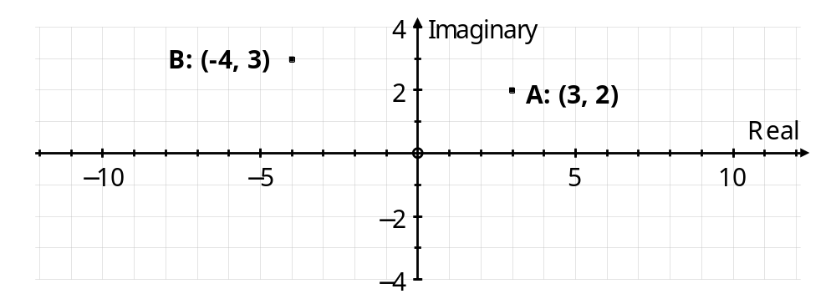
3 + 2i as the point A (3, 2), and –4 + 3i as the point (–4, 3).

Complex numbers and vectors
Complex numbers under addition (or subtraction) behave just like vectors under addition (or subtraction). We can show complex numbers on the Argand diagram as either points or vectors.
(a + bi) + (c + di) = (a + c) + (b + di) ⇔ $\left(\begin{matrix}a \\ b\end{matrix}\right)+ \left(\begin{matrix}c \\ d\end{matrix}\right) = \left(\begin{matrix}a+c \\ b+d\end{matrix}\right)$
(a + bi) – (c + di) = (a – c) + (b – di) ⇔ $\left(\begin{matrix}a \\ b\end{matrix}\right)- \left(\begin{matrix}c \\ d\end{matrix}\right) = \left(\begin{matrix}a-c \\ b-d\end{matrix}\right)$
or
Re
Im
z₁
z₂
z₁ – z₂
Re
Im
z₁
z₂
z₁ + z₂

Multiplication by i
i(3 + 4i) = –4 + 3i – on an Argand diagram this would have the effect of a positive quarter turn about the origin.
Re
Im
z
iz
x (a, b)
x (–b, a)

In general;
i(a + bi) = –b + ai

Modulus of a complex number
This is just like polar co-ordinates.
Re
Im
⏐z⏐
x z = a + bi
θ
The modulus of z is ⏐z⏐ and
is the length of the complex number
⏐z⏐ = $\sqrt{a^{2}+b^{2}}$.
z z* = (a + bi)(a – bi) = a² + b²
⇒ z z* = ⏐z⏐².

Argument of a complex number
The argument of z is arg z = the angle made by the complex number with the positive x-axis.
By convention, –π < arg z ≤ π .
N.B. Always draw a diagram when finding arg z.

Example: Find the modulus and argument of z = –6 + 5i.
Solution: First sketch a diagram (it is easy to get the argument wrong if you don’t).
Re
Im
⏐z⏐
x (–6, 5)
θ
6
5
α
⏐z⏐ = $\sqrt{6^{2}+5^{2}} = \sqrt{61}$
and tan α = $\frac{5}{6}$ ⇒ α = 0⋅694738276
⇒ arg z = θ = π – α = 2.45 to 3 s.f.

Equality of complex numbers
a + bi = c + di ⇒ a – c = (d – b)i
⇒ (a – c)² = (d – b)² i ² = – (d – b)² squaring both sides
But (a – c)² ≥ 0 and – (d – b)² ≤ 0
⇒ (a – c)² = – (d – b)² = 0
⇒ a = c and b = d
Thus a + bi = c + di
⇒ real parts are equal (a = c), and imaginary parts are equal (b = d).

Square roots
Example: Find the square roots of 5 + 12i, in the form a + bi, a, b ∈ $R$.
Solution: Let $\sqrt{5+12i}$ = a + bi
⇒ 5 + 12i = (a + bi)² = a² – b² + 2abi
Equating real parts ⇒ a² – b² = 5, I
equating imaginary parts ⇒ 2ab = 12 ⇒ a = $\frac{6}{b}$
Substitute in I ⇒ ${\left(\frac{6}{b}\right)}^{2}- b^{2}=5$
⇒ 36 – b⁴ = 5b² ⇒ b⁴ + 5b² – 36 = 0
⇒ (b² – 4)(b² + 9) = 0 ⇒ $b^{2}$ = 4
⇒ b = ± 2, and a = ± 3
⇒ $\sqrt{5+12i}$ = 3 + 2i or –3 – 2i .

Roots of equations
(a) Any polynomial equation with complex coefficients has a complex solution.
The is The Fundamental Theorem of Algebra, and is too difficult to prove at this stage.
Corollary: Any complex polynomial can be factorised into linear factors over the complex numbers.
(b) If z = a + bi is a root of α_{n} z^{n} + α_{n–1} z^{n–1} + α_{n–2} z^{n–2} + … + α ₂ z ² + α ₁ z + α ₀ = 0,
and if all the α _{i} are real,
then the conjugate, z* = a – bi is also a root.
The proof of this result is in the appendix.
(c) For any polynomial with real coefficients, and zeros a + bi, a – bi,
(z – (a + bi))(z – (a – bi)) = z² – 2az + a² – b² will be a quadratic factor in which the coefficients are all real.
(d) Using (a), (b), (c), (d) we can see that any polynomial with real coefficients can be factorised into a mixture of linear and quadratic factors, all of which have real coefficients.
Example: Show that 3 – 2i is a root of the equation z³ – 8z² + 25z – 26 = 0.
Find the other two roots.
Solution: Put z = 3 – 2i in z³ – 8z² + 25z – 26
= (3 – 2i)³ – 8(3 – 2i)² + 25(3 – 2i) – 26
= 27 – 54i + 36i ² – 8i ³ – 8(9 – 12i + 4i ²) + 75 – 50i – 26
= 27 – 36 – 72 + 32 + 75 – 26 + (–54 + 8 + 96 – 50)i
= 0 + 0i
⇒ 3 – 2i is a root
⇒ the conjugate, 3 + 2i, is also a root since all coefficients are real
⇒ (z – (3 + 2i))(z – (3 – 2i)) = z² – 6z + 13 is a factor.
Factorising, by inspection,
z³ – 8z² + 25z – 26 = (z² – 6z + 13)(z – 2) = 0
⇒ roots are z = 3 ± 2i, or 2

2 Numerical solutions of equations

Accuracy of solution
When asked to show that a solution is accurate to n d.p., you must look at the value of f (x) ‘half’ below and ‘half’ above, and conclude that
there is a change of sign in the interval, and the function is continuous, therefore there is a solution in the interval correct to n d.p.
Example: Show that α = 2⋅0946 is a root of the equation
f (x) = x³ – 2x – 5 = 0, accurate to 4 d.p.
Solution:
f (2.09455) = –0⋅0000165…, and f (2.09465) = +0⋅00997
There is a change of sign and f is continuous
⇒ there is a root in [2⋅09455, 2⋅09465] ⇒ root is α = 2⋅0946 to 4 d.p.

Interval bisection
(i) Find an interval [a, b] which contains the root of an equation f (x) = 0.
(ii) x = $\frac{a+b}{2}$ is the mid-point of the interval [a, b]
Find $f\left(\frac{a+b}{2}\right)$ to decide whether the root lies in $\left[a,\frac{a+b}{2}\right]$ or $\left[\frac{a+b}{2}, b\right]$ .
(iii) Continue finding the mid-point of each subsequent interval to narrow the interval which contains the root.

Example: (i) Show that there is a root of the equation
f (x) = x³ – 2x – 7 = 0 in the interval [2, 3].
(ii) Find an interval of width 0\.25 which contains the root.

Solution: (i) f (2) = 8 – 4 – 7 = –3, and f (3) = 27 – 6 – 7 = 14
There is a change of sign and f is continuous ⇒ there is a root in [2, 3].
(ii) Mid-point of [2, 3] is x = 2⋅5, and f (2⋅5) = 15⋅625 – 5 – 7 = 3⋅625
⇒ root in [2, 2⋅5]
Mid-point of [2, 2⋅5] is x = 2⋅25,
and f (2⋅25) = 11⋅390625 – 4⋅5 – 7 = –0⋅109375
⇒ root in [2⋅25, 2⋅5], which is an interval of width 0⋅25

Linear interpolation
To solve an equation f (x) using linear interpolation.
First, find an interval which contains a root,
second, assume that the curve is a straight line and use similar triangles to find where it crosses the x-axis,
third, repeat the process as often as necessary.
Example: (i) Show that there is a root, α, of the equation
f (x) = x³ – 2x – 9 = 0 in the interval [2, 3].
(ii) Use linear interpolation once to find an approximate value of α.
Give your answer to 3 d.p.
Solution: (i) f (2) = 8 – 4 – 9 = –5, and f (3) = 27 – 6 – 9 = 12
There is a change of sign and f is continuous ⇒ there is a root in [2, 3].
(ii) From (i), curve passes through (2, –5) and (3, 12), and we assume that the curve is a straight line between these two points.
Let the line cross the x-axis at (α, 0)
Using similar triangles
(2, –5)
(3, 12)
2
3
5
3 – α
α
12
α – 2
$\frac{3-α}{α-2}=\frac{12}{5}$
⇒ 15 – 5α = 12α – 24
⇒ α = $\frac{39}{17}=2\frac{5}{17}$
⇒ α = 2⋅294 to 3 d.p.

Newton-Raphson
α
P
M
N
x
y
b
a

Suppose that the equation f (x) = 0 has a root at x = α, ⇒ f (α) = 0
To find an approximation for this root, we first find a value x = a near to x = α (decimal search).
In general, the point where the tangent at P, x = a, meets the x-axis, x = b, will give a better approximation.
At P, x = a, the gradient of the tangent is f ′(a),
and the gradient of the tangent is also $\frac{PM}{NM}$.
PM = y = f (a) and NM = a – b
⇒ f ′(a) = $\frac{PM}{NM}$ = $\frac{f(a)}{a-b}$ ⇒ b = a – $\frac{f(a)}{f^{'}(a)}$.
Further approximations can be found by repeating the process, which would follow the dotted line converging to the point (α, 0).
This formula can be written as the iteration x_{n +1} = x_{n} – $\frac{f(x_{n})}{f^{'}(x_{n})}$
Example: (i) Show that there is a root, α, of the equation
f (x) = x³ – 2x – 5 = 0 in the interval [2, 3].
(ii) Starting with x₀ = 2, use the Newton-Raphson formula to
find x₁, x₂ and x₃, giving your answers to 3 d.p. where appropriate.

Solution: (i) f (2) = 8 – 4 – 5 = –1, and f (3) = 27 – 6 – 5 = 16
There is a change of sign and f is continuous ⇒ there is a root in [2, 3].
(ii) f (x) = x³ – 2x – 5 ⇒ f ′ (x) = 3x² – 2
⇒ x₁ = x₀ – $\frac{f(x_{0})}{f^{'}(x_{0})}$ = 2 – $\frac{8-4-5}{12-2}$ = 2⋅1
⇒ x₂ = 2⋅094568121 = 2⋅095
⇒ x₃ = 2⋅094551482 = 2⋅095

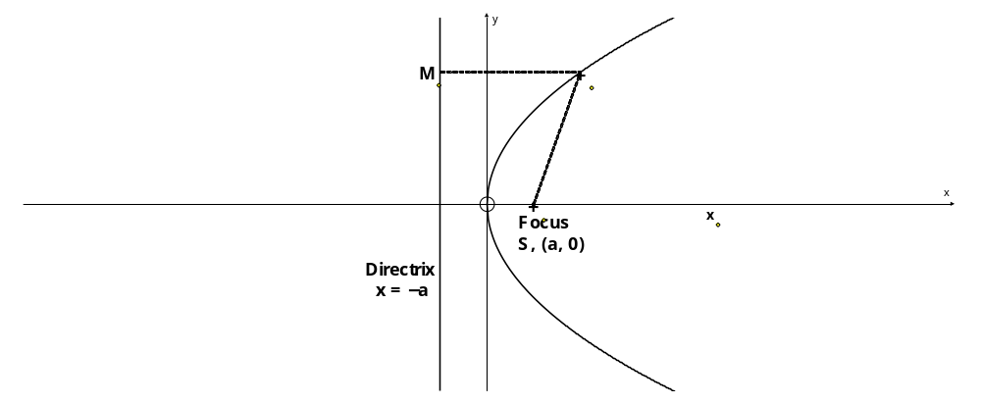
3 Coordinate systems

Parabolas
P (at², 2at)
y² = 4ax is the equation of a parabola which passes through the origin and has the x-axis as an axis of symmetry.

Parametric form
x = at², y = 2at satisfy the equation for all values of t. t is a parameter, and these equations are the parametric equations of the parabola y² = 4ax.

Focus and directrix
The point S (a, 0) is the focus, and
the line x = – a is the directrix.
Any point P of the curve is equidistant from the focus and the directrix, PM = PS.
Proof: PM ² = at² – (–a) = at² + a
PS ² = (at² – a)² + (2at)² = a²t⁴ – 2a²t² + a² + 4a²t²
= a²t⁴ + 2a²t² + a² = (at² + a)² = PM ²
⇒ PM = PS.

Gradient
For the parabola y² = 4ax, with general point P, (at², 2at), we can find the gradient in two ways:
- y² = 4ax
⇒ 2y $\frac{dy}{dx}$ = 4a ⇒ $\frac{dy}{dx}$ = $\frac{2a}{y}$
- At P, x = at², y = 2at
⇒ $\frac{dy}{dt}$ = 2a, $\frac{dx}{dt}$ = 2at
⇒ $\frac{dy}{dx}$ = $\frac{{dy}/{dt}}{{dx}/{dt}} = \frac{2a}{2at} = \frac{1}{t}$

Tangents and normals
Example: Find the equations of the tangents to y² = 8x at the points where x = 18, and show that the tangents meet on the x-axis.
Solution: x = 18 ⇒ y² = 8 × 18 ⇒ y = ±12
2y $\frac{dy}{dx}$ = 8 ⇒ $\frac{dy}{dx}$ = ± $\frac{1}{3}$ since y = ±12
⇒ tangents are y – 12 = $\frac{1}{3}$ (x – 18) ⇒ x – 3y + 18 = 0 at (18, 12)
and y + 12 = $-\frac{1}{3}$ (x – 18) ⇒ x + 3y + 18 = 0. at (18, –12)
To find the intersection, add the equations to give
2x + 36 = 0 ⇒ x = –18 ⇒ y = 0
⇒ tangents meet at (–18, 0) on the x-axis.

Example: Find the equation of the normal to the parabola given by x = 3t², y = 6t.
Solution: x = 3t², y = 6t ⇒ $\frac{dx}{dt}$ = 6t, $\frac{dy}{dt}$ = 6,
⇒ $\frac{dy}{dx}$ = $\frac{{dy}/{dt}}{{dx}/{dt}} = \frac{6}{6t} = \frac{1}{t}$
⇒ gradient of the normal is –t
⇒ equation of the normal is y – 6t = –t(x – 3t²).
Notice that this ‘general equation’ gives the equation of the normal for any particular value of t:– when t = –3 the normal is y + 18 = 3(x – 27) ⇔ y = 3x – 99.

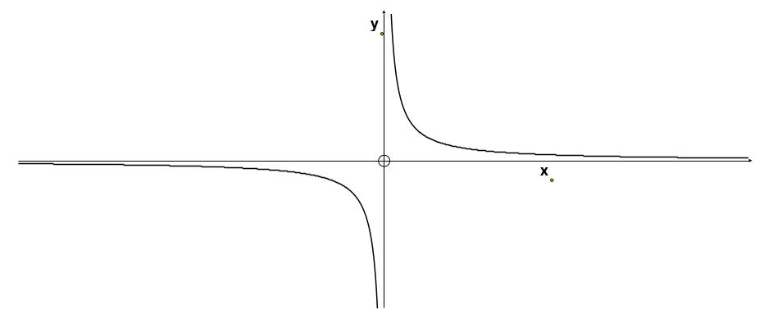
Rectangular hyperbolas
A rectangular hyperbola is a hyperbola in which the asymptotes meet at 90º.
xy = c² is the equation of a rectangular hyperbola in which the x-axis and y-axis are perpendicular asymptotes.

Parametric form
x = ct, y = $\frac{c}{t}$ are parametric equations of the hyperbola xy = c².

Tangents and normals
Example: Find the equation of the tangent to the hyperbola xy = 36 at the points where x = 3.
Solution: x = 3 ⇒ 3y = 36 ⇒ y = 12
y = $\frac{36}{x}$ ⇒ $\frac{dy}{dx}$ = – $\frac{36}{x^{2}}$ = –4 when x = 3
⇒ tangent is y – 12 = –4(x – 3) ⇒ 4x + y – 24 = 0.

Example: Find the equation of the normal to the hyperbola given by x = 3t, y = $\frac{3}{t}$.
Solution: x = 3t, y = $\frac{3}{t}$ ⇒ $\frac{dx}{dt}$ = 3, $\frac{dy}{dt}$ = $\frac{-3}{t^{2}}$
⇒ $\frac{dy}{dx}$ = $\frac{{dy}/{dt}}{{dx}/{dt}} = \frac{\frac{-3}{t^{2}}}{3} = \frac{-1}{t^{2}}$
⇒ gradient of the normal is t²
⇒ equation of the normal is y – $\frac{3}{t}$ = t²(x – 3t)
⇒ t³x – y = 3t⁴ – 3.

4 Matrices
You must be able to add, subtract and multiply matrices.

Order of a matrix
An r × c matrix has r rows and c columns;
the fiRst number is the number of Rows
the seCond number is the number of Columns.

Identity matrix
The identity matrix is I = $\left(\begin{matrix}1 & 0 \\ 0 & 1\end{matrix}\right)$.
Note that MI = IM = M for any matrix M.

Determinant and inverse
Let M = $\left(\begin{matrix}a & b \\ c & d\end{matrix}\right)$ then the determinant of M is
Det M = | M | = ad – bc.

To find the inverse of M = $\left(\begin{matrix}a & b \\ c & d\end{matrix}\right)$
Note that M ^{–1}M = M M ^{–1} = I
(i) Find the determinant, ad – bc. If ad – bc = 0, there is no inverse.
(ii) Interchange a and d (the leading diagonal)
Change sign of b and c, (the other diagonal)
Divide all elements by the determinant, ad – bc.
⇒ $M^{-1}={}^{\frac{1}{ad-bc}}\left(\begin{matrix}d & -b \\ -c & a\end{matrix}\right)$.
Check:
M ^{–1}M = ${}^{\frac{1}{ad-bc}}\left(\begin{matrix}d & -b \\ -c & a\end{matrix}\right)\left(\begin{matrix}a & b \\ c & d\end{matrix}\right) = {}^{\frac{1}{ad-bc}}\left(\begin{matrix}da-bc & 0 \\ 0 & -bc+ad\end{matrix}\right)= \left(\begin{matrix}1 & 0 \\ 0 & 1\end{matrix}\right)=I$
Similarly we could show that M M ^{–1} = I.

Example: M = $\left(\begin{matrix}4 & 2 \\ 5 & 3\end{matrix}\right)$ and MN = $\left(\begin{matrix}-1 & 2 \\ 2 & 1\end{matrix}\right)$. Find N.
Solution: Notice that M^{–1} (MN) = (M^{–1}M)N = IN = N multiplying on the left by M^{–1}
But MNM^{–1} ≠ IN we cannot multiply on the right by M^{–1}
First find M^{–1}
Det M = 4 × 3 – 2 × 5 = 2
⇒ $M^{-1}={}^{\frac{1}{2}}\left(\begin{matrix}3 & -2 \\ -5 & 4\end{matrix}\right)$
Using M^{–1} (MN) = IN = N
⇒ N =${}^{\frac{1}{2}}\left(\begin{matrix}3 & -2 \\ -5 & 4\end{matrix}\right)\left(\begin{matrix}-1 & 2 \\ 2 & 1\end{matrix}\right)$ = ${}^{\frac{1}{2}}\left(\begin{matrix}-7 & 4 \\ 13 & -6\end{matrix}\right)$ = $\left(\begin{matrix}-3.5 & 2 \\ 6.5 & -3\end{matrix}\right)$ .

Linear Transformations
A matrix can represent a transformation, but the point must be written as a column vector before multiplying by the matrix.
Example: The image of (2, 3) under T = $\left(\begin{matrix}4 & 5 \\ 1 & 2\end{matrix}\right)$ is given by $\left(\begin{matrix}4 & 5 \\ 1 & 2\end{matrix}\right)\left(\begin{matrix}2 \\ 3\end{matrix}\right) =\left(\begin{matrix}23 \\ 8\end{matrix}\right)$
⇒ the image of (2, 3) is (23, 8).
Note that the image of (0, 0) is always (0, 0)
⇔ the origin never moves under a matrix (linear) transformation

Basis vectors
The vectors i = $\left(\begin{matrix}1 \\ 0\end{matrix}\right)$ and j = $\left(\begin{matrix}0 \\ 1\end{matrix}\right)$ are called basis vectors, and are particularly important in describing the geometrical effect of a matrix, and in finding the matrix for a particular geometric transformation.
$\left(\begin{matrix}a & b \\ c & d\end{matrix}\right)\left(\begin{matrix}1 \\ 0\end{matrix}\right)=\left(\begin{matrix}a \\ c\end{matrix}\right)$ and $\left(\begin{matrix}a & b \\ c & d\end{matrix}\right)\left(\begin{matrix}0 \\ 1\end{matrix}\right)=\left(\begin{matrix}b \\ d\end{matrix}\right)$
i = $\left(\begin{matrix}1 \\ 0\end{matrix}\right)$ → $\left(\begin{matrix}a \\ c\end{matrix}\right)$, the first column, and j = $\left(\begin{matrix}0 \\ 1\end{matrix}\right)$ → $\left(\begin{matrix}b \\ d\end{matrix}\right)$, the second column
This is a more important result than it seems!

Finding the geometric effect of a matrix transformation
We can easily write down the images of i and j, sketch them and find the geometrical transformation.
Example: Find the geometrical effect of the matrix $T= \left(\begin{matrix}2 & 0 \\ 0 & 3\end{matrix}\right)$
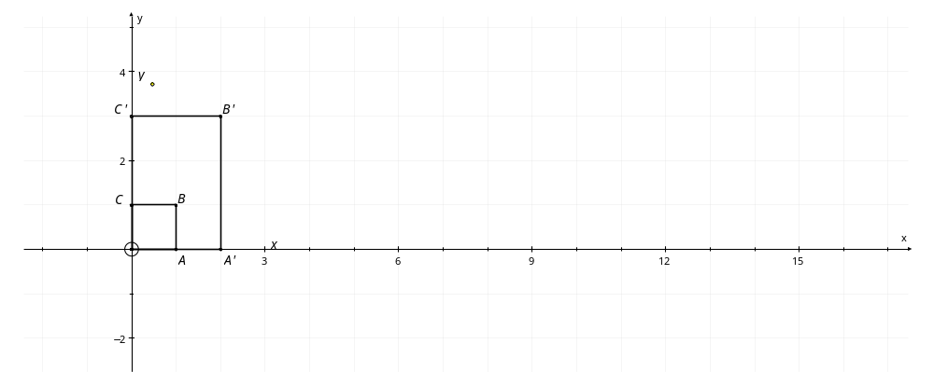
Solution: Find images of i, j and $\left(\begin{matrix}1 \\ 1\end{matrix}\right)$, and show on a sketch. Make sure that you letter the points
$$\left(\begin{matrix}2 & 0 \\ 0 & 3\end{matrix}\right)\left(\begin{matrix}1 & 0 & 1 \\ 0 & 1 & 1\end{matrix}\right)=\left(\begin{matrix}2 & 0 & 2 \\ 0 & 3 & 3\end{matrix}\right)$$
From sketch we can see that the transformation is a two-way stretch, of factor 2 parallel to the x-axis and of factor 3 parallel to the y-axis.

Finding the matrix of a given transformation.
Example: Find the matrix for a shear with factor 2 and invariant line the x-axis.
Solution: Each point is moved in the x-direction by a
distance of (2 × its y-coordinate).
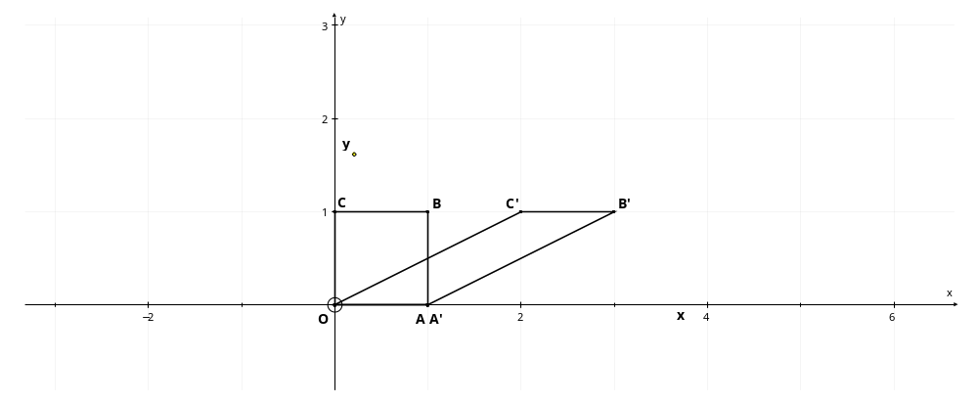
i = $\left(\begin{matrix}1 \\ 0\end{matrix}\right)$ → $\left(\begin{matrix}1 \\ 0\end{matrix}\right)$ (does not move as it is on the invariant line).
This will be the first column of the matrix $\left(\begin{matrix}1 & * \\ 0 & *\end{matrix}\right)$
j = $\left(\begin{matrix}0 \\ 1\end{matrix}\right)$ → $\left(\begin{matrix}2 \\ 1\end{matrix}\right)$. This will be the second column of the matrix $\left(\begin{matrix}* & 2 \\ * & 1\end{matrix}\right)$
⇒ Matrix of the shear is $\left(\begin{matrix}1 & 2 \\ 0 & 1\end{matrix}\right)$.

Example: Find the matrix for a reflection in the line y = –x.
Solution: First find the images of i and j . These will be the two columns of the matrix.
A (1, 0)
A′ (0, –1)
B (0, 1)
B′ (–1, 0)
x
y
y = –x
×
×
×
×

i = $\left(\begin{matrix}1 \\ 0\end{matrix}\right)$ → $\left(\begin{matrix}0 \\ -1\end{matrix}\right)$. This will be the first column of the matrix $\left(\begin{matrix}0 & * \\ -1 & *\end{matrix}\right)$
j = $\left(\begin{matrix}0 \\ 1\end{matrix}\right)$ → $\left(\begin{matrix}-1 \\ 0\end{matrix}\right)$. This will be the second column of the matrix $\left(\begin{matrix}* & -1 \\ * & 0\end{matrix}\right)$
⇒ Matrix of the reflection is $\left(\begin{matrix}0 & -1 \\ -1 & 0\end{matrix}\right)$.

Rotation matrix
From the diagram we can see that
A (1, 0)
A′ (cosθ , sinθ)
B (0, 1)
B′
(–sinθ, cosθ)
x
y
θ
θ
cosθ
cosθ
sinθ
sinθ
×
×
×
×
i = $\left(\begin{matrix}1 \\ 0\end{matrix}\right)$ → $\left(\begin{matrix}\cos{θ} \\ \sin{θ}\end{matrix}\right)$ ,
j = $\left(\begin{matrix}0 \\ 1\end{matrix}\right)$ → $\left(\begin{matrix}-\sin{θ} \\ \cos{θ}\end{matrix}\right)$
These will be the first and second columns of the matrix
⇒ matrix is $R_{θ}= \left(\begin{matrix}\cos{θ} & -\sin{θ} \\ \sin{θ} & \cos{θ}\end{matrix}\right)$.

Determinant and area factor
For the matrix $A= \left(\begin{matrix}a & b \\ c & d\end{matrix}\right)$
b
d
c
a
(b, d)
(a, c)
b
d
c
a
x
y
1
1
$\left(\begin{matrix}a & b \\ c & d\end{matrix}\right)\left(\begin{matrix}1 \\ 0\end{matrix}\right)=\left(\begin{matrix}a \\ c\end{matrix}\right)$
and $\left(\begin{matrix}a & b \\ c & d\end{matrix}\right)\left(\begin{matrix}0 \\ 1\end{matrix}\right)=\left(\begin{matrix}b \\ d\end{matrix}\right)$
⇒ the unit square is mapped on to the parallelogram as shown in the diagram.
The area of the unit square = 1.
The area of the parallelogram = (a + b)(c + d) – 2 × (bc + $\frac{1}{2}$ ac + $\frac{1}{2}$ bd)
= ac + ad + bc + bd – 2bc – ac – bd
= ad – bc = det A.
All squares of the grid are mapped onto congruent parallelograms
⇒ area factor of the transformation is det A = ad – bc.

5 Series
You need to know the following sums
$$\sum_{r=1}^{n}{r}=1+2+3+…+n = \frac{1}{2}n(n+1)$$
$$\sum_{r=1}^{n}{r^{2}}=1^{2}+2^{2}+3^{2}+…+n^{2} = \frac{1}{6}n(n+1)(2n+1)$$
$$\sum_{r=1}^{n}{r^{3}}=1^{3}+2^{3}+3^{3}+…+n^{3} = \frac{1}{4}n^{2}(n+1)^{2}$$
$${\left(\sum_{r=1}^{n}{r}\right)}^{2}$$
= ${\left(\frac{1}{2}n(n+1)\right)}^{2}=$ a fluke, but it helps to remember it
$$\sum_{r=1}^{n}{r(r^{2}-3)}$$
Example: Find .
Solution:
= $\frac{1}{4}n^{2}(n+1)^{2} - 3×\frac{1}{2}n(n+1)$
$$\sum_{r=1}^{n}{r(r^{2}-3)}= \sum_{r=1}^{n}{r^{3}}- 3\sum_{r=1}^{n}{r}$$
= $\frac{1}{4}n\left(n+1\right)\left\{n\left(n+1\right)- 6\right\}$
= $\frac{1}{4}n\left(n+1\right)\left(n+3)(n-2\right)$
Example: Find S_{n} = 2² + 4² + 6² + … + (2n)².

Solution: S_{n} = 2² + 4² + 6² + … + (2n)² = 2²(1² + 2² + 3² + … + n²)
= 4 × $\frac{1}{6}n(n+1)(2n+1)$ = $\frac{2}{3}n(n+1)(2n+1)$ .
$$\sum_{r=5}^{n+2}{r^{2}}$$
Example: Find
$$\sum_{r=5}^{n+2}{r^{2}} = \sum_{r=1}^{n+2}{r^{2}} - \sum_{r=1}^{4}{r^{2}}$$
Solution: notice that the top limit is 4 not 5
= $\frac{1}{6}\left(n+2\right)\left(n+2+1\right)\left(2\left(n+2\right)+1\right)-\frac{1}{6} ×4×5×9$
= $\frac{1}{6}\left(n+2\right)\left(n+3\right)\left(2n+5\right)-30$.

6 Proof by induction
- Show that the result/formula is true for n = 1 (and sometimes n = 2 , 3 ..).
Conclude
“therefore the result/formula ………. is true for n = 1”.
- Make induction assumption
“Assume that the result/formula ………. is true for n = k”.
Show that the result/formula must then be true for n = k + 1
Conclude
“therefore the result/formula ………. is true for n = k + 1”.
- Final conclusion
“therefore the result/formula ………… is true for all positive integers, n, by mathematical induction”.

Summation
Example: Use mathematical induction to prove that
S_{n} = 1² + 2² + 3² + … + n² = $\frac{1}{6}n(n+1)(2n+1)$
Solution: When n = 1, S₁ = 1² = 1 and S₁ = $\frac{1}{6}×1\left(1+1\right)\left(2×1+1\right)= \frac{1}{6}×1×2×3 =1$
⇒ S_{n} = $\frac{1}{6}n(n+1)(2n+1)$ is true for n = 1.
Assume that the formula is true for n = k
⇒ S_{k} = 1² + 2² + 3² + … + k² = $\frac{1}{6}k(k+1)(2k+1)$
⇒ S_{k + 1} = 1² + 2² + 3² + … + k² + (k + 1)² = $\frac{1}{6}k(k+1)(2k+1)$ + (k + 1)²
= $\frac{1}{6}\left(k+1\right)\left\{k\left(2k+1\right)+6\left(k+1\right)\right\}$
= $\frac{1}{6}\left(k+1\right)\left\{2k^{2}+7k+6\right\}$ = $\frac{1}{6}\left(k+1\right)\left(k+2\right)(2k+3)$
= $\frac{1}{6}\left(k+1\right)\left\{\left(k+1\right)+1\right\}\left\{2\left(k+1\right)+1\right\}$
⇒ The formula is true for n = k + 1
⇒ S_{n} = $\frac{1}{6}n(n+1)(2n+1)$ is true for all positive integers, n, by mathematical induction.

Recurrence relations
Example: A sequence, 4, 9, 19, 39, … is defined by the recurrence relation
u₁ = 4, u_{n + 1} = 2u_{n} + 1. Prove that u_{n} = 5 × 2^{n − 1} − 1.
Solution: When n = 1, u₁ = 4, and u₁ = 5 × 2¹⁻¹ − 1 = 5 − 1 = 4, ⇒ formula true for n = 1.
Assume that the formula is true for n = k, ⇒ u_{k} = 5 × 2^{k − 1} − 1.
From the recurrence relation,
u_{k + 1} = 2u_{k} + 1 = 2(5 × 2^{k − 1} − 1) + 1
⇒ u_{k + 1} = 5 × 2^{k} − 2 + 1 = 5 × 2 ^{(k + 1) − 1} − 1
⇒ the formula is true for n = k + 1
⇒ the formula is true for all positive integers, n, by mathematical induction.

Divisibility problems
Considering f (k + 1) − f (k), will often lead to a proof,
but a more reliable way is to consider f (k + 1) − m × f (k), where m is chosen to eliminate the exponential term.
Example: Prove that f (n) = 5^{n} − 4n − 1 is divisible by 16 for all positive integers, n.
Solution: When n = 1, f (1) = 5¹ − 4 − 1 = 0, which is divisible by 16, and so f (n) is divisible by 16 when n = 1.
Assume that the result is true for n = k, ⇒ f (k) = 5^{k} − 4k − 1 is divisible by 16.
Considering f (k + 1) − 5 × f (k) we will eliminate the 5^{k} term.
f (k + 1) − 5 × f (k) = (5^{k + 1} − 4(k + 1) − 1) − 5 × (5^{k} − 4k − 1)
= 5^{k + 1} − 4k − 4 − 1 − 5^{k + 1} + 20k + 5 = 16k
⇒ f (k + 1) = 5 × f (k) + 16k
Since f (k) is divisible by 16 (induction assumption), and 16k is divisible by 16, then f (k + 1) must be divisible by 16,
⇒ the result is true for n = k + 1
⇒ f (n) = 5^{n} − 4n − 1 is divisible by 16 for all positive integers, n, by mathematical induction.

Example: Prove that f (n) = 2^{2n + 3} + 3^{2n − 1} is divisible by 5 for all positive integers n.
Solution: When n = 1, f (1) = 2² ⁺ ³ + 3² ⁻ ¹ = 32 + 3 = 35 = 5 × 7, and so the result is true for n = 1.
Assume that the result is true for n = k
⇒ f (k) = 2^{2k + 3} + 3^{2k − 1} is divisible by 5
We could consider either
f (k + 1) − 2² × f (k), which would eliminate the 2^{2k + 3} term I
or f (k + 1) − 3² × f (k), which would eliminate the 3^{2k − 1} term II
I ⇒ f (k + 1) − 2² × f (k) = 2^{2(k + 1) + 3} + 3^{2(k + 1) − 1} − 2² × (2^{2k + 3} + 3^{2k − 1})
= 2^{2k + 5} + 3^{2k + 1} − 2^{2k + 5} − 2² × 3^{2k − 1}
⇒ f (k + 1) − 4 × f (k) = 9 × 3^{2k − 1} − 4 × 3^{2k − 1} = 5 × 3^{2k − 1}
⇒ f (k + 1) = 4 × f (k) − 5 × 3^{2k − 1}
Since f (k) is divisible by 5 (induction assumption), and 5 × 3^{2k − 1} is divisible by 5, then f (k + 1) must be divisible by 5.
⇒ f (n) = 2^{2n + 3} + 3^{2n − 1} is divisible by 5 for all positive integers, n, by mathematical induction.

Powers of matrices
Example: If $M= \left(\begin{matrix}2 & -1 \\ 0 & 1\end{matrix}\right)$, prove that $M^{n}= \left(\begin{matrix}2^{n} & 1-2^{n} \\ 0 & 1\end{matrix}\right)$ for all positive integers n.
Solution: When n = 1, $M^{1}= \left(\begin{matrix}2^{1} & 1-2^{1} \\ 0 & 1\end{matrix}\right) =\left(\begin{matrix}2 & -1 \\ 0 & 1\end{matrix}\right) =M$
⇒ the formula is true for n = 1.
Assume the result is true for n = k ⇒ $M^{k}= \left(\begin{matrix}2^{k} & 1-2^{k} \\ 0 & 1\end{matrix}\right)$ .
$M^{k+1}= MM^{k} = \left(\begin{matrix}2 & -1 \\ 0 & 1\end{matrix}\right)\left(\begin{matrix}2^{k} & 1-2^{k} \\ 0 & 1\end{matrix}\right)$ = $\left(\begin{matrix}{2×2}^{k} & 2-2×2^{k}-1 \\ 0 & 1\end{matrix}\right)$
⇒ $M^{k+1}= \left(\begin{matrix}2^{k+1} & 1-2^{k+1} \\ 0 & 1\end{matrix}\right)$⇒ The formula is true for n = k + 1
⇒ $M^{n}= \left(\begin{matrix}2^{n} & 1-2^{n} \\ 0 & 1\end{matrix}\right)$ is true for all positive integers, n, by mathematical induction.

7 Appendix

Complex roots of a real polynomial equation
Preliminary results:
I (z₁ + z₂ + z₃ + z₄ + … + z_{n})* = z₁* + z₂* + z₃* + z₄* + … + z_{n}*,
by repeated application of (z + w)* = z* + w*
II (z^{n})* = (z*) ^{n}
(zw)* = z*w*
⇒ (z^{n})* = (z^{n-1}z)* = (z^{n-1})*(z)* = (z^{n-2}z)*(z)* = (z^{n-2})*(z)*(z)* … = (z*) ^{n}

Theorem: If z = a + bi is a root of α_{n} z^{n} + α_{n–1} z^{n–1} + α_{n–2} z^{n–2} + … + α ₂ z ² + α ₁ z + α ₀ = 0,
and if all the α _{i} are real,
then the conjugate, z* = a – bi is also a root.
Proof: If z = a + bi is a root of the equation α_{n} z^{n} + α_{n–1} z^{n–1} + … + α ₁ z + α ₀ = 0
then α_{n} z^{n} + α_{n–1} z^{n–1} + … + α ₂ z ² + α ₁ z + α ₀ = 0
⇒ (α_{n} z^{n} + α_{n–1} z^{n–1} + … + α ₂ z ² + α ₁ z + α ₀)* = 0 since 0* = 0
⇒ (α_{n} z^{n})* + (α_{n–1} z^{n–1})* + … + (α ₂ z ²)* + (α ₁ z)* + (α ₀)* = 0 using I
⇒ α_{n}*( z^{n})* + α_{n–1}*(z^{n–1})* + …+ α ₂*( z ²)* + α ₁*( z)* + α ₀* = 0 since (zw)* = z*w*
⇒ α_{n}( z^{n})* + α_{n–1}(z^{n–1})* + … + α ₂( z²)*+ α ₁( z)* + α ₀ = 0 α_{i} real ⇒ α_{i}* = α_{i}
⇒ α_{n}( z*) ^{n} + α_{n–1}(z*) ^{n–1} + … + α ₂(z*)² + α ₁(z*) + α ₀ = 0 using II
⇒ z* = a – bi is also a root of the equation.

Formal definition of a linear transformation
A linear transformation T has the following properties:
(i) $T\left(\begin{matrix}kx \\ ky\end{matrix}\right) =kT\left(\begin{matrix}x \\ y\end{matrix}\right)$
(ii) $T\left(\begin{matrix}x_{1} \\ y_{1}\end{matrix}+\begin{matrix}x_{2} \\ y_{2}\end{matrix}\right) =T\left(\begin{matrix}x_{1} \\ y_{1}\end{matrix}\right)+T\left(\begin{matrix}x_{2} \\ y_{2}\end{matrix}\right)$
It can be shown that any matrix transformation is a linear transformation, and that any linear transformation can be represented by a matrix.

Derivative of x^{n}, for any integer
We can use proof by induction to show that $\frac{d}{dx}\left(x^{n}\right)= nx^{n-1}$, for any integer n.
1) We know that the derivative of x⁰ is 0 which equals 0x⁻¹,
since x⁰ = 1, and the derivative of 1 is 0
⇒ $\frac{d}{dx}\left(x^{n}\right)= nx^{n-1}$ is true for n = 0.
2) We know that the derivative of x¹ is 1 which equals 1 × x^{1 – 1}
⇒ $\frac{d}{dx}\left(x^{n}\right)= nx^{n-1}$ is true for n = 1
Assume that the result is true for n = k
⇒ $\frac{d}{dx}\left(x^{k}\right) = kx^{k-1}$
⇒ $\frac{d}{dx}\left(x^{k+1}\right) =$ $\frac{d}{dx}\left(x×x^{k}\right)=x×\frac{d}{dx}\left(x^{k}\right)+ 1×x^{k}$ product rule
⇒ $\frac{d}{dx}\left(x^{k+1}\right) = x×kx^{k-1}+x^{k}=kx^{k}+x^{k}=(k+1)x^{k}$
⇒ $\frac{d}{dx}\left(x^{n}\right)= nx^{n-1}$ is true for n = k + 1
⇒ $\frac{d}{dx}\left(x^{n}\right)= nx^{n-1}$ is true for all positive integers, n, by mathematical induction.
3) We know that the derivative of x⁻¹ is −x⁻² which equals −1 × x^{−1 – 1}
⇒ $\frac{d}{dx}\left(x^{n}\right)= nx^{n-1}$ is true for n = −1
Assume that the result is true for n = k
⇒ $\frac{d}{dx}\left(x^{k}\right) = kx^{k-1}$
⇒ $\frac{d}{dx}\left(x^{k-1}\right) =$ $\frac{d}{dx}\left(\frac{x^{k}}{x}\right)=\frac{x×\frac{d}{dx}\left(x^{k}\right) - x^{k}×1}{x^{2}}$ quotient rule
⇒ $\frac{d}{dx}\left(x^{k+1}\right) = \frac{x×kx^{k-1} - x^{k}}{x^{2}} = \frac{(k-1)x^{k}}{x^{2}}=\left(k-1\right)x^{k-2}= (k-1)x^{\left(k-1\right)-1}$
⇒ $\frac{d}{dx}\left(x^{n}\right)= nx^{n-1}$ is true for n = k − 1
We are going backwards (from n = k to n = k − 1), and, since we started from n = −1,
⇒ $\frac{d}{dx}\left(x^{n}\right)= nx^{n-1}$ is true for all negative integers, n, by mathematical induction.
Putting 1), 2) and 3), we have proved that
$\frac{d}{dx}\left(x^{n}\right)= nx^{n-1}$, for any integer n.

8 Index

Appendix, 22
Complex numbers
Argand diagram, 4
argument, 5
arithmetical operations, 3
complex conjugate, 3
complex number plane, 4
definitions, 3
equality, 6
modulus, 5
multiplication by i, 5
polynomial equations, 6
similarity with vectors, 4
square roots, 6
Complex roots of a real polynomial equation, 22
Derivative of x^{n}, for any integer, 23
Determinant
area factor, 17
Linear transformation
formal definition, 22
Matrices
determinant, 14
identity matrix, 14
inverse matrix, 14
order, 14
Matrix transformations
area factor, 17
basis vectors, 15
finding matrix for, 16
geometric effect, 16
rotation matrix, 17
Numerical solutions of equations
accuracy of solution, 8
interval bisection, 8
linear interpolation, 9
Newton Raphson method, 10
Parabolas
directrix, 11
focus, 11
gradient - parametric form, 11
normal - parametric form, 12
parametric form, 11
tangent - parametric form, 12
Proof by induction
divisibility problems, 20
general principles, 19
powers of matrices, 21
recurrence relations, 20
summation, 19
Rectangular hyperbolas
gradient - parametric form, 13
parametric form, 12
tangent - parametric form, 13
Series
standard summation formulae, 18
Transformations
area factor, 17
basis vectors, 15
finding matrix for, 16
geometric effect, 16
matrices, 16
rotation matrix, 17

