Work out angles a and b  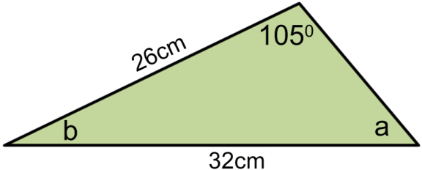  Can you work out the perimeter of the triangle? | Work out vectors$\vec{EC}$ and $\vec{DB}$in terms of c and d  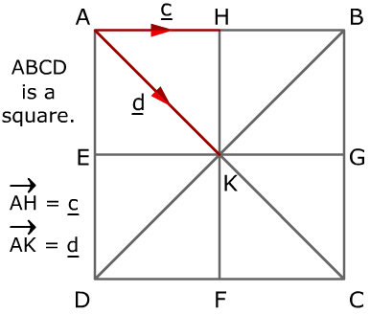 | 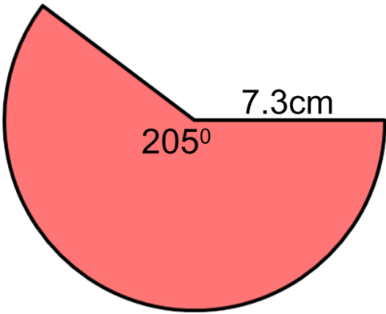  Find the area and perimeter of the sector below | 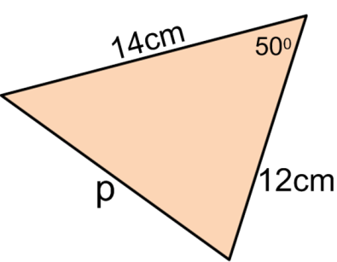  Find the missing length, p  Can you work out the area of the triangle?
Work out the surface area of the shape below  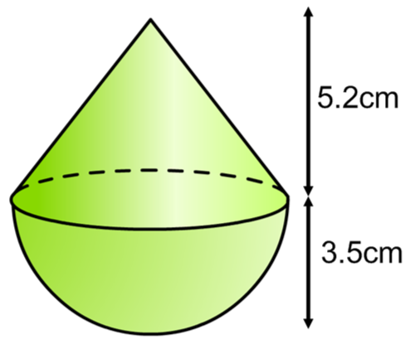 | Explain, using diagrams, when you would use the sine rule and when you would use the cosine rule.  Can you create a problem that would require you to use both? | Find the length of the spider web that goes in a straight line from A to B.  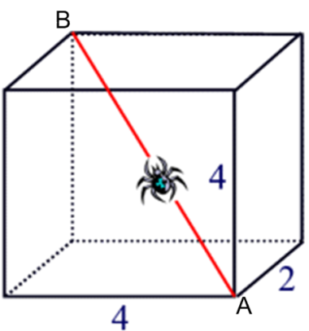 | Find the angle QSR  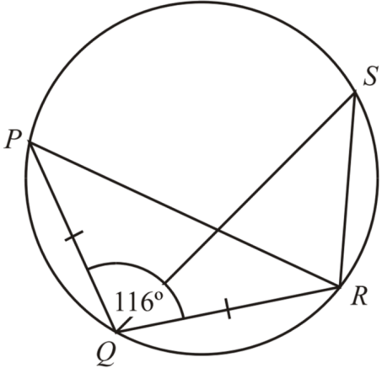
The two cereal boxes are similar shapes. Work out the weight of the larger box.  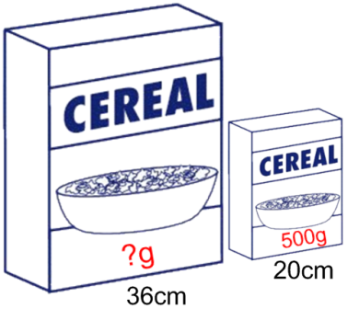 | Find the missing lengths p and q.  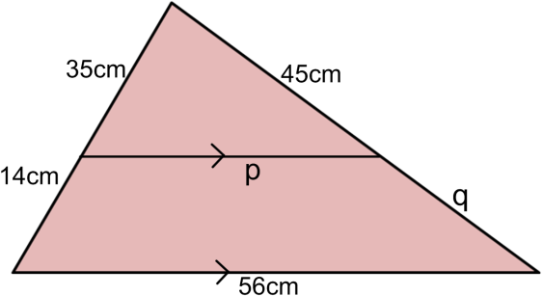 | Copy and enlarge using a Scale Factor of -½ from COE at (-1, -1)  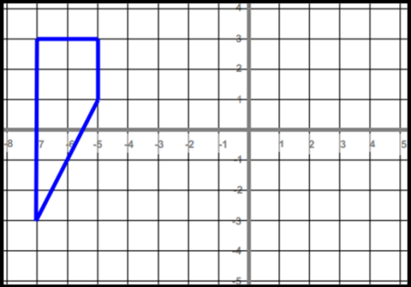 | Find the volume of the Frustum  