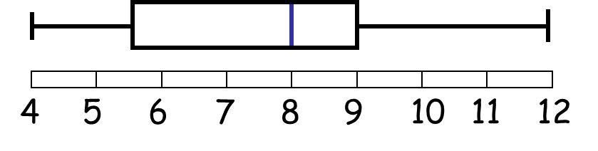
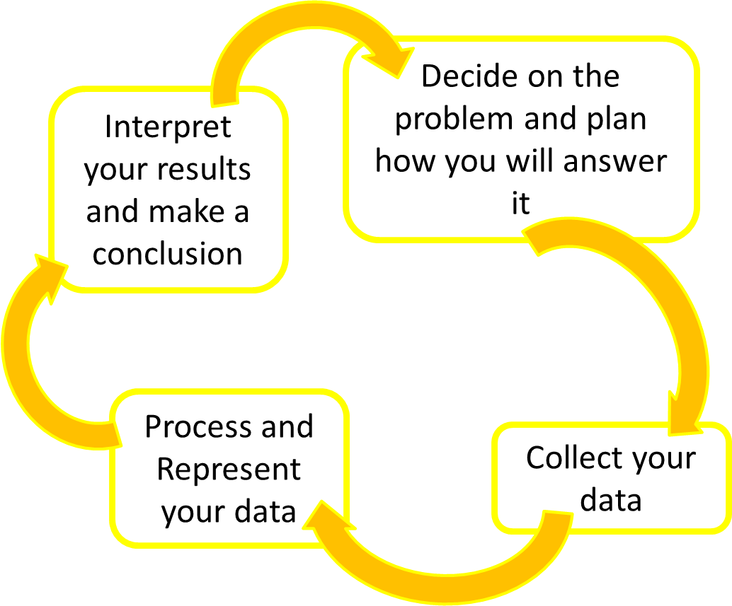
What diagrams will you use and why?
Box plot showing the number of computers per 100 people in 2000
What method might you use for your sample and why?

You should also evaluate how reliable your results are and say how you could improve them.

e.g.
The Data Handling Cycle

