Year 8 – Spring Assessment 2

Time: 45 minutes Calculator allowed

Name: .................................... Maths Teacher: .........................

Date: ......................... Maths Class: .........................
Answer all the questions
Read the questions carefully
Show your working
Check your answers

Mark (45)

Things I need to practise:
Things I did well:

Q1. Screenwash
Screenwash is used to clean car windows.
To use Screenwash you mix it with water.
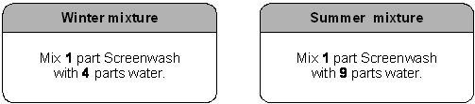

(a) In winter, how much water should I mix with 150ml of Screenwash?
.......................... ml
1 mark

(b) In summer, how much Screenwash should I mix with 450ml of water?
.......................... ml
1 mark

(c) Is this statement correct?

25% of winter mixture is Screenwash.

Tick () Yes or No.

 | True |  |  | False

Explain your answer.

1 mark

Q2. Cutting a cake
Ben is 10 years old.
Cindy is 15 years old.
Tom is 20 years old.
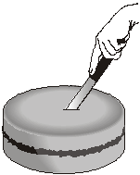

They are going to cut a cake into 3 slices from the centre.
The size of the slices will be proportional to their ages.
What will the angle at the centre of Ben’s slice be?

..................°
2 marks
Q3. (a) One morning last summer Ravi carried out a survey of the birds in the school garden.
He saw 5 pigeons, 20 crows, 25 seagulls and 45 sparrows.
Complete the line below to show the ratios.

 | Pigeons | : | Crows | : | Seagulls | : | Sparrows
 | 1 | : | ........... | : | ........... | : | ...........

2 marks

(b) What percentage of all the birds Ravi saw were sparrows?
..............................%
1 mark

Q4. Yoghurt
A dessert has both fruit and yoghurt inside.
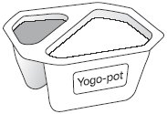
Altogether, the mass of the fruit and yoghurt is 175g.
The ratio of the mass of fruit to the mass of yoghurt is 2 : 5
What is the mass of the yoghurt?

...................... g
2 marks

Q5. Tennis prizes
Each year, there is a tennis competition in Australia and another one in France.
The table shows how much money was paid to the winner of the men’s
competition in each country in 2002.

Country | Money
Australia | 1000 000 Australian dollars  (£1 = 2.70 Australian dollars)
France | 780 000 Euros  (£1 = 1.54 Euros)

Which country paid more money?
You must show your working.

Tick () the country that paid more.

 |  | Australia |  | France

2 marks

Q6. Grey and black designs
(a) In this design, the ratio of grey to black is 3 : 1
What percentage of the design is black?
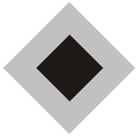
............................%
1 mark

(b) In this design, 60% is grey and the rest is black.
What is the ratio of grey to black?
Write your ratio in its simplest form.
............. : .............
2 marks

Q7. Here are some exchange rates.

£1 = 2.03 American dollars
£1 = 2.15 Canadian dollars

Use the exchange rates to answer this question.
(a) How many more Canadian dollars than American dollars would you get for £250?

dollars

2 marks

(b) How many more pounds (£) would you get for 250 American dollars than for 250 Canadian dollars?

£

2 marks

Q8. Ratio
(a) On this necklace the ratio of black beads to white beads is 1 : 3
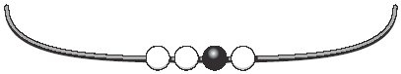
How many more black beads do you need to add to make the
ratio of black to white 3 : 1?

................... black beads
1 mark

(b) Here is the necklace again.
How many more black beads and white beads do you need to add to make the ratio of black to white 3 : 2?

....................... black beads, ....................... white beads
1 mark

Q9. Red and blue cubes
In a bag, there are red and blue cubes in the ratio 4 : 7
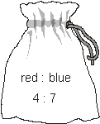

I add 10 more red cubes to the bag.
Now there are red and blue cubes in the ratio 6 : 7
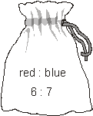

How many blue cubes are in the bag?

...................
2 marks

Q10. Shadows
Tom’s height is 1.8m.
He stands near a tree.
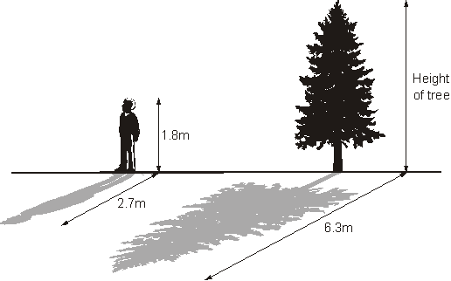
Not drawn accurately
At 4pm, the length of Tom’s shadow is 2.7m.
At 4pm, the length of the tree’s shadow is 6.3m.

What is the height of the tree?

m

2 marks

Q11. Best buy
You can buy jars of the same jam in two sizes.
454g for £1.59 340g for £1.25

Which jar is better value for money?
You must show working to explain your answer.

Tick () your answer.
A B
2 marks

Q12. Juice
The table shows a recipe for a fruit drink.

Type of juice | Amount
Orange | litre
Cranberry | litre
Grape | litre
 | Total 1 litre

I want to make 1litres of the same drink.
Complete the table below to show how much of each type of juice to use.
Show your working.

Type of juice | Amount
Orange | litre
Cranberry | litre
Grape | litre
 | Total 1 litres

2 marks

Q13. Centenarians
People who live to be 100 years old are called centenarians.
In 1998 there were 135 000 centenarians.
The ratio of male to female was 1 : 4
How many female centenarians were there in 1998?
Show your working.

...............................
2 marks

Q14. Oranges and lemons
I fill a glass with orange juice and lemonade in the ratio 1 : 4
I drink of the contents of the glass, then I fill the glass using orange juice.
Now what is the ratio of orange juice to lemonade in the glass?

Show your working, and write the ratio in its simplest form.

............... : ...............
3 marks
Q15. Star shapes
The diagram shows two shapes that are mathematically similar.
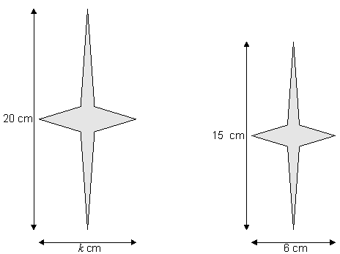

(a) What is the value of k?

..............................
1 mark

(b) I want to draw another shape that is mathematically similar to the ones in the diagram, but of a different size.
Give the length and width of a shape I could draw.

length .............................. cm width .............................. cm
1 mark

Q16. Coffee
A cup of coffee costs £1.75
The diagram shows how much money different people get when you buy a cup of coffee.
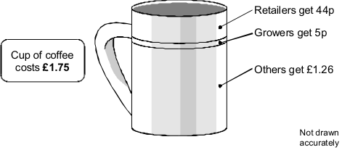
(a) Complete the table to show what percentage of the cost of a cup of coffee goes to retailers, growers and others.
Show your working.

Retailers | %
Growers | %
Others | %

2 marks

(b) Some people think the growers should get more.
Suppose the percentages change to:
Retailers | 23%
Growers | 10%
Others | 67%

Suppose the retailers still got 44p from each cup of coffee sold.
How much would a cup of coffee cost?
Show your working.
£

2 marks
Q17. Sale

A shop had a sale. All prices were reduced by 15% | 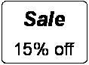

A pair of shoes cost £38.25 in the sale.

What price were the shoes before the sale?
Show your working.

£

2 marks

Q18. Here are the dimensions of a solid gold bar.
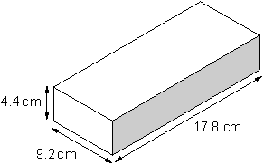

Use the information below to calculate how much this gold bar is worth in British pounds (£).
• The gold bar is a cuboid.
• The density of gold is 19.3 grams per cm³
• 1 ounce is 28.35 grams.
• The price of gold is 670 US dollars per ounce.
• 1 US dollar is 0.508 British pounds.

£

3 marks

