Revision
1. Construct an equilateral triangle with 6.5cm sides. You must show all your construction lines.
(3 marks)
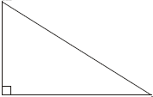
B C
A
40º
Find the length of x
6cm
2.
x
(3 marks)
………..….……………

3. What is the probability of picking a king out of a full deck of cards?
(2 marks)
………..….……………

4. What is the interquartile range of 6, 8, 13, 2, 4, 4, 15, 13?
(2 marks)
………..….……………

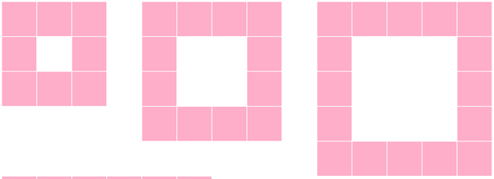
Topic Homework

1. How many squares are there in the 7th pattern?
(1 mark)
………..….……………

2. Which pattern would have 56 squares in it?
(1 mark)
………..….……………

3. Work out the n^{th} term of the sequence and then try and explain in words how you can “see” how this relates to this pattern.
(2 marks)
4. Draw a pattern to represent the sequence 3n + 2
(2 marks)

5.

How many tiles would be in the next-but-one pattern?
(1 mark)

6. Can you explain in words how the pattern grows?
(1 mark)

7. $4p+11=3$
(2 marks)
………..….……………

8. $\frac{a}{5}+3=9$
(2 marks)
………..….……………

9. $7\left(m-2\right)=3m+2$
(3 marks)
………..….……………

10. $5y+6 =30-3y$
(3 marks)
………..….……………

11. Write down 2 equations which have a solution of m = 4
………..….……………
(2 marks)
………..….……………

