Year 8 – Spring Assessment 2

Time: 45 minutes Calculator allowed

Name: .................................... Maths Teacher: .........................

Date: ......................... Maths Class: .........................
Answer all the questions
Read the questions carefully
Show your working
Check your answers

Mark (45)

Things I need to practise:
Things I did well:

Q1. Caribbean cordial
Here are the ingredients for a cordial used to make a drink.
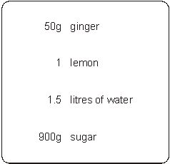
Jenny is going to make this cordial with 25g of ginger.
How much lemon, water and sugar should she use?
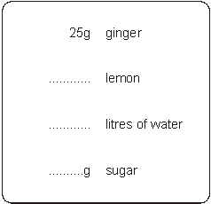
3 marks

Q2. Boxes
Lisa has some boxes that are all cubes of the same size.
She uses four of the boxes to make a pile with a height of 72 cm.
She puts one more box on top of the pile.
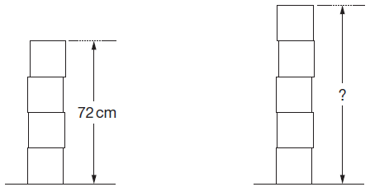
Work out the height of the pile of five boxes.

....................... cm
2 marks

Q3. Litres to gallons
A petrol station shows this information:

10 litres = 2.2 gallons

How many gallons is 50 litres?

..................... gallons
2 marks
Q4. Building kits
Toy building kits come in three sizes.
The ratio of bricks to doors is the same in each pack.
(a) Work out how many doors there are in a Standard pack.
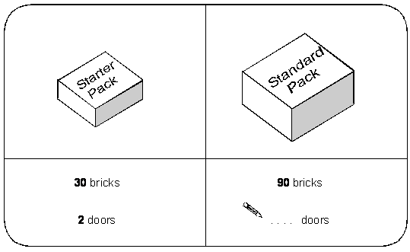
1 mark

(b) Work out how many bricks there are in a Super pack.
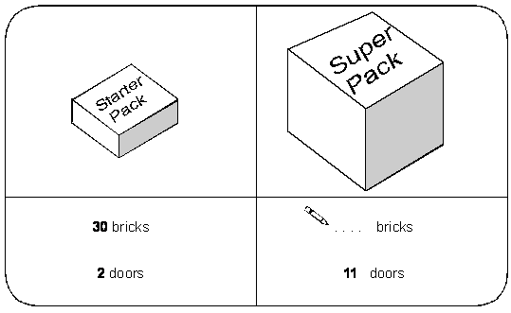
1 mark

Q5. Doughnuts
Here are the prices of doughnuts at two different shops.

Shop A |  | Shop B
3 doughnuts for £2 |  | 5 doughnuts for £3.50

I want to buy 15 doughnuts.
In which shop are the doughnuts cheaper?
You must show your working.

Tick () your answer.
Shop A Shop B
2 marks

Q6. Screenwash
Screenwash is used to clean car windows.
To use Screenwash you mix it with water.
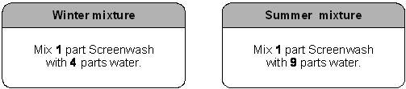

(a) In winter, how much water should I mix with 150ml of Screenwash?
.......................... ml
1 mark

(b) In summer, how much Screenwash should I mix with 450ml of water?
.......................... ml
1 mark

(c) Is this statement correct?

25% of winter mixture is Screenwash.

Tick () Yes or No.

 | True |  |  | False

Explain your answer.

1 mark

Q7. Paint
You can make different colours of paint by mixing red, blue and yellow in different proportions.
For example, you can make green by mixing 1 part blue to 1 part yellow.
(a) To make purple, you mix 3 parts red to 7 parts blue.
How much of each colour do you need to make 20 litres of purple paint?
Give your answer in litres.
..................... litres of red and ..................... litres of blue
2 marks

(b) To make orange, you mix 13 parts yellow to 7 parts red.
How much of each colour do you need to make 10 litres of orange paint?
Give your answer in litres.
..................... litres of yellow and ..................... litres of red
2 marks

Q8 One morning last summer Ravi carried out a survey of the birds in the school garden.
He saw 5 pigeons, 20 crows, 25 seagulls and 45 sparrows.
Complete the line below to show the ratios.

 | Pigeons | : | Crows | : | Seagulls | : | Sparrows
 | 1 | : | ........... | : | ........... | : | ...........

2 marks

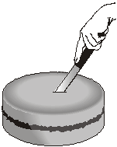
Q9. Cutting a cake
Ben is 10 years old.
Cindy is 15 years old.
Tom is 20 years old.

They are going to cut a cake into 3 slices from the centre.
The size of the slices will be proportional to their ages.
What will the angle at the centre of Ben’s slice be?

..................°
2 marks
Q10. Yoghurt
A dessert has both fruit and yoghurt inside.
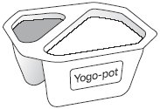
Altogether, the mass of the fruit and yoghurt is 175g.
The ratio of the mass of fruit to the mass of yoghurt is 2 : 5
What is the mass of the yoghurt?

...................... g
2 marks
Q11. Tennis prizes
Each year, there is a tennis competition in Australia and another one in France.
The table shows how much money was paid to the winner of the men’s
competition in each country in 2002.

Country | Money
Australia | 1000 000 Australian dollars  (£1 = 2.70 Australian dollars)
France | 780 000 Euros  (£1 = 1.54 Euros)

Which country paid more money?
You must show your working.

Tick () the country that paid more.

 |  | Australia |  | France

2 marks

Q12. Grey and black designs
(a) In this design, the ratio of grey to black is 3 : 1
What percentage of the design is black?
............................%
1 mark

(b) In this design, 60% is grey and the rest is black.
What is the ratio of grey to black?
Write your ratio in its simplest form.
............. : .............
2 marks

Q13. Here are some exchange rates.

£1 = 2.03 American dollars
£1 = 2.15 Canadian dollars

Use the exchange rates to answer this question.
(a) How many more Canadian dollars than American dollars would you get for £250?

dollars

2 marks

(b) How many more pounds (£) would you get for 250 American dollars than for 250 Canadian dollars?

£

2 marks

Q14. Ratio
(a) On this necklace the ratio of black beads to white beads is 1 : 3
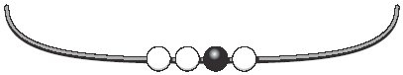
How many more black beads do you need to add to make the
ratio of black to white 3 : 1?

................... black beads
1 mark

(b) Here is the necklace again.
How many more black beads and white beads do you need to add to make the ratio of black to white 3 : 2?

....................... black beads, ....................... white beads
1 mark

Q15. Red and blue cubes
In a bag, there are red and blue cubes in the ratio 4 : 7
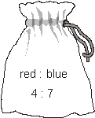

I add 10 more red cubes to the bag.
Now there are red and blue cubes in the ratio 6 : 7
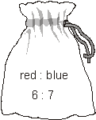

How many blue cubes are in the bag?

...................
2 marks

Q16. Shadows
Tom’s height is 1.8m.
He stands near a tree.
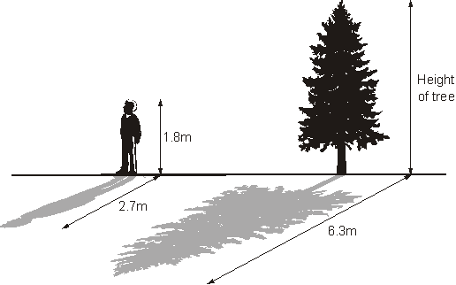
Not drawn accurately
At 4pm, the length of Tom’s shadow is 2.7m.
At 4pm, the length of the tree’s shadow is 6.3m.

What is the height of the tree?

m

2 marks

Q17. Best buy
You can buy jars of the same jam in two sizes.
454g for £1.59 340g for £1.25

Which jar is better value for money?
You must show working to explain your answer.

Tick () your answer.
A B
2 marks

Q18. Juice
The table shows a recipe for a fruit drink.

Type of juice | Amount
Orange | litre
Cranberry | litre
Grape | litre
 | Total 1 litre

I want to make 1litres of the same drink.
Complete the table below to show how much of each type of juice to use.
Show your working.

Type of juice | Amount
Orange | litre
Cranberry | litre
Grape | litre
 | Total 1 litres

2 marks

Q19. Centenarians
People who live to be 100 years old are called centenarians.
In 1998 there were 135 000 centenarians.
The ratio of male to female was 1 : 4
How many female centenarians were there in 1998?
Show your working.

...............................
2 marks

