Revision
1. Construct a triangle with a 7cm side, and angles of 40º and 65º. You must show all your construction lines.
(3 marks)
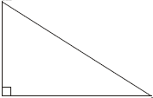
B C
A
30º
Find the length of x
7cm
2.
(3 marks)
………..….……………

x

3. What is the probability of rolling a prime number on a die?
(2 marks)
………..….……………

4. What is the median of 6, 8, 13, 2, 4, 4, 15, 13?
(2 marks)
………..….……………

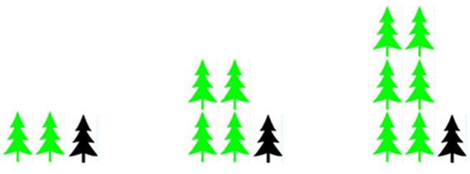
Topic Homework

1. How many light coloured trees are there in the 6th pattern?
(1 mark)
………..….……………
2. How many trees in total are there in the 15th pattern?
(1 mark)
………..….……………
3. Describe in words how this pattern grows.
4. Can you write this in algebra?
(1 mark)
(1 mark)
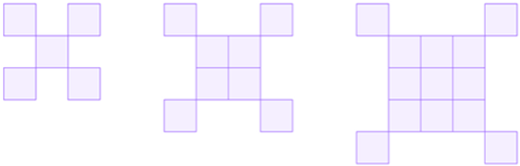

5. Draw the next pattern in the sequence
(1 mark)
………..….……………

6. How many squares would there be in the next-but-one pattern?
(1 mark)
………..….……………

7. Can you explain how the pattern grows?
(words 1 mark)
(algebraically 2 marks)

8. $4p-7=13$
(2 marks)
………..….……………

9. $\frac{2a}{5}=6$
(2 marks)
………..….……………

10. $3f+11=-10$
(2 marks)
………..….……………

11. $5\left(m-8\right)=3m+20$
(3 marks)
………..….……………

12. $8m-2 =9-3m$
(3 marks)
………..….……………

