Year 8 – Spring Assessment 2

Time: 45 minutes Calculator allowed

Name: .................................... Maths Teacher: .........................

Date: ......................... Maths Class: .........................
Answer all the questions
Read the questions carefully
Show your working
Check your answers

Mark (45)

Things I need to practise:
Things I did well:

Q1. Dollars
In America, there are coins each worth 25 cents.
These coins are called quarters because four of them make one dollar.
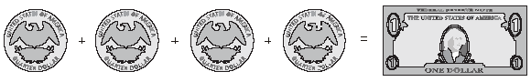
(a) Altogether, how many quarters make 3 dollars?
....................
1 mark

(b) Laura has 20 quarters. How many dollars is that?
....................
1 mark

(c) Dev wants to change 10 dollars into quarters. How many quarters should he get?
....................
1 mark

Q2. Plastic bottles
(a) Look at this information about recycling:

25 large plastic bottles can be recycled to make 1 fleece jacket.

Write the missing number in this sentence.
200 large plastic bottles can be recycled to make ...................... fleece jackets.
1 mark

(b) In a survey, 9 out of 10 people said they would like to recycle more.
What percentage of people said they would like to recycle more?

...................... %
1 mark
Q3. Shopping
Some people in a supermarket are shopping for food.
(a) 100g of cheese costs 46p.
Peter buys 250g of the cheese.
How much does he pay?

£

1 mark

(b) Tins of beans cost 36p each.
What is the largest number of these tins John can buy with £2?

.....................
1 mark
Q4. Caribbean cordial
Here are the ingredients for a cordial used to make a drink.
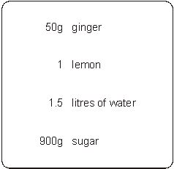
(a) Jenny is going to make this cordial with 25g of ginger.
How much lemon, water and sugar should she use?
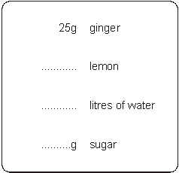
3 marks

(b) The finished drink should be cordial and water.
Jenny puts 100 ml of cordial in a glass.
How much water should she put with it?

.........................ml
1 mark

Q5. Balancing
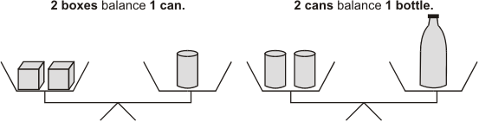

How many boxes make each of these balance?

(a)
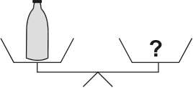
..................... boxes
1 mark

(b)
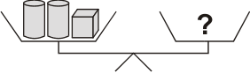
..................... boxes
1mark

(c)
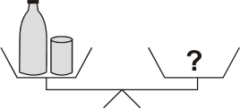
..................... boxes
1 mark

(d) Joe has these four things:
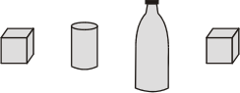
He wants to put them on the scales to make them balance.
Show where each thing must go on the scales.
1 mark

Q6. Weighing
There are two small tins and one big tin on these scales.
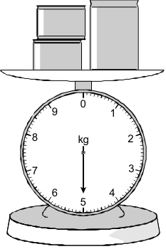

The two small tins each have the same mass.
The mass of the big tin is 2.6 kg.
What is the mass of one small tin?
Show your working.

kg

2 marks

Q7. Boxes
Lisa has some boxes that are all cubes of the same size.
She uses four of the boxes to make a pile with a height of 72 cm.
She puts one more box on top of the pile.
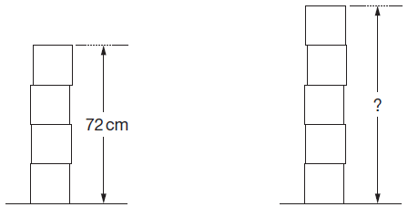

Work out the height of the pile of five boxes.

....................... cm
2 marks

Q8. Litres to gallons
A petrol station shows this information:

10 litres = 2.2 gallons

How many gallons is 50 litres?

..................... gallons
2 marks

Q9. Building kits
Toy building kits come in three sizes.
The ratio of bricks to doors is the same in each pack.
(a) Work out how many doors there are in a Standard pack.
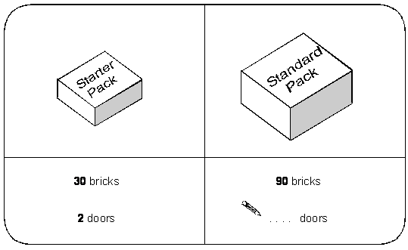
1 mark

(b) Work out how many bricks there are in a Super pack.
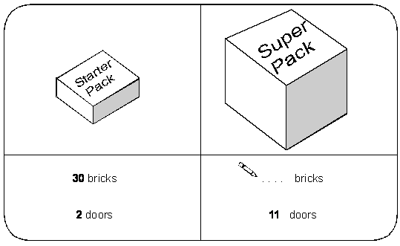
1 mark

Q10. Doughnuts
Here are the prices of doughnuts at two different shops.

Shop A |  | Shop B
3 doughnuts for £2 |  | 5 doughnuts for £3.50

I want to buy 15 doughnuts.
In which shop are the doughnuts cheaper?
You must show your working.

Tick () your answer.
Shop A Shop B
2 marks

Q11. Screenwash
Screenwash is used to clean car windows.
To use Screenwash you mix it with water.
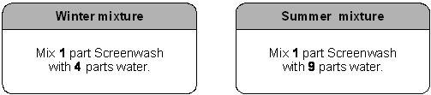

(a) In winter, how much water should I mix with 150ml of Screenwash?
.......................... ml
1 mark

(b) In summer, how much Screenwash should I mix with 450ml of water?
.......................... ml
1 mark

(c) Is this statement correct?

25% of winter mixture is Screenwash.

Tick () Yes or No.

 | True |  |  | False

Explain your answer.

1 mark

Q12. Paint
You can make different colours of paint by mixing red, blue and yellow in different proportions.
For example, you can make green by mixing 1 part blue to 1 part yellow.
(a) To make purple, you mix 3 parts red to 7 parts blue.
How much of each colour do you need to make 20 litres of purple paint?
Give your answer in litres.
..................... litres of red and ..................... litres of blue
2 marks

(b) To make orange, you mix 13 parts yellow to 7 parts red.
How much of each colour do you need to make 10 litres of orange paint?
Give your answer in litres.
..................... litres of yellow and ..................... litres of red
2 marks

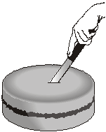
Q13. Cutting a cake
Ben is 10 years old.
Cindy is 15 years old.
Tom is 20 years old.

They are going to cut a cake into 3 slices from the centre.
The size of the slices will be proportional to their ages.
What will the angle at the centre of Ben’s slice be?

..................°
2 marks

Q14. One morning last summer Ravi carried out a survey of the birds in the school garden.
He saw 5 pigeons, 20 crows, 25 seagulls and 45 sparrows.
Complete the line below to show the ratios.

 | Pigeons | : | Crows | : | Seagulls | : | Sparrows
 | 1 | : | ........... | : | ........... | : | ...........

2 marks

Q15. Yoghurt
A dessert has both fruit and yoghurt inside.
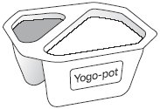
Altogether, the mass of the fruit and yoghurt is 175g.
The ratio of the mass of fruit to the mass of yoghurt is 2 : 5
What is the mass of the yoghurt?

...................... g
2 marks
Q16. Conversion
Here are some exchange rates.

£1 = 2.03 American dollars
£1 = 2.15 Canadian dollars

Use the exchange rates to answer this question.
How many more Canadian dollars than American dollars would you get for £250?

dollars

2 marks
Q17. Tennis prizes
Each year, there is a tennis competition in Australia and another one in France.
The table shows how much money was paid to the winner of the men’s
competition in each country in 2002.

Country | Money
Australia | 1000 000 Australian dollars  (£1 = 2.70 Australian dollars)
France | 780 000 Euros  (£1 = 1.54 Euros)

Which country paid more money?
You must show your working.

Tick () the country that paid more.

 |  | Australia |  | France

2 marks

Q18. Grey and black designs
(a) In this design, the ratio of grey to black is 3 : 1
What percentage of the design is black?
............................%
1 mark

(b) In this design, 60% is grey and the rest is black.
What is the ratio of grey to black?
Write your ratio in its simplest form.
............. : .............
2 marks

