Revision
1. Construct a triangle with a 6cm side, a 55º angle and a 4cm side. You must show all your construction lines.
(3 marks)
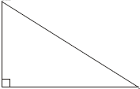
B C
A
30º
Use the sin ratio find the length of x
8cm
2.
(3 marks)
………..….……………
x

3. What is the probability of rolling a square number on a die?
(2 marks)
………..….……………

4. What is the median of 7, 4, 5, 9, 11, 2 ?
(2 marks)
………..….……………

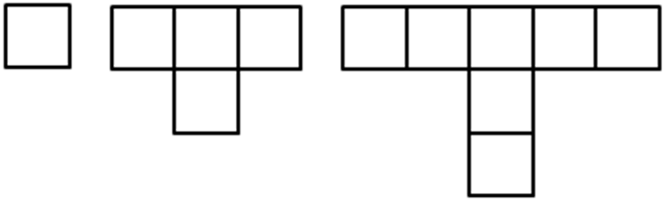
Topic Homework
1.

How many squares are there in the 4th pattern?
(1 mark)
………..….……………

2. Which number pattern has 19 squares in it?
(1 mark)
………..….……………

3. Describe in words how this pattern grows.

(1 mark)
4. Can you find the n^{th} term of this sequence?
(1 mark)
………..….……………
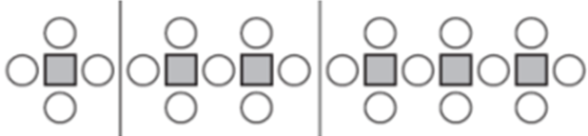
5.

Draw the next pattern in the sequence
(1 mark)
6. Fill in the four gaps in the table below
Term Number | Number of Squares | Number of Circles
1 | 1 | 4
2 | 2
3 | 3 | 10
4 |  | 13
 | 10

(4 marks)

8. $3p-2=10$
(2 marks)
………..….……………

9. $\frac{a+1}{2}=5$
(2 marks)
………..….……………

10. $2f+4=9$
(2 marks)
………..….……………

11. $5m+1 =2m+7$
(3 marks)
………..….……………

12. $4 =3m+10$
(2 marks)
………..….……………

