Year 8 – Spring Assessment 2

Time: 45 minutes Calculator allowed

Name: .................................... Maths Teacher: .........................

Date: ......................... Maths Class: .........................
Answer all the questions
Read the questions carefully
Show your working
Check your answers

Mark (38)

Q1. Fractions
Things I need to practise:
Things I did well:
The shapes in this question are drawn on square grids.
(a) Shade of the shape below.
1 mark

(b) What fraction of the shape below is shaded?
.............
1 mark

Q2. Dollars
In America, there are coins each worth 25 cents.
These coins are called quarters because four of them make one dollar.
(a) Altogether, how many quarters make 3 dollars?
....................
1 mark

(b) Laura has 20 quarters. How many dollars is that?
....................
1 mark

(c) Dev wants to change 10 dollars into quarters. How many quarters should he get?
....................
1 mark

Q3. School trip
On a school trip each teacher can take no more than 20 pupils.
(a) Three teachers go on a school trip.
What is the greatest number of pupils they can take with them?
.................... pupils
1 mark

(b) The table shows how many pupils go on three school trips.
Complete the table to show the least number of teachers that must go with each school trip.

 | Number  of people | Number  of teachers
 | 100
 | 104
 | 199

2 marks

Q4. Biscuits
Sue and Ben each have 12 biscuits.
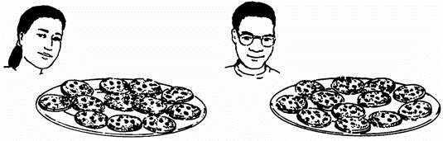

(a) Sue eats a quarter of her biscuits.
How many biscuits does Sue eat?
1 mark

(b) Ben eats 6 of his 12 biscuits.
What fraction of his biscuits does Ben eat?
1 mark

(c) How many biscuits are left altogether?
1 mark

Q5. American dollars

£1 = 1.56 dollars

How much is £1.50 in dollars?

dollars

1 mark

Q6. Plastic bottles
(a) Look at this information about recycling:

25 large plastic bottles can be recycled to make 1 fleece jacket.

Write the missing number in this sentence.
200 large plastic bottles can be recycled to make …................... fleece jackets.
1 mark

(b) In a survey, 9 out of 10 people said they would like to recycle more.
What percentage of people said they would like to recycle more?

…................... %
1 mark

Q7. Shopping
Some people in a supermarket are shopping for food.
(a) 100g of cheese costs 46p.
Peter buys 300g of the cheese.
How much does he pay?

£

1 mark

(b) Tins of beans cost 36p each.
What is the largest number of these tins John can buy with £2?

…..................
1 mark

Q8. Caribbean cordial
Here are the ingredients for a cordial used to make a drink.
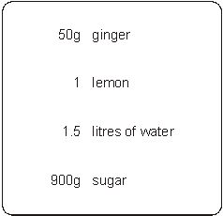
(a) Jenny is going to make this cordial with 25g of ginger.
How much lemon, water and sugar should she use?
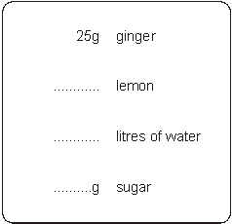
3 marks

(b) The finished drink should be cordial and water.
Jenny puts 100 ml of cordial in a glass.
How much water should she put with it?

…......................ml
1 mark

Q9. Weighing
There are two small tins and one big tin on these scales.
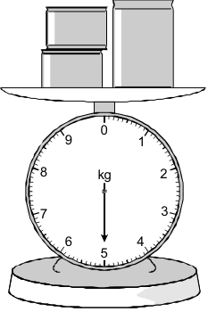

The two small tins each have the same mass.
The mass of the big tin is 2.6 kg.
What is the mass of one small tin?
Show your working.

kg

2 marks

Q10. Boxes
Lisa has some boxes that are all cubes of the same size.
She uses four of the boxes to make a pile with a height of 72 cm.
She puts one more box on top of the pile.
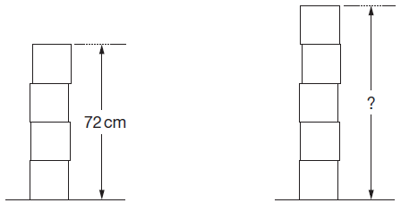

Work out the height of the pile of five boxes.

....................... cm
2 marks

Q11. Litres to gallons
A petrol station shows this information:

10 litres = 2.2 gallons

How many gallons is 50 litres?

..................... gallons
2 marks

Q12. Building kits
Toy building kits come in three sizes.
The ratio of bricks to doors is the same in each pack.
(a) Work out how many doors there are in a Standard pack.
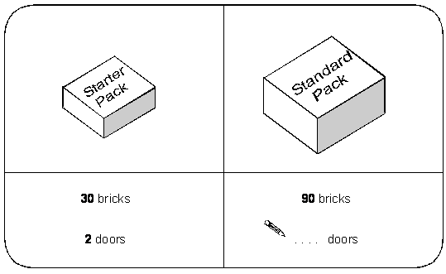
1 mark

(b) Work out how many bricks there are in a Super pack.
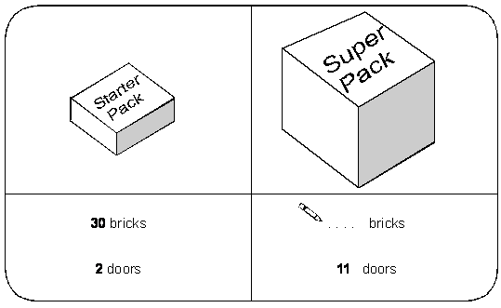
1 mark

Q13. Doughnuts
Here are the prices of doughnuts at two different shops.

Shop A |  | Shop B
3 doughnuts for £2 |  | 5 doughnuts for £3.50

I want to buy 15 doughnuts.
In which shop are the doughnuts cheaper?
You must show your working.

Tick () your answer.
Shop A Shop B
2 marks

Q14. Screenwash
Screenwash is used to clean car windows.
To use Screenwash you mix it with water.
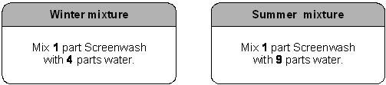

(a) In winter, how much water should I mix with 150ml of Screenwash?
.......................... ml
1 mark

(b) In summer, how much Screenwash should I mix with 450ml of water?
.......................... ml
1 mark

(c) Is this statement correct?

25% of winter mixture is Screenwash.

Tick () Yes or No.

 | True |  |  | False

Explain your answer.

1 mark

Q15. Paint
You can make different colours of paint by mixing red, blue and yellow in different proportions.
For example, you can make green by mixing 1 part blue to 1 part yellow.
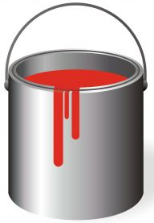

Green Paint = 1 part Blue + 1 part Yellow

To make purple, you mix 3 parts red to 7 parts blue.
Purple Paint = 3 parts Blue + 2 parts Red

How much of each colour do you need to make 10 litres of purple paint?
Give your answer in litres.
..................... litres of blue and ..................... litres of red
2 marks

Q16. One morning last summer Ravi carried out a survey of the birds in the school garden.
He saw 5 pigeons, 20 crows, 25 seagulls and 45 sparrows.
Complete the line below to show the ratios.

 | Pigeons | : | Crows | : | Seagulls | : | Sparrows
 | 1 | : | ........... | : | ........... | : | ...........

2 marks

Q17. Yoghurt
A dessert has both fruit and yoghurt inside.
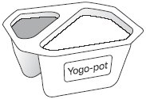
Altogether, the mass of the fruit and yoghurt is 175g.
The ratio of the mass of fruit to the mass of yoghurt is 2 : 5
What is the mass of the yoghurt?

...................... g
2 marks

